Republic of Tajikistan

MINISTRY OF HEALTH AND SOCIAL PROTECTION

MILLATI SOLIM: TAJIKISTAN HEALTHY NATION PROJECT

RESETTLEMENT FRAMEWORK

July 2023

CONTENT

Abbreviations 5
Glossary of Terms 6
Introduction 9
1. Project Description 10
2. Rationale for ESS 5 and RF Scope 15
3. Objectives and Principles of Resettlement Planning 17
4. Legal Frameworks and Policies Related to Land Acquisition and Resettlement 19
4.1 Relevant Legislation of the Republic of Tajikistan on Land Administration 19
4.2 National Social Legal Provisions and Regulations 21
4.3 The World Bank Environmental and Social Standard on Land Acquisition, Restrictions on Land Use, and Involuntary Resettlement (ESS5) 22
4.4 Comparison of national legislation and WB ESS 5 25
5. RAP Preparation, Approval and Disclosure Process 29
5.1 Census, Social and Economic Surveys, Inventory of Losses 29
5.2 Preparation of Resettlement Action Plans 29
5.3 Disclosure and approval 30
6. Eligibility Criteria and Procedures for Various Categories of Project Affected People 31
6.1 Principles 31
6.2 Eligibility Criteria and Entitlements 31
6.3 Entitlement Matrix: Eligible PAPs, Assets and Compensation Guidelines 32
6.4 Voluntary Land Donation 35
6.5 Methods to Determine Cut-Off Dates 36
7. Methods of Valuating Affected Assets 37
7.1 Type of Compensation Payments 37
7.2 Preparation of Asset Inventory 37
7.3 Valuation Method 37
7.3.1. Compensation for Land 37
7.3.2 Calculation of Crops and Fruit Trees Compensation Rate 38
7.3.3. Compensation for Structures 38
7.3.4. Compensation for Community Assets 38
7.3.5. Compensation for Sacred Sites 39
7.3.6. Compensation for Loss of Businesses 39
8. RF and RAP Implementation Arrangements and Procedures 40
8.1 Overview 40
8.2 Screening of Project Activities 41
8.2.1 List of Non-Eligible Activities for Subprojects 41
8.3 Socio-Economic Profiling and Inventory of Losses 43
8.4 Due Diligence Review of Linked Activities 43
8.5 Estimates of affected population and assets in the project affected areas 43
8.6. Roles and Responsibilities 43
8.7 Monitoring and Evaluation Arrangements 45
8.7.1 Monitoring Plans 45
8.7.2 Monitoring and Reporting Responsibilities 46
8.8 Implementation Budget 47
9. Public Consultations and Disclosure 48
9.1 RF Disclosure 48
9.2 Public Consultations 48
9.3 Grievance Mechanism 48
9.3.1 Overall Process 48
9.3.2 Procedures: 49
9.3.3 Grievance Resolution Process 50
9.3.4 Grievance Log 51
9.3.5 Monitoring and Reporting on Grievances 52
9.3.6 World Bank Grievance Redress System 52
ANNEXES 53
Annex 1. Outline of the RAP process. 53
Annex 2: Screening report form of expected social impacts 54
Annex 3: PAP census form and inventory of the land fund 55
Annex 4: Inventory of PAP’s land assets 56
Annex 5: PAP rights for compensation 56
Annex 6: Outline of the Resettlement Action Plan and Abbreviated Resettlement Action Plan 57
Annex 7: Voluntary Land Donation Criteria and Form 60
Annex 8: Minutes of Public Consultations 62
Minutes of Stakeholder Consultations on E&S instruments in Gazantarak Jamoat, Devashtich District, Sughd Region 62
Minutes of Stakeholder Consultations on E&S instruments Yakhtan Jamoat, Devashtich District, Sughd Region 65
Minutes of Stakeholder Consultations on E&S instruments Kurush Jamoat, Spitamen District, Sughd Region 66
Minutes of Stakeholder Consultations on E&S instruments Yangiobod Jamoat, Spitamen District, Sughd Region 68
Minutes of Stakeholder Consultations on E&S instruments Navobod Jamoat, J. Balkhi District, Khatlon region 71
Minutes of Stakeholder Consultations on E&S instruments Guliston Jamoat, J. Balkhi District, Khatlon region 74
Minutes of Stakeholder Consultations on E&S instruments Fakhrobod Jamoat, Khuroson District, Khatlon region 77
Minutes of Stakeholder Consultations on E&S instruments Kyzyl Kala Jamoat, Khuroson District 80

Abbreviations

ARAP  CERP | Abbreviated Resettlement Action Plan  Contingent Emergency Response Component
CME  CHC  DHC  ECDP  EMR  EPR | Continuous Medical Education  City Health Center  District Health Center  Early Childhood Development Project  Electronic Medical Record  Electronic Patient Registry
E&S | Environmental and Social
ESF | Environmental and Social Framework
ESMF | Environmental and Social Management Framework
ESS | Environmental and Social Standards
FM | Family Medicine
GFP | Grievance Focal Point
GMG | Grievance Management Group
GM | Grievance Mechanism
GRS  HEPR  HPAU | Grievance Redress System (WB)  Health Emergency Preparedness and Response  Health Policy and Analysis Unit
HSIP | Health Services Improvement Project
IOL  LAN | Inventory of Losses  Local area networks
LSG | Local self-government (jamoat)
MoHSPP | Ministry of Health and Social Protection of Population
NGO | Non-Governmental Organization
PAP | Project Affected Person
PHC  PFM | Primary Health Care  Public Finance Management
TSG | Technical Support Group
RAP | Resettlement Action Plan
RF | Resettlement Framework
RPHCIRD | Reforms, Primary Healthcare, and International Relations Department of the MoHSPP
WB | World Bank

Glossary of Terms

In this Resettlement Policy Framework, unless the context dictates otherwise, the following terms will have the following meanings:

“Census” is a complete count of the population affected by a project activity including collation of demographic and property information. This will identify and determine the number of Project Affected Persons (PAP) and the nature and levels of impact.

“Compensation” means the payment in kind, cash or other assets given in exchange for the taking of land, loss of other types of assets (including fixed assets) or loss of livelihoods resulting from project activities.

“Consultation”: The process of gathering information or advice from stakeholders and taking these views into account when making project decisions and/or setting targets and defining strategies.

“Cut-off date” is the date by which PAPs and their affected assets, as relevant, have been identified and new entrants to the site cannot make claims to compensation or resettlement assistance. Persons whose ownership, use of occupancy prior to the cut-off date can be demonstrated remain eligible for assistance, regardless of their identification in the census.

“Economic Rehabilitation Assistance” means the provision of development assistance in addition to compensation such as land preparation, credit facilities, training, or job opportunities, needed to enable PAPs to improve their living standards, income earning capacity and production levels; or at least maintain them at pre-project levels.

“Engagement”: A process in which a company builds and maintains constructive and sustainable relationships with stakeholders impacted over the life of a project. This is part of a broader “stakeholder engagement” strategy, which also encompasses governments, civil society, employees, suppliers, and others with an interest in the project.

“Environmental and Social Standards” (ESSs) set out the requirements for Borrowers/Clients relating to the identification and assessment of environmental and social risks and impacts associated with projects supported by the Bank through Investment Project Financing. Ten ESSs establish the standards that the Borrower/Client and the project should meet through the project life cycle.

“Involuntary resettlement” means the involuntary taking of land resulting in direct economic, physical and social impacts caused by:
- the involuntary taking of land resulting in:
- relocation or loss of shelter;
- loss of assets or access to assets; or

- loss of income sources or means of livelihood, whether or not the PAP has moved to another location.

- The involuntary restriction of access to legally designated parks and protected areas resulting in adverse impacts on the livelihoods of the displaced persons.

“Jamoat”: Refers to the local self-governing body at the sub-district level, administering several villages and functioning based on the Law of the Republic of Tajikistan “On Self-Government Bodies in Towns and Villages” (1994, amended 2009 and 2017).

“Land” includes anything growing on or permanently affixed to land, such as crops, buildings and other improvements, and appurtenant water bodies.

“Land acquisition” refers to all methods of obtaining land for project purposes, which may include outright purchase, expropriation of property and acquisition of access rights, such as easements or rights of way. Land acquisition may also include: (a) acquisition of unoccupied or unutilized land whether or not the landholder relies upon such land for income or livelihood purposes; (b) repossession of public land that is used or occupied by individuals or households; and (c) project impacts that result in land being submerged or otherwise rendered unusable or inaccessible.

“Livelihood” refers to the full range of means that individuals, families and communities utilize to make a living, such as wage-based income, agriculture, fishing, foraging, other natural resource-based livelihoods, petty trade and bartering.

“Local communities”: Refers to groups of people living in close proximity to a project that could potentially be impacted by a project. (“Stakeholders,” in contrast, refers to the broader group of people and organizations with an interest in the project.)

“Non-Government Organizations”: Private organizations, often not-for-profit, that facilitate community development, local capacity building, advocacy, and environmental protection.

“Partnerships”: In the context of engagement, partnerships are defined as collaboration between people and organizations to achieve a common goal and often share resources and competencies, risks and benefits.

“Project”: Refers to this WB-funded Strengthening Resilience of the Agriculture Sector Project.

“Project Area”: A geographical area within which direct and indirect impacts attributable to a project can be expected. Typically, a Project Area is (i) unique to a project (ii) larger than the actual footprint of a project; and encompasses socio-economic issues and impacts, as well as issues and impacts associated with other disciplines (e.g. environment, health and safety). Defining the Project Area is used to determine a project’s area of influence and responsibilities. It also provides guidance on the area within which impacts need to be monitored, and managed, and it also assists with defining project stakeholders that should be engaged during an ESIA process.

“Project affected persons” (PAPs) means persons who are impacted by involuntary resettlement as defined below.

“Restrictions on land use” refers to limitations or prohibitions on the use of agricultural, residential, commercial or other land that are directly introduced and put into effect as part of the project. These may include restrictions on access to legally designated parks and protected areas, restrictions on access to other common property resources, and restrictions on land use within utility easements or safety zones.

“Resettlement Action Plan (RAP)” is a resettlement instrument (document) to be prepared when subproject locations are identified. RAPs contain specific and legally binding requirements to be abided by to resettle and compensate the affected party before implementation of the project activities causing adverse impacts.

“Resettlement Assistance” means the measures to ensure that project affected persons who may require to be physically relocated are provided with assistance such as moving allowances, residential housing or rentals whichever is feasible and as required, for ease of resettlement during relocation.

“Replacement cost for houses and other structures” means the prevailing open market cost of replacing affected structures, in an area and of the quality similar to or better than that of the affected structures. Such costs will include: (a) the cost of the materials, (b) transporting building materials to the construction site; (c) any labor and contractors’ fees; and (d) any registration or transfer costs.

“Resettlement Policy Framework (RF)’ is an instrument to be used throughout project implementation. The RF sets out the resettlement objectives and principles, organizational arrangements and funding mechanisms for any resettlement, that may be necessary during project implementation. The RF guides the preparation of Resettlement Action Plans of individual sub projects in order to meet the needs of the people who may be affected by the project. The Resettlement Action Plans for the Project will therefore be prepared in conformity with the provisions of this RF.

“Replacement cost” means replacement of assets with an amount sufficient to cover full cost of lost assets and related transaction costs. The cost is to be based on Market rate (commercial rate) according to the legislation of the Republic of Tajikistan. In terms of land, this may be categorized as follows; (a) “Replacement cost for agricultural land” means the pre-project or pre-displacement, whichever is higher, market value of land of equal productive potential or use located in the vicinity of the affected land, plus the costs of: (b) preparing the land to levels similar to those of the affected land; and (c) any registration and transfer taxes.

“Replacement cost” is defined as a method of valuation yielding compensation sufficient to replace assets, plus necessary transaction costs associated with asset replacement. Where functioning markets exist, replacement cost is the market value as established through independent and competent real estate valuation, plus transaction costs. Where functioning markets do not exist, replacement cost may be determined through alternative means, such as calculation of output value for land or productive assets, or the undepreciated value of replacement material and labor for construction of structures or other fixed assets, plus transaction costs. In all instances where physical displacement results in loss of shelter, replacement cost must at least be sufficient to enable purchase or construction of housing that meets acceptable minimum community standards of quality and safety. The valuation method for determining replacement cost should be documented and included in relevant resettlement planning documents. Transaction costs include administrative charges, registration or title fees, reasonable moving expenses, and any similar costs imposed on affected persons. To ensure compensation at replacement cost, planned compensation rates may require updating in project areas where inflation is high or the period of time between calculation of compensation rates and delivery of compensation is extensive.

“Pre-Feasibility phase”: The phase of a project which includes a Screening Study to identify social and environmental fatal flaws, and a Scoping Study to identify and assess the social and environmental issues of a proposed project and evaluate project design alternatives prior to proceeding to project feasibility.

“Security of tenure” means that resettled individuals or communities are resettled to a site that they can legally occupy, where they are protected from the risk of eviction and where the tenure rights provided to them are socially and culturally appropriate. In no event will resettled persons be provided tenure rights that are in effect weaker than the rights they had to the land or assets from which they have been displaced.

“Stakeholder”: Refers to individuals or groups who: (a) are affected or likely to be affected by the project (project-affected parties); and (b) may have an interest in the project (other interested parties). Stakeholders are defined as people or entities that are affected or may have an interest in the Project.

“Subproject”: Refers to a subproject to be funded under the Strengthening Resilience of the Agriculture Sector in Tajikistan Project.

“Voluntary Land Donation” - means communities or individuals may agree to voluntarily provide land for sub-projects for desired community benefits. The operative principles in voluntary land donation are “informed consent and power of choice”. Informed consent means the people involved are fully knowledgeable about the project and its implications and consequences and freely agree to participate in the project Power of choice refers to the people involved have option to agree or disagree, without adverse consequences imposed formally or informally by others.

Introduction

The Ministry of Health and Social Protection of Population (MoHSPP) of Tajikistan is preparing the Millati Solim: Tajikistan Healthy Nation Project with the World Bank’s Health, Nutrition and Population Global Practice assistance. Millati Solim: Tajikistan Healthy Nation Project will support Tajikistan’s ambitious plan to implement a revised version of the Mandatory Health Insurance Law and take necessary steps towards achieving Universal Health Coverage.
The project will have positive social impacts, as it will contribute to (i) improved quality and equity of PHC services in selected districts/regions and (ii) strengthened national capacity to respond to health emergencies. Social risks could emanate from the following planned investments: (i) investments in PHC service delivery capacity (human resources, infrastructure, and equipment) at the PHC level in selected districts and at the national level, and (ii) national capacity and physical infrastructure enhancement to improve response to various emergencies, including: training of health workers; repairing, equipping, and modernizing public health workplaces; construction of warehouses for emergency medical equipment and goods at the regional level; procurement of medical goods to stockpile for future emergencies; and investment in biosecurity and transportation arrangement to improve regionally coordinated research into pathogens and other potential causes of health emergencies.

One of the key challenges for the project will be to ensure social ‘inclusion’. Exclusion may happen due to differentials in: (i) geography – given the vast expanse of the PHC facilities throughout the country and the fact that some of the terrain is mountainous and remote, particularly near the Afghanistan border, it is likely that some areas (regions, districts and villages) may not be covered by the project; (ii) scale of investments – large and richer districts/regions may receive preferential investments; (iii) absorption capacity - technologies developed should be more friendly to health workers at large, and (iv) administrative expediency and economy in reaching out to rural health workers and vulnerable households in remote and poor areas across the country.

The project recognizes the significance of and adopts the World Bank’s Environmental and Social Standards (ESS), for identifying and assessing as well as managing the environmental and social (E&S) risks and impacts associated with this investment project. Both the environmental and social (E&S) risks for the Project are rated Moderate at this stage. The following Environmental and Social Standards (ESS) are relevant to the Project: ESS 1 – Assessment and Management of Environmental and Social Risks and Impacts; ESS 2 – Labor and Working Conditions; ESS 3 – Resource Efficiency and Pollution and Management; ESS 4 – Community Health and Safety; ESS 5 - Land Acquisition, Restrictions on Land Use, and Involuntary Resettlement; and ESS 10 – Stakeholders Engagement and Information Disclosure.

In compliance with the ESS5, this Resettlement Policy Framework (RF) was prepared, which serves the following specific purposes: (i) Reviews the existing national legal framework, compares it with the ESS 5 for gaps, if any, and indicates gap-filling measures; (ii) Describes the approach to the securing private land, assets and other common property resources; (iii) Specifies the scope of the project with a well-defined exclusion list; (iv) Defines the valuation process of impacted assets; (v) Defines the process for preparation of Social Impact Assessment and RAPs and their review; (vi) Defines of the cutoff date for Title and Non-Title holders; (vii) Identifies the consultation mechanisms/approaches to be adopted while preparing and implementing RAPs including public disclosures; (viii) Defines the monitoring and evaluation arrangements including Grievance Mechanisms (GM); and (ix) Defines the institutional and implementation arrangements --role/responsibilities of different stakeholders.

1. Project Description

The objectives of the Project are to (i) improve the quality and efficiency of primary healthcare services in Selected Districts and (ii) strengthen the national capacity to respond to public health emergencies.
Component 1 (Primary Healthcare [PHC] Strengthening) will be implemented in selected districts to be defined by the MoHSPP. Components 2, 3 and 4 will have a national scope. However, activities under Component 2 (Digitalization and Strategic Purchasing of PHC services) will be designed for national scale up but will first be implemented in Sughd Oblast and Dushanbe City.
The proposed project will have the following components:
Component 1: Quality Improvements of Primary Care through Primary Healthcare Strengthening
The objective of this component is to improve the conditions for delivering quality PHC services by making PHC facilities service ready. This will be achieved through investments in service delivery capacity (human resources, infrastructure, and equipment) in the 16 selected districts representing all regions in the country and in interventions to ignite the demand for PHC services among the population.
Subcomponent 1.1: Quality Improvements of Primary Care through Investments in Human Resources and Demand Stimulation will address the pressing need to invest in human resources working at the PHC level in 16 selected districts. This will be achieved by developing sustainable national policy options for retaining family medicine doctors and nurses and other specialists working at the PHC level in rural areas (which are also most sensitive to climate change impacts) through the development of a human resource strategy for retention of these cadres. The subcomponent will support the implementation of identified retention strategies in the 16 target districts. With support of this subcomponent, knowledge and management of PHC providers will be improved through: (i) in-person training of doctors and nurses in family medicine in the 16 target districts, (ii) PHC management training in the 16 target districts, (iii) development and establishment of a national online platform for delivery of continuous medical education (CME) to PHC providers, which will also allow them to access the latest evidence-based clinical guidelines and climate change knowledge, (iv) technical assistance to revise the specialty standards and curricula for specialists working at the PHC level. To allow for the delivering of training, this sub-component will support the Republican Clinical Training Center, including their regional branches, with minor rehabilitation of their offices, and office equipment for their staff as well as simulation centers to improve training of doctors and nurses. This subcomponent will also support demand-side investments and citizen engagement (CE) to improve uptake of PHC services, including for reproductive maternal, newborn, child and adolescent health and nutrition (RMNCHA-N) services. Such demand-side interventions will include mobile outreach to citizens through Mobile Engage with health promotion, prevention, and behavioral change communication. This will also raise the citizen’s awareness of climate-sensitive diseases as well as MoHSPP’s online Grievance Redress Mechanism (GRM). Moreover, a yearly phone-based National Patient Survey to measure citizen’s view and satisfaction with healthcare services at the PHC level will be financed, to allow for MoHSPP to stay tuned to the needs and desires of the citizens. To prepare for the implementation of the amended Law on the Prevention of Domestic Violence, this subcomponent will support the integration of GBV services in the health sector with a particular focus on PHC level. This will be done through a three-pronged approach focused on the level of (i) national policy development (e.g. development of referral pathways, develop clinical guidelines etc.), (ii) interventions at the PHC level (e.g. training of healthcare workers in GBV response), and (iii) the individual (healthcare workers and citizens awareness about GBV through e.g. Mobile Engage).
This subcomponent will finance goods, minor rehabilitation, non-consulting services, international and local technical assistance, and training.
Subcomponent 1.2: Quality Improvements of Primary Care through Physical Infrastructure Improvements through investments in rehabilitation of existing and, where needed, construction of new priority PHC facilities in 16 selected project districts, as well as provision of basic medical/laboratory and computer equipment. Support under this subcomponent will focus on RHCs and a limited number of DHC/CHC, which collectively cover predominant shares of population in their catchment areas. This subcomponent will aim to ensure uninterrupted basic functionality and capacity of selected PHC facilities to make facilities service ready to deliver quality PHC services and fulfill requirements for accreditation. By ensuring that PHC staff have good working conditions and basic medical/laboratory, office, and computer equipment and furniture to provide essential PHC services, it will contribute to improving quality of front-line PHC services and making it more attractive for health workers to work at the PHC level and for citizens to visit these facilities. It will also support development of an evidence-based concept of providing mobile PHC services to populations in remote areas and investments to implement recommendations outlined in the concept in the 16 districts.
This sub-component will finance civil works, goods, international and local technical assistance, and training.
Component 2: Efficiency enhancing reforms in the PHC network
Component 2 supports structural reforms related to strategic purchasing and digitalization of PHC to improve efficiency and quality of PHC services, and to drive enhanced spending efficiency, equity, and financial sustainability of the overall health sector. The activities financed under this component are designed to be implemented at national scale. Building on lessons learned, including from previous pilots in Tajikistan, the Project will be fully integrated in the public finance context and operate by making changes to national systems (e.g., public financial management (PFM) system) rather than relying on Project-specific parallel or temporary arrangements, which may be quicker to implement but less sustainable and effective in the long run. During the project period, the changes to national systems will be developed to allow for digitalization and strategic purchasing at the PHC level and these will be implemented in pioneer regions, Sughd region and Dushanbe city. By paying primary care providers based on a mix of capitation, fee-for-service and other output-based measures this component will introduce a new incentive environment with increased focus on performance, that in turn will drive efficiency in health spending.
PBCs are used under Component 2 to strengthen the Project’s results orientation and to incentivize structural reforms. Similar incentives have been used successfully to nudge structural reforms in Tajikistan under the ECDP Project. These additional conditions for disbursements will ensure that the necessary activities to develop policy and institutional changes needed to introduce strategic purchasing and digitalization are not only developed but also approved at the national level, enabling the Project to support their implementation. Furthermore, it is foreseen that additional incentives to nudge changes in the public financial management system important for strategic purchasing and to increase the share of public health expenditures in relation to total public expenditure will be introduced in the forthcoming development policy lending operation.

Subcomponent 2.1: Strategic Purchasing of PHC services
Subcomponent 2.1 will build the foundations for introducing strategic purchasing in the health sector and support the establishment of the purchasing structure of purchaser. Building on an ongoing pilot to establish strategic purchasing in 5 districts in Sughd region as well as the experience with PBF under HSIP, this component will first finance the establishment of the purchasing structure of purchaser, a semi-autonomous legal entity with regional branches that will act as a single purchaser of the health care services. This includes conception of the structure of purchasing structure of purchaser, the creation of the legal framework, as well as its establishment, initial staff costs and capacity building of the purchasing structure of purchaser. The purchasing structure of purchaser will be mainly staffed by relevant civil servants that will be transferred from the MoHSPP, MoF, and other relevant Government agencies (e.g., MedStat) at the national level and from the local administrations at the regional branches level. These transferred staff will continue to be paid as civil servants by the Government. In addition to this, new employees will be hired, and are estimated to reach 35 individuals by the end of the Project. The operating costs of the purchasing structure of purchaser, including the costs for the 35 new staff, will be transferred to the Government over the lifetime of the Project per the table below to ensure sustainability of the purchasing structure of purchaser beyond the end of the Project. The financing of recurrent expenditures for staff during the first years is motivated by the fact that the expenditures are transitional, as they are supporting a new institution not previously budgeted for by the Government. The establishment of the purchasing structure of purchaser and introduction of the strategic purchasing will change the flow of funds for the health sector. The funds from the state budget will be transferred to the purchasing structure of purchaser, and purchasing structure of purchaser will use these funds to pay for healthcare services. This change will be gradual and start with pioneer regions. A detailed assessment of the needed regulatory and legal changes to introduce strategic purchasing as the PHC level is currently being conducted and will inform this component.
The subcomponent will finance a number of national foundational activities needed for a sustainable introduction of strategic purchasing. This includes a domestic resource mobilization strategy for the health sector at the national level, which is essential for the sustainability of Component 2 and to eventually implement the Law on Health Insurance. Moreover, the subcomponent will finance the revision and costing of the national PHC benefit package to determine which services the purchasing structure of purchaser will purchase at the PHC level. At the national level, the subcomponent will finance the development of a service delivery network masterplan to optimize the service delivery network as well as the development and implementation of an accreditation program for PHC providers, as accreditation will eventually be a prerequisite for all providers for contracting with the purchasing structure of purchaser. In addition, it will finance the development and implementation of a national roadmap for the legal and regulatory changes needed to transition from the current, primarily input-based, PHC payment mechanism to payments based on capitation and outputs. A detailed assessment of needed regulatory and legal changes is currently being conducted to inform this roadmap. This will need to include revision of staffing norms and the deepening of the already initiated changes to the PFM systems to create more autonomy for PHC providers. The subcomponent will also finance the development of a national PHC contracting mechanism, a change management strategy for the structural reforms, and the implementation of strategic purchasing in pioneer areas (Sughd region and Dushanbe city), this includes training of healthcare workers and PHC managers in strategic purchasing.
This subcomponent will finance goods, non-consulting services, international and local technical assistance, training, and eligible expenditures linked to PBCs (see below).
The PBC listed below is linked to sub-component 2.1 and serves to incentivize reform implementation.
- PBC 1: Policy and institutional reforms for introducing strategic purchasing adopted. PBC 1 rewards the following five results: (i) health service delivery network masterplan developed and approved, (ii) purchasing structure of purchaser established and operational, (iii) regulatory framework to increase the PHC providers autonomy developed and approved, (iv) single state-guaranteed benefit package for PHC developed, costed and approved, and (v) staffing norms revised and approved. Disbursement of US$4 million in total will be linked to achievement of the targets defined for this PBC.

Subcomponent 2.2: Digitalization of PHC network
Subcomponent 2.2 will support the digitalization and infrastructure upgrades of the PHC network. To provide reliable and quality data for capitation formula and calculation of outcome indicators, this subcomponent will finance development and expansion of the EPR and basic EMR in PHC facilities. The EPR is necessary for implementation of capitation formula, while the EMR system is needed to provide reliable electronic data for calculation of outcome indicators by the purchasing structure of purchaser. Sub-component 2.2 will finance the implementation of the EPR and EMR in the two pioneer regions (however the EPR and EMR will be developed to allow for national level scale-up), this includes training of healthcare workers and PHC managers in these new systems.
This subcomponent will also finance infrastructure upgrades of priority PHC facilities to the level needed to meet accreditation criteria in pioneer regions. This includes renovation/extension of rural and urban PHC facilities, internet access/local area networks (LAN), procurement of PHC equipment, labs, computers/tablets/smartphones, and other goods required by the accreditation program. The difference between the infrastructure upgrades financed under this subcomponent and subcomponent 1.2 is that this subcomponent will only finance specific requests to make facilities in pioneer regions ready to meet accreditation criteria, while subcomponent 1.2 will make larger investments in infrastructure upgrades in the 16 target districts selected under Component 1. The PBC below is linked to subcomponent 2.2 and serves to incentivize reform implementation.
- PBC 2: PBC 2 rewards the following two results: (i) EPR is functional and integrated with the civil registry, and (ii) EMRs are functional. Disbursement of US$2 million in total will be linked to achievement of the targets defined for this PBC.
The PBCs will be linked to expenditures related to the achievement of the PDO. For PBC 1, the conditions will be linked to expenditures related to the establishment and operationalization of the purchasing structure of purchaser, including equipment and furniture for the MoHSPP new building where purchasing structure of purchaser will be hosted, as well as technical assistance related to the development of: the revised masterplan, the regulatory framework to increase the PHC provider autonomy, the revised and costed single state-guaranteed benefit package, and changes in staffing norms. For PBC 2 the conditions will be linked to expenditures related to the development and implementation of Electronic Medical Records (EMR) and Electronic Patient Registry (EPR). These expenditures linked to both PBCs are directly attributable to the activities defined under the PBCs in Component 2.
Verification of achievement of PBC targets will be conducted by an Independent Verification Agency. The MoHSPP will hire an Independent Verification Agency (IVA) that will verify the achievement of the PBC targets as well as their technical merit. Terms of Reference (TOR) for the IVA will also define technical criteria for each result that the IVA will verify. The contracted IVA, which will be an independent private, academic or international organization, will work together with local institutions such as Chamber of Accounts (internal auditor) to build their capacity to verify results during the project period. Thus, there will be a training and technical assistance component included in the TOR for the IVA. The timelines specified for achievement of PBC targets are indicative rather than strict time-bound conditions. On achievement of PBC targets, the MoHSPP will submit to the World Bank satisfactory evidence that the respective PBC targets have been achieved in accordance with respective provisions in the Project Operations Manual (POM), including corresponding eligible expenditure reports. In verifying eligible expenditures, attention will be paid to ensuring that there are no withdrawals against eligible expenditures that have already been financed by, or requested to be financed by, any other Bank-financed project. Such a mechanism will also provide the possibility to reconcile with any other possible financing of health expenditures by other donors. For more details, see PBC Verification Protocol Table.
This subcomponent will finance civil works, goods, international and local technical assistance, training, and eligible expenditures linked to PBCs.

Component 3: Health Emergency Preparedness and Response will strengthen the HEPR capabilities in Tajikistan to improve the capacity to prevent, prepare, and respond to health emergencies. It will finance the following: (i) technical assistance to conduct detailed assessment of the public health (SES) , and to build national capacity to prevent, detect and respond to emergencies, including updating national standard operating procedures (SOP) and protocols, and development of facility-based (PHC) emergency plans in 16 target districts of Component 1; (ii) training of PHC workers in infection prevention and control as well as antimicrobial resistance in 16 project districts and training of epidemiologists at the national level; (iii) providing technical assistance to strengthening the coordination of emergency response between the PHC network and SES; (iv) strengthening laboratory systems of SES regional branches through procurement of transportation of specimen and samples, procurement of basic lab equipment for prevention and detection of disease and minor rehabilitation of lab facilities; (v) training and technical assistance to strengthen community engagement on public health-focused risk communication, including procurement and rolling out of alert systems; (vi) technical assistance for costing of a National Action Plan for Introduction of IHR (2005) under Health Security (NAPHS) and implementation of priority activities , including dissemination and advocacy for implementation; (vii) upgrades of regional branches of SES and entry points, including minor rehabilitation, procurement of equipment; (viii) procurement of a limited stockpile of emergency goods as well as items for sanitary quarantine points at the border, as per government-approved lists to be defined in the POM, minor rehabilitation of two warehouses (one ware house of SES at the national level and one warehouse of SES of Khatlon branch) where the stockpile and items for sanitary quarantine points will be kept; (ix) annual simulation exercises of various types and scale to improve functionality of emergency coordination mechanism, and (x) technical assistance to increase capacity of the MoSHPP to lead, convene and coordinate assistance related to HEPR. In all activities, participation of women in the public health emergency management and decision-making will be enforced by ensuring gender balance among training participants, in working groups/decision-making bodies, in hiring of consultants, policy experts, and by reporting sex-disaggregated monitoring data.
This sub-component will finance civil works, goods, non-consulting services, international and local technical assistance, simulation exercises and training.
Component 4: Project Management, Coordination, and Results Monitoring. This component will finance project management and operating costs as well as project audits. To allow for capacity building of the MoHSPP and MoF, it will also provide technical assistance and training for the establishment of a Health Policy and Analysis Unit (HPAU) in the MoHSPP and in the area of health financing primarily targeting the social expenditure department in the MoF. In addition, it will support procurement of equipment and furniture for the new MoHSPP building, which will house all key MoHSPP-subordinated organizations and sectoral investment projects, to allow for improved stewardship of the MoHSPP and better coordination of DP assistance in the sector.
This component will also support nationally and sub-nationally representative health facility surveys to facilitate project monitoring and evaluation (M&E). The component will finance 8 biannual FASTR surveys staring in 2024 until the end of the Project period, which collect data on service-readiness, as well as one endline SDI survey in 2027, that gathers information on wide range of structural and process quality indicators. The baseline SDI survey in 2023 and the first two FASTR surveys, one in 2023 and one in 2024, are financed by Bank executed funding provided by the GFF. The endline SDI survey will be implemented by an independent third party (survey firm/organization), which will be selected jointly by the MoHSPP and the World Bank. While MoHSPP remains the implementing agency for the Project financed surveys, the MoHSPP and World Bank technical teams, will work closely together on all surveys to ensure high quality of survey data. This subcomponent will finance goods, non-consulting services, international and local technical assistance, and training.
Component 5: Contingent Emergency Response. The objective of this component is to improve Tajikistan’s capacity to respond to disasters. Following an eligible crisis or emergency, the Recipient may request the Bank to reallocate project funds to support emergency response and reconstruction. This component would draw from the uncommitted grant resources under the Project from other project components to cover emergency response. An emergency eligible for financing is an event that has caused or is likely imminently to cause, a major adverse economic and/or social impact to the Recipient, associated with a disaster. The POM will include a specific annex for the Contingent Emergency Response Component, which lays out the provisions for activating and implementing the component.

2. Rationale for ESS 5 and RF Scope

The newly adopted Environmental and Social Standards (October, 2018) set out the requirements for Borrowers relating to the identification and assessment of environmental and social risks and impacts associated with projects supported by the Bank through Investment Project Financing. The Bank believes that the application of these standards, by focusing on the identification and management of environmental and social risks, will support Borrowers in their goal to reduce poverty and increase prosperity in a sustainable manner for the benefit of the environment and their citizens. The standards will: (a) support Borrowers in achieving good international practice relating to environmental and social sustainability; (b) assist Borrowers in fulfilling their national and international environmental and social obligations; (c) enhance nondiscrimination, transparency, participation, accountability and governance; and (d) enhance the sustainable development outcomes of projects through ongoing stakeholder engagement.

Ten Environmental and Social Standards establish the standards that the Borrower and the project will meet through the project life cycle. ESS5 on Land Acquisition, Restrictions on Land Use and Involuntary Resettlement recognizes that project-related land acquisition and restrictions on land use can have adverse impacts on communities and persons. The proposed activities are not expected to generate serious adverse effects to human health and the social environment. However, the project-related land acquisition or restrictions on land use may cause physical and economic displacement. To prevent, avoid, mitigate and reduce those risks and to meet ESS5 requirements the present Resettlement Policy Framework (RF) was developed.

Components 1 and 3 of the Millati Solim Project include investments in construction and rehabilitation, equipment, solar panels, and water supply for selected primary health care (PHC) facilities; rehabilitation of premises and upgrade of equipment of Sanitary and Epidemiological Services, PHC, and border points Rehabilitation works will lead to temporary impacts related to limited access to healthcare facilities and services. The new construction will invariably require land acquisition. While the project is expecting that the Government will make land available, due diligence is required to ensure that there is no resultant physical, and/ or economic displacement. Resettlement risks will be addressed through implementation of the Resettlement Framework (RF) to be prepared, adopted, disclosed, and consulted upon prior to Project Appraisal.

Although the detailed impacts under the components will only be known once detailed technical designs are prepared, the MoHSPP intended to develop a RF to address possible impacts related to land acquisition and access restrictions and risks involving potential links to some of the subproject interventions that might considered as ‘associated facilities’ under the ESS5. The RF identifies the possible impacts from project activities, describe the range of potential impacts (temporary and permanent) to land use/access and structures and describes how compensation rates will be determined and procedures for the same.

RF lays bare the next steps on preparing and implementing resettlement action plans (RAP). The framework clarifies resettlement principles, organizational arrangements, and design criteria to be applied to subprojects or project components to be prepared during project implementation. Once the subproject or individual project components are defined and the necessary information becomes available, such a framework will be expanded into a specific resettlement action plan. Project activities that will cause physical and/or economic displacement will not commence until such specific plans have been finalized and approved by the Bank.

Where there is a gap between national and World Bank procedures, the latter will prevail for all activities financed under this project. The RF will serve as a screening device to ascertain if there will be any impacts resulting from project activities. The RF is intended as a practical tool to guide the preparation of social risk and impact mitigation instruments such as Resettlement Action Plans (RAPs) and necessary due diligence for activities during implementation of the comprehensive project. If any impacts are identified, the Government of the Republic of Tajikistan will develop ESF instruments for each subproject based on the guidelines and procedures highlighted in the RF document.

This RF will be approved by the Government of the Republic of Tajikistan and cleared with the World Bank (WB). Once the document has been approved, it will be uploaded to WB’s external website and be available locally through the development center/Infoshop, in compliance with the WB’s policy. The RF will be translated into Russian and/or Tajik and further will be distributed in such a way as to be available to central and local government agencies and potential PAPs. Implementation of the planned project investments will only take place following these approvals and information sharing/consultation.

3. Objectives and Principles of Resettlement Planning

The Resettlement Framework (RF) aims at describing policies and procedures to ensure that people adversely affected under the Project are adequately consulted with on project activities and receive compensation or assistance that will at least restore pre-project level of livelihoods.

The RF provides policies and procedures to determine requirements of the World Bank’s ESS on Land Acquisition, Restrictions on Land Use, and Involuntary Resettlement (ESS5), to assess potential expected risks and impacts, to identify detailed steps to develop appropriate mitigation measures, including mitigation and compensation for the impact caused under the project including:
- involuntary land acquisition (temporary or permanent);
- loss of, or impact on, assets or access thereto;
- loss of standing crops, trees income source or livelihoods, regardless of whether the project affected persons (PAPs) will be resettled, or not;
- restricted access to natural resources, public places and services;
- legal framework, eligibility criteria of displaced population, valuation methodology, compensation provision, entitlement matrix, implementation process, consultation procedures,
- due diligence procedures in case of project interventions linked to other development activities supported by the Government and other funding agencies
- grievance redress mechanisms, entitlement payment procedures, and monitoring and evaluation procedures for land acquisition and resettlement under this project.

The basic objectives of the RF are to: (i) guide MoHSPP TSG, the national and local governments (Provincial, District, Jamoat) in properly identifying, compensating, and restoring the livelihoods of Project Affected Persons (PAPs), (ii) serve as a binding document to ensure payment of compensation and assistance to PAPs, and (iii) provide direction in preparing, updating, implementing and monitoring subproject Abbreviated RAPs and RAPs. The RF includes measures to ensure that PAPs are (i) informed about their options and rights pertaining to resettlement; (ii) consulted on, offered choices among, and provided with technically and economically feasible resettlement alternatives; and (iii) provided prompt and effective compensation at full replacement cost for losses of assets attributable directly to the Project.

The RF is based on the following principles:

- Involuntary resettlement is to be avoided or at least minimized.

- PAPs are to be suitably assisted in their efforts to improve, or at least restore, incomes and living standards.

- PAPs are fully informed and consulted on compensation options.

- Lack of formal legal land title is not a barrier to compensation or alternative forms of rehabilitation assistance.

- Particular attention is paid to socially vulnerable groups, such as ethnic minorities, female headed households, elderly households, etc. and appropriate assistance is provided to help them adapt to project-related changes.

- Land acquisition and resettlement is conceived and executed as a part of the project, and the full costs of compensation are included in project costs and benefits.

- Compensation/rehabilitation assistance will be paid prior to displacement and prior to ground leveling, demolition, and in any case, before an impact occurs.

- Compensation is to be paid at full replacement cost to PAPs, without deductions for depreciation or any other purpose.

It should be noted that according to World Bank’s ESS5, the term “involuntary resettlement” encompasses more than the ‘physical relocation or resettlement’ of affected people. It is defined as the direct social and economic impacts of a project that are permanent or temporary and are caused by the involuntary taking of land resulting in (i) relocation or loss of shelter; (ii) loss of assets or access to assets; (iii) loss of income sources or means of livelihood, whether or not the affected persons must move to another location; or (iv) the involuntary restriction of access to legally designated parks and protected areas resulting in adverse impacts on the livelihoods of the displaced persons. The ESS5 also applies in case any subproject activities found as ‘linked’ or ‘associated facility’. This ESS requirements and provisions apply to all components of the project that result in involuntary resettlement, regardless of the source of financing. It also applies to other activities resulting in involuntary resettlement, i.e. in the judgment of the Bank, are (a) directly and significantly related to the Bank-assisted project, (b) necessary to achieve its objectives as set forth in the project documents; and (c) carried out, or planned to be carried out, contemporaneously with the project.

It should be further noted that no changes to the RF entitlement matrix, eligibility criteria, compensation rates or other entitlements to assistance can be made without prior approval of the World Bank. Any RAPs prepared on the basis of the RF will also be subject to prior approval of the World Bank.

4. Legal Frameworks and Policies Related to Land Acquisition and Resettlement

4.1 Relevant Legislation of the Republic of Tajikistan on Land Administration

The Constitution of the Republic of Tajikistan establishes exclusive state property on land whereas the state ensures its effective use in the best interests of the people. The amendments to the Land Code, that took place in August 2012 allow alienating land use rights and land use rights became subject to buying/selling, gift, exchange, pledge and other transactions. Amendments to the Mortgage Law, allow the individual land user to pledge his/her user rights to the land plot to another individual, bank or institution at the current market price. The implementing mechanisms for these amendments are being developed, although this right provides greater scope and flexibility to the land user. Cost of realty, constructions and assets should be compensated to physical persons.

The Land Code of the Republic of Tajikistan is the most systematized code of rules regulating the complex of legal relations arising during the process of exercising the land use rights. Matters related to suspension of land use rights, in case of their acquisition, and compensation of losses to land users and losses connected to withdrawal of land from the turnover are considered in two chapters and nine articles of the Land Code. These articles contain basic provisions on land acquisition for public and state purposes. The Code allows the state to seize the land from land users for the needs of projects implemented in the interests of state and at the state scale, and describes methods, system and order of protection of rights and interests of persons whose land is subject for withdrawal for the purposes of the project, and provides for the complex of compensatory measures to cover the land users’ losses. The Regulation about an order of compensation of the land users’ losses and losses of agricultural production, approved by the Resolution of the Government of the Republic of Tajikistan # 641, dd. 30th December 2011, establishes concrete and detailed order of reimbursement of the land users’ losses.

Following are main provisions regarding the involuntary resettlement indicated in the Land Code:

- Acquisition of the land plots for the purposes of the state and public needs have to be done after provision of the equivalent land plot;

- New dwelling, production and other buildings, similar to those seized, have to be constructed on the new plot in established order;

- Losses occurred during the land plot acquisition have to be compensated in full amount, including missed profit, and losses should be calculated at market cost;

- Construction of buildings and compensation of losses will be made by the institutions and organizations in whose favor the land is seized (project beneficiaries);

- Provision of the new land plot, construction of buildings, compensation of all types of losses, including loss of incomes, have to be done before the official land acquisition from the land users.

According to the Articles 41 and 43 of the Land Code the land plot could be seized for the purposes of state or public needs but only upon equal compensation of realty, constructions and crops located on this plot. This compensation could be less than the current market cost of such realty as the law states about the principle of compensation at the market price.

The Land Code requires that the institution which is interested in the land acquisition should justify the necessity of such acquisition and demonstrate that the plot of land should be seized and there is no alternative for the project implementation. The land plot could be seized in cases of need of construction of buildings and constructions or implementation of works of the state interest. If the project presents the interest of the state, the beneficiary of the project has to prepare a proposal on land acquisition required for the purposes of commencement of such acquisition. In accordance with the Law, the process of acquisition has to be completed and all people and households which were included into the project zone provided with the compensation before permission is granted to commence construction.

Regulation on the order of compensation for losses of land users and damage of the agricultural production process, approved by the Resolution of the Government of the Republic of Tajikistan # 641 (2011). The Regulation has been developed in accordance with the Land Code (article 43) and article 51 of the Law of the Republic of Tajikistan "On normative legal acts". It applies to agricultural land for all types and categories of land and provides that:
- Evaluation of land associated with compensation for losses of land users and losses associated with the withdrawal of land from circulation, is carried out in case of the land withdrawal for state and public needs before the withdrawal of land from individuals and legal entities.
- When land is withdrawn for state and public needs, all costs are assessed in the manner prescribed by the regulatory legal acts of the Republic of Tajikistan at market prices and are calculated taking into account the location of the land plot.
- Losses of agricultural production associated with the withdrawal of land from circulation are compensated by individuals and legal entities who are provided with agricultural land for non-agricultural purposes.

The article 2 of the Regulations states, that when assessing the damage caused to the land user, the following are taken into account:
- the cost of registration of the right to use land;
- the cost of real estate located on the land plot, taking into account fruit trees, berry, protective and other perennial plantings;
- cost of work in progress (plowing, application of mineral fertilizers, sowing and other works);
- the cost of unharvested crops;
- losses caused to the land user due to the early termination of his obligations under the contracts.
The assessment of all damages and losses will be done and valuation of compensation decided by the Commission on Assessment of Damages and Losses. The Commission consists of the following members:
- Deputy chairperson of the District (as chairperson of the commission),
- Chairperson of the District committee of land resources and usage (incl. construction),
- District architect
- Representatives of the Department for Water Usage,
- Representatives of the District Environment Committee,
- Representatives of the Department for Sanitation and Fire Control,
- Representatives of the land users where lands are taken permanently or temporarily,
- Representatives of organizations, which have a stake in land distribution and other representatives of organizations according to the local authority’s decision.

Table 1. Laws and Regulations on Land Administration in Tajikistan

- The Constitution of the Republic of Tajikistan establishes land as an exclusive property of the state.

- The Land Code, Civil Code, rules on land allocation for individuals and legal entities.

- The Land Code of the Republic of Tajikistan is a systematized code of rules regulating complex of relations arising in the process of possession and use of land.

- The Civil Code of the Republic of Tajikistan is regulating the legal status of participants of civil circulation, grounds for arising of rights and order of their implementation, contractual obligations, property and non-property relations.

- The Law of the Republic of Tajikistan “On Land Valuation” establishes legal grounds for normative land valuation (2001)

- The Law of the Republic of Tajikistan “On Local Bodies of the State Authority” establishes normative grounds for allocation and reallocation of land (2004)

- The Law of the Republic of Tajikistan “On Land Management” regulates relations connected to legal grounds of activities in the sphere of land management (2008).

- The State Land Cadaster is a system of information and documentation on natural, economic and legal status of lands, their categories, qualitative characteristics and economic value.
- Regulation on the order of compensation for losses of land users and damage of the agricultural production process, approved by the Resolution of the Government of the Republic of Tajikistan # 641, establishes an order of compensation of losses of land users (2011).
- The Civil Procedural Code of the Republic of Tajikistan establishes an order, rules and terms of judicial protection in case of legal proceedings on matters related to involuntary resettlement.
- The Economical Procedural Code of the Republic of Tajikistan also establishes an order, rules and terms of judicial protection in case of legal proceedings on matters related to involuntary resettlement.
Law on Protection and Use of Objects of Historical and Cultural Heritage (2012, amended in 2017) regulates social relations in the field of protection, use, preservation and promotion of objects of historical and cultural heritage. Article 5 prohibits construction of new objects on the territory of objects of historical and cultural heritage without authorized permission, while Article 21 covers measures to be taken to restore historical sites and cultural heritage and their preparation for rehabilitation works.

4.2 National Social Legal Provisions and Regulations

Law on Freedom of Information is underpinned by Article 25 of the Constitution, which states that governmental agencies, social associations and officials are required to provide each person with the possibility of receiving and becoming acquainted with documents that affect her or his rights and interests, except in cases anticipated by law.

Per the Law on Public Associations, a public association may be formed in one of the following organizational and legal forms: public organization, public movement, or a body of public initiative. Article 4 of this law establishes the right of citizens to found associations for the protection of common interests and the achievement of common goals. It outlines the voluntary nature of associations and defines citizens’ rights to restrain from joining and withdrawing from an organization. August 2015 amendments to this legislation require NGOs to notify the Ministry of Justice about all funds received from international sources prior to using the funds.

The 2014 Law on Public Meetings, Demonstrations and Rallies (Article 10) bans persons with a record of administrative offenses (i.e. non-criminal infractions) under Articles 106, 460, 479 and 480 of the Code for Administrative Offences from organizing gatherings. Article 12 of the Law establishes that the gathering organizers must obtain permission from local administration fifteen days prior to organizing a mass gathering.

Law on Local Governments (2004) assigns a district or city chairman the authority to control over the natural resource management, construction and reconstruction of natural protection areas, to oversee the local structures in sanitary epidemiological surveillance, waste management, health and social protection of population within the administrative territory. No public gathering is implemented without official notification of local government (district khukumat).

Law of Republic of Tajikistan on Appeals of Individuals and Legal Entities (2016) contains legal provisions on established information channels for citizens to file their complaints, requests and grievances. Article 14 of the Law sets the timeframes for handling grievances, which is 15 days from the date of receipt that do not require additional study and research, and 30 days for the appeals that need additional study. These legal provisions will be taken into account by the project-based Grievance Redress Mechanism.

Labor Code prohibits forced labor (Article 8). The Labor Code also sets the minimum age at which a child can be employed as well as the conditions under which children can work (Articles 113, 67, and 174). The minimum employment age is 15, however, in certain cases of vocational training, mild work may be allowed for 14-year old (Article 174 of the Labor Code). In addition, there are some labor restrictions on what type of work can be done, and what hours of work are permissible by workers under the age of 18. Examples of labor restrictions include: those between 14 and 15 cannot work more than 24 hours per week while those under 18 cannot work more than 35 hours per week; during the academic year, the maximum number of hours is half of this, 12 and 17.5 hours, respectively. These limitations are consistent with the ILO Convention on Minimum Age. In addition, Law on Parents Responsibility for Children’s Upbringing and Education, makes parents responsible for ensuring their children not involved in heavy and hazardous work and that they are attending school.

4.3 The World Bank Environmental and Social Standard on Land Acquisition, Restrictions on Land Use, and Involuntary Resettlement (ESS5)

The WB’s ESS5 recognizes that project-related land acquisition and restrictions on land use can have adverse impacts on communities and persons. Project-related land acquisition or restrictions on land use may cause physical displacement (relocation, loss of residential land or loss of shelter), economic displacement (loss of land, assets or access to assets, leading to loss of income sources or other means of livelihood), or both. The term “involuntary resettlement” refers to these impacts. Resettlement is considered involuntary when affected persons or communities do not have the right to refuse land acquisition or restrictions on land use that result in displacement.

ESS5 Objectives

    - To avoid involuntary resettlement or, when unavoidable, minimize involuntary resettlement by exploring project design alternatives;
    - To avoid forced eviction;
    - To mitigate unavoidable adverse social and economic impacts from land acquisition or
restrictions on land use by: (a) providing timely compensation for loss of assets at replacement cost and (b) assisting displaced persons in their efforts to improve, or at least restore, their livelihoods and living standards, in real terms, to pre-displacement levels or to levels prevailing prior to the beginning of project implementation, whichever is higher.
    - To improve living conditions of poor or vulnerable persons who are physically displaced, through provision of adequate housing, access to services and facilities, and security of tenure.
    - To conceive and execute resettlement activities as sustainable development programs, providing sufficient investment resources to enable displaced persons to benefit directly from the project, as the nature of the project may warrant.
    - To ensure that resettlement activities are planned and implemented with appropriate disclosure of information, meaningful consultation, and the informed participation of those affected.

This ESS applies to permanent or temporary physical and economic displacement resulting from the following types of land acquisition or restrictions on land use undertaken or imposed in connection with project implementation:
- Land rights or land use rights acquired or restricted through expropriation or other compulsory procedures in accordance with national law;
- Land rights or land use rights acquired or restricted through negotiated settlements with property owners or those with legal rights to the land, if failure to reach settlement would have resulted in expropriation or other compulsory procedures;
- Restrictions on land use and access to natural resources that cause a community or groups within a community to lose access to resource usage where they have traditional or customary tenure, or recognizable usage rights. This may include situations where legally designated protected areas, forests, biodiversity areas or buffer zones are established in connection with the project;
- Relocation of people without formal, traditional, or recognizable usage rights, who are occupying or utilizing land prior to a project specific cut-off date;
- Displacement of people as a result of project impacts that render their land unusable or inaccessible;
- Restriction on access to land or use of other resources including communal property and natural resources such as marine and aquatic resources, timber and non-timber forest products, fresh water, medicinal plants, hunting and gathering grounds and grazing and cropping areas;
- Land rights or claims to lands or resources relinquished by individuals or communities without full payment of compensation; and
- Land acquisition or land use restrictions occurring prior to the project, but which were undertaken or initiated in anticipation of, or in preparation for, the project.

This ESS does not apply to impacts on incomes or livelihoods that are not a direct result of land acquisition or land use restrictions imposed by the project. Such impacts will be addressed in accordance with ESS1.

This ESS does not apply to voluntary, legally recorded market transactions in which the seller is given a genuine opportunity to retain the land and to refuse to sell it and is fully informed about available choices and their implications. However, where such voluntary land transactions may result in the displacement of persons, other than the seller, who occupy, use or claim rights to the land in question, this ESS will apply.

Where a project supports land titling or other activities intended to confirm, regularize or determine land rights, a social, legal and institutional assessment will be required under ESS1. The assessment aims to identify potential risks and impacts, as well as appropriate design measures to minimize and mitigate adverse economic and social impacts, especially those that affect poor and vulnerable groups. This ESS does not apply to disputes between private parties in land titling or related contexts. However, where persons are required to vacate land as a direct result of a project-supported determination that the land in question is state land, this ESS will apply (in addition to the relevant provisions of ESS1).

This ESS does not apply to land use planning or the regulation of natural resources to promote their sustainability on a regional, national or subnational level (including watershed management, groundwater management, fisheries management, and coastal zone management). Where a project supports such activities, the Borrower will be required to conduct a social, legal and institutional assessment under ESS1, in order to identify potential economic and social risks and impacts of the planning or regulation, and appropriate measures to minimize and mitigate them, in particular those that affect poor and vulnerable groups.

This ESS does not apply to management of refugees from, or persons internally displaced by, natural disasters, conflict, crime or violence.

ESS5 Requirements

Project design
The Borrower will demonstrate that involuntary land acquisition or restrictions on land use are limited to direct project requirements for clearly specified project purposes within a clearly specified period of time. The Borrower will consider feasible alternative project designs to avoid or minimize land acquisition or restrictions on land use, especially where this would result in physical or economic displacement, while balancing environmental, social, and financial costs and benefits, and paying particular attention to gender impacts and impacts on the poor and vulnerable.

Compensation and benefits for affected persons
When land acquisition or restrictions on land use (whether permanent or temporary) cannot be avoided, the Borrower will offer affected persons compensation at replacement cost, and other assistance as may be necessary to help them improve or at least restore their standards of living or livelihoods. Compensation standards for categories of land and fixed assets will be disclosed and applied consistently. Compensation rates may be subject to upward adjustment where negotiation strategies are employed. In all cases, a clear basis for calculation of compensation will be documented, and compensation distributed in accordance with transparent procedures.

Community engagement
The Implementing Agency will engage with affected communities, including host communities, through the process of stakeholder engagement described in ESS10 on Stakeholder Engagement and Information Disclosure. Decision-making processes related to resettlement and livelihood restoration will include options and alternatives from which affected persons may choose. Disclosure of relevant information and meaningful participation of affected communities and persons will take place during the consideration of alternative project designs, and thereafter throughout the planning, implementation, monitoring, and evaluation of the compensation process, livelihood restoration activities, and relocation process.

Grievance mechanism
The Implementing Agency will ensure that a grievance mechanism for the project is in place, in accordance with ESS10 as early as possible in project development to address specific concerns about compensation, relocation or livelihood restoration measures raised by displaced persons (or others) in a timely fashion. Where possible, such grievance mechanisms will utilize existing formal or informal grievance mechanisms suitable for project purposes, supplemented as needed with project-specific arrangements designed to resolve disputes in an impartial manner.

Planning and implementation
Where land acquisition or restrictions on land use are unavoidable, the Borrower will, as part of the environmental and social assessment, conduct a census to identify the persons who will be affected by the project, to establish an inventory of land and assets to be affected, to determine who will be eligible for compensation and assistance, and to discourage ineligible persons, such as opportunistic settlers, from claiming benefits. The social assessment will also address the claims of communities or groups who, for valid reasons, may not be present in the project area during the time of the census, such as seasonal resource users. In conjunction with the census, the Borrower will establish a cutoff date for eligibility. Information regarding the cut-off date will be well documented and will be disseminated throughout the project area at regular intervals in written and (as appropriate) non-written forms and in relevant local languages. This will include posted warnings that persons settling in the project area after the cutoff date may be subject to removal.

To address the resettlement impact, this ESS requires preparation of a RAP for the land acquisition process, once the extent of the direct impact is known. Where an impact is minor (less than 200 people, no person is physically displaced, and less than 10 percent of their productive assets are lost), an Abbreviated RAP can be prepared. For projects with significant impacts, a full RAP is required. The ESS5 requires that special attention is to be paid to the needs of vulnerable groups of the impacted population, especially to the residents living below the poverty line, the residents without land rights, the elderly, women, children, and ethnic minorities.
In principle, the Land Code of the Republic of Tajikistan and the World Bank ESS5 both adhere to the objective of compensation at replacement cost, but Tajikistan legislation does not provide for rehabilitation and in practice this has been left to ad hoc arrangements made by the Government of the Republic of Tajikistan.

To clarify these issues and reconcile eventual gaps between Tajikistan legislation and World Bank Policy, this RF has been drafted for the Project, ensuring compensation at replacement cost of all items, the rehabilitation of non-titled people and informal settlers, and the provision of subsidies or allowances for PAPs who may be relocated, suffer business losses, or may be severely affected.

The main provisions affording reconciliation of the differences between Land Code of Tajikistan and World Bank’s ESS5 include:

- Any PAPs, regardless of title or not, will be entitled to compensation (for structures, crops and trees) and rehabilitation measures under the project. This includes land-less people using land and squatters.
- PAPs and affected communities will be consulted on options and any impacts of land acquisition and resettlement.
- A social screening will be conducted to identify the level of potential impacts and appropriate mitigation measures.
- If land for land compensation is not technically feasible or socially viable, compensation will be in cash at full replacement cost at current market value.
- Compensation for any other assets affected (structures, crops and trees, as well as business/income loss) will be in cash or kind at full replacement cost at current market value. Vulnerable and poor PAPs will be entitled to additional measures as relevant, and gender issues will be addressed.
- Maintenance works will avoid or minimize, as far as possible, the need for land acquisition and resettlement.
- Compensation for temporary loss of land or assets, or for temporary disruption of income will be provided.

It must be especially noted that under the WB ESS5, status of those without legal title is clearly defined. In accordance with this policy, those people who do not possess official legal title or judicial rights for the land use, but still use the state land are entitled to receive compensation, taking into account the investments they made into the state land, their labor and lost assets, but not for land ownership as in the case of a titled owner. Instead, alternative sites are allocated for their use, or other forms of assistance in lieu of land compensation, are provided to those informally using or occupying land to the project cut-off date.

4.4 Comparison of national legislation and WB ESS 5

Analysis of previous resettlement documentation including resettlement plans, frameworks shows that there are some divergences between World Bank Policy and Tajikistan’s legislation in the sphere of compensation for involuntary resettlement took place in the investment projects. The main discrepancies are in public consultation before resettlement activities, detail explanation of entitlements to project affected households, and provision of just compensation instead of full replacement cost, carry out socioeconomic surveys among PAPs. Tajik Laws only provide compensation for land to the PAPs with land titles and no compensation to encroachers for the same. The World Bank ESS5 provides for compensation for land to both legal owners and encroachers. ESS5 states that where there is a conflict between the Bank and government frameworks, those of the Bank shall take precedence.
It is important to note that because of State ownership of lands in Tajikistan, land use is only possible with the permission of local authorities on the basis of a lease or on other terms. Accordingly, land use issues are fully covered by land legislation and are not governed by provisions of customary law, traditional practices, or neighborhood relationships, etc. According to the Tajik laws, those who use or occupy land without a lease or other type of official permission will not be entitled to legal compensation. The State will have the right to seize the land from those “illegal land users”. Persons who take up their residence on the area after the cut-off date are not entitled to compensation or any other form of resettlement assistance.
ESS 5 highlights that particular attention should be paid to the needs of the most vulnerable groups among those displaced, especially those below the poverty line, the landless, the elderly, people with disabilities, women and children, indigenous peoples, ethnic minorities, and also other categories of displaced persons whose interests may not be protected by national legislation with regard to the compensations for the land plots subject to withdrawal.
In case of disparity of the laws of the Tajikistan with the requirements of the WB ESS5 provisions on involuntary resettlement, the principles and procedures of ESS5 should be applied. This priority of WB norms over the national legislation is required for World Bank financed projects and provided by the national legislation.

Table 2. A comparison between the Tajik legislation and the World Bank ESS 5

Legal Provision | Tajik Law | WB ESS5 | Reconciliation Needs or Harmonized Framework
Resettlement plans | No specific provisions for the process of resettlement planning, but commissions are established to determine the type and value of compensation . Decisions of the district level commission or, if appropriate, a working group will be issued in the form of the target district Decree/s (for example Decree on land allocation). Detailed procedures of the commission work to be described in the POM. | Resettlement instruments (RAP, RF, etc.) need to be prepared and implemented before any displacement can take place | Different. Where differences exist between local law and WB practices, the policy difference will be resolved in the favor of the latter
Public consultations | No specific provisions | Consultations are an integral part of ESS5 and 10 | Different, ESS 10 (SEP) will be applied
Entitlements:  a) natural/legal persons who have formal legal rights to land | Entitled to compensation | Entitled to compensation | Same in principle and application.
b) natural/legal persons who lack formal legal rights to land when the census begins, but have a claim to such land or assets (provided that such claims can be recognized under Tajik laws) | Entitled to compensation | Entitled to compensation | Same in principle and application.
c) natural/legal persons who have no recognizable legal right or claim to the land they are occupying | Not entitled to compensation | Entitled to compensation for structure if any but not land | WB practice to be applied
Assistance to vulnerable and severely  affected PAP | There are no special laws or regulations for livelihood restoration due to land acquisition and involuntary resettlement impact. | These PAPs are to be identified and special assistance is provided to restore/ improve their pre-project level of livelihoods based on the RAP | Different in principle and application. WB ESS 5 requirements will be applied.
Procedural mechanisms | - Information disclosure. Law on Access to Information requires information disclosure on regular basis, however resettlement related issues are never disclosed, as no specific requirement exists.  - Public consultation. Matters of local importance to be publicly discussed with local authorities. But no requirement to consult directly the PAPs.  - Grievance Procedures. Each state agency/ministry must follow to detail instructions (approved by government) on registering and reviewing the concerns and claims from citizens. No anonymous complaints are accepted.  - Asset acquisition conditions. Property can be acquired only after full compensation is paid to PAPs. | - Information disclosure. Resettlement-related documents to be timely disclosed in the PAP language.  - Public consultation. Meaningful public consultations are to be held with the PAPs. PAPs should be informed about their entitlements and options, as well as resettlement alternatives.  - Grievance procedure. A Grievance Redress Mechanism (GRM) is to be established for each project. Information on GRM is to be communicated to the PAPs. Anonymous complaints are filed and processed.  - Asset acquisition conditions. Property can be acquired only after full compensation is paid to the PAPs. | - Partially the same, except there is no requirement to conduct public consultation.

5. RAP Preparation, Approval and Disclosure Process

The first step in the process of preparing a RAP is the assessment to identify land plots and assets that may be affected by the Project. This assessment of land plots affected will be carried out by the MoHSPP TSG Social Specialist in conjunction with the representatives of local governments and will be used to identify the types and nature of potential impacts associated with the activities proposed for implementation under the Project, to adopt respective impact mitigation measures. This assessment also shows that the prevention or minimization of resettlement is a key criterion in preparation of the RAP prior to implementation of the Project.

The assessment will be carried out according to the established criteria detailed in Annex 1 and will be documented in the form of a report on screening (see Annex 1-4) of the expected social impacts, following the adoption of main technical solutions or detailed sub-projects.

The design will not be completed until it is clearly established that all attempts have been made to minimize the impacts of resettlement. If the assessment indicates the need for physical displacement, land acquisition, impact on assets or negative impact on economic resources, whether or not there is physical displacement, the next step will be a social and economic census and inventory of the land resources and assets in order to determine the extent of the need for resettlement. This will be followed by the development of the RAP for the Project, following the steps outlined below.

5.1 Census, Social and Economic Surveys, Inventory of Losses

The census and socio economic survey shall be carried out using a structured questionnaire to record the details of the present occupants of land being acquired, their tenure status (primary land user or secondary land user), the extent of land required for the proposed improvements, in order to: (i) assess the magnitude of impact to private assets; and (ii) to assess the extent of physical and/or economic displacement, as well as standard of living, inventory of assets, sources of income, level of indebtedness, profile of household members, health and sanitation, perceived benefits and impacts of the sub-project and resettlement preferences of those who require to relocate. This information would facilitate the preparation of a resettlement action plan to mitigate adverse impact.

The purpose of the baseline socio-economic survey of affected persons is to capture the socio-economic characteristics of the affected persons and to establish monitoring and evaluation parameters. The key socio-economic indicators will be used as a benchmark for monitoring the socio-economic status of project affected persons. The survey shall cover all PAPs and the survey shall also collect gender-disaggregated data to address gender issues in resettlement. As part of socio-economic survey, a wide range of consultations with different impacted groups as well as other stakeholders will be conducted to ascertain their views and preferences. Based on the outcome of these consultations the design changes, if required, and mitigation measures will be incorporated. Consultations will include women and their concerns and reactions, in particular to land tenure, livelihood impacts, delivery of compensation, and resettlement planning, will be addressed through appropriate mitigation.

A cut-off date will be established during the census and will be the date of the population census and enumeration of impacted assets. Following the census, a RAP will be developed based on the collected data of impacts and impacted persons.

5.2 Preparation of Resettlement Action Plans

RAP will be prepared after the social and economic census and the identification of project affected parties. The RAP will be drafted in consultation with the project affected parties. In particular, consultations will be held on compensation entitlement, as well as on emerging obstacles to economic and livelihood activities, on assessment methods, compensation, possible assistance, PAPs' inspirations, grievance mechanisms, as well as on the timeline for implementation. The final version of the RAP will incorporate PAP's remarks/comments. The key RAP elements indicated in ESS5 are listed below. The RAP contents are also outlined in Annex 6.

The abbreviated RAP will include several standard sections, such as: description of project impact and valuation of affected assets, description of affected people and of their basic socioeconomic and demographic characteristics, institutional arrangement and implementation procedures, compensation and assistance to be provided to affected people; results of consultations, monitoring and evaluation procedures, timeline and budget, at minimum. The data on the project-affected households are considered as an important component of the ARAP; however, due to respect for privacy, the information relating to particular individuals and households shall not be subject to public disclosure. Data collected at the beginning of the ARAP process can then be used as a baseline to ensure affected persons and households are able to maintain, or preferably improve, their standard of living to pre-project levels.

Where a full RAP needs to be developed, it should include the following at minimum: (i) baseline census and socioeconomic survey information; (ii) specific compensation rates and standards; (iii) policy entitlements related to any additional impacts which are not identified in this RF but which are identified through the census or survey during implementation; (iv) programs for improvement or restoration of livelihoods and standards of living; (v) implementation schedule for resettlement activities; (vi) and detailed cost estimate.

5.3 Disclosure and approval
The following steps should be followed after full/ abbreviated RAP preparation:
- The draft RAP shall be subject to discussion with PAPs who will receive a copy of the RAP a week before the discussion. Public consultations shall be attended by PAPs, LSG representatives, MoHSPP, TSG representatives, and NGO representatives.
- After the discussion, comments and proposals shall be reflected in the RAP.
- The RAP shall include a section of the consultation process with the matrix of comments and proposals for the inclusion and implementation thereof.
- The Social Development Specialist shall submit the RAP to the Project Coordinator for approval.
- After inclusion of the comments received as a result of disclosure of the RAP and after approval thereof by the Project Coordinator, the RAP shall be officially sent to the WB for review and confirmation on the compliance with ESS5 and other applicable policies/procedures.
- Once the World Bank confirms the acceptability of the quality of each RAP, it shall be disclosed on the WB website, published as a final RAP on the MoHSPP/ TSG website and re-shared with all stakeholders. Private information about PAPs shall not be made publicly available.

No changes shall be made to the compensation entitlement matrix, eligibility criteria, compensation rates, or provisions for assistance without the prior World Bank's consent.

6. Eligibility Criteria and Procedures for Various Categories of Project Affected People

This section sets out eligibility criteria, which are necessary to determine who will be eligible for resettlement and benefits, and to discourage claims of ineligible people.

6.1 Principles

The involuntary taking of land results in relocation or loss of shelter; and loss of assets or access to assets or loss of income sources or means of livelihood, whether or not the PAPs must move to another location. Meaningful consultations with the affected persons, local authorities and community leaders will therefore allow for establishment of criteria by which displaced persons will be deemed eligible for compensation and other resettlement assistance.

ESS5 Eligibility Classification

Affected persons may be classified as persons:

(a) Who have formal legal rights to land or assets;
(b) Who do not have formal legal rights to land or assets, but have a claim to land or assets that is recognized or recognizable under national law; or
(c) Who have no recognizable legal right or claim to the land or assets they occupy or use.

Those covered under (a) and (b) above are to be provided compensation for the land they lose, and other assistance in accordance with this RF.

Persons covered under (c) above are to be provided with resettlement assistance in lieu of compensation for the land they occupy, and other assistance, as necessary, to achieve the objectives set out in this RF, if they occupy the project area prior to a cut-off date established by the project authorities in close consultation with the potential PAPs, local community leaders and the respective local authorities and acceptable to the World Bank.

Persons who encroach on the area after the cut-off date are not entitled to compensation or any other form of resettlement assistance. All persons included in (a), (b) or (c) above are to be provided with compensation for loss of assets other than land. It is therefore clear that all project affected persons irrespective of their status or whether they have formal titles, legal rights or not, squatters or otherwise encroaching illegally on land, are eligible for some kind of assistance if they occupied the land or had use of it, before the entitlement cut-off date.

Eligibility for assistance under World Bank ESS5 also applies for project affected persons even if it is deemed that Tajikistan legal provisions provide for temporary or permanent acquisition of private land immediately adjacent to existing public roads without compensation.

6.2 Eligibility Criteria and Entitlements

The RF stipulates eligibility and provisions for compensating all types of losses (land, crops/trees, structures, business/employment, and workdays/wages). All PAPs including non-titled or informal dwellers will be compensated for lost assets (crops, structures, trees and/or business losses) and will receive (i) compensation (as required, to match replacement value), and/or (ii) replacement land, structures, seedlings, other resettlement assistance such as shifting allowance, assistance with rebuilding structures, compensation for loss of workdays/income.

The criteria for eligibility is based on PAPs belonging to one of three groups: (a) those who have title or formal legal rights to land; (b) those who do not have formal legal rights to land at the time of the Inventory of Losses (IOL)/Detailed Measurement Survey (DMS) or census begins but have a claim to such land or assets—provided that such claims are recognized under the laws of the country or become recognized through a process identified in the RAP; and, (c) those who have no recognizable legal right or claim to the land they are occupying (i.e. non-titled users or informal settlers).

The PAPs who are entitled to compensation under the Project include:

- Persons whose structures are in part, or in total, affected temporarily or permanently by the Project;

- Persons whose residential or commercial premises and/or agricultural land (or other productive land) is in part, or in total, affected (permanently or temporarily) by the Project;

- Persons whose businesses are affected in part, or in total, (temporarily or permanently) by the Project;

- Persons whose employment or hired labor or share-cropping agreement is affected, temporarily or permanently, by the Project;

- Persons whose crops (annual and perennial) and/or trees are affected in part, or in total, by the Project;

- Persons whose access to community resources or property is affected in part, or in total, by the Project.

Where land is to be acquired, titled or legalizable PAPs will receive compensation for land acquired by the Project at replacement cost. This will be in cash at replacement value or land-for-land with a combination of productive potential, location advantages, and other factors of which is at least equivalent to the advantages of the land taken to the satisfaction of the PAP (of equal size and/or productive value and be satisfactory to the PAP). Non-titled PAPs are not eligible for compensation for land but will receive compensation for assets attached to land and other assistance as required, in lieu of land compensation.

Households headed by single women with dependents and other vulnerable households will be eligible for further assistance to fully mitigate project impacts. Table below presents the Project’s entitlement matrix, based on potential losses.

Compensation eligibility will be limited by a cut-off date to be set for each subproject and PAPs who settle in the affected areas after the cut-off date will not be eligible for compensation. They, however, will be given sufficient advance notice, requested to vacate premises and dismantle affected structures prior to project implementation. Their dismantled structures will not be confiscated, and they will not pay any fine or sanction. Forced eviction will only be considered after all other efforts are exhausted.

6.3 Entitlement Matrix: Eligible PAPs, Assets and Compensation Guidelines

Project Impact | PAP Category | Asset Affected | Compensation Guide
Permanent  acquisition of land  for works such as  construction of  small infrastructure  facilities (schools, water pipelines, energy sub-stations etc.) | Primary land user | Land | Replacement land of equivalent market value as priority option within 3 km radius. Failing availability of land, cash compensation at replacement cost. If over 10% of land is acquired, an additional 5% of replacement value will be paid (increasing to 10% if over 20%) as a severe impact subsidy. If the remainder of the plot is not economically viable the entire plot will be compensated
Temporary  acquisition of land  for works, or  construction. | Primary land user | Land | Rental estimated value of land based on market rates and restoration of land and all assets thereon to former status. In the case of loss of income, disturbance allowance set on the basis of minimum wage for each week (7 days) of disturbance calculated on a pro rata basis.
Temporary  acquisition of land for works, or construction | User/occupier without  Certificate | Land | Restoration, replacement or  compensation of all assets damaged or removed. In the case of loss of income, disturbance allowance set on the basis of minimum wage for each week (7 days) of disturbance calculated on a pro rata basis.
Permanent  acquisition of land  for works such as  construction of  small infrastructure facilities. | Land renter or share-  Cropper | Land | In addition to land user compensation. Re-imbursement of rent for remainder of contract period, plus 3 months of rent or 3 months of market price of share-  cropping produce as disturbance allowance.
Permanent  acquisition of land  for works  associated with the  construction of  small scale infrastructure. | User/occupier without  Certificate | Land | Compensation equal to 3 months of rent/share-cropping benefit as disturbance allowance.
Permanent  acquisition of land  for works  associated with the  construction of small-scale infrastructure. | Primary land user | Crops | In addition to land compensation, will be allowed to take standing crop and cash compensation for 2 seasons or annual crop yield depending on the crop.
Permanent  acquisition of land  for works  associated with the  construction of  small scale infrastructure facilities. | Tenant farmer, share-  cropper or informal  user/occupier | Crops | In addition to land compensation, allowed to take standing crop and cash compensation for 2 seasons or annual crop yield depending on the crop.
Permanent  acquisition of land  for works  associated with the  construction of small- scale infrastructure facilities. | Owner | Business | In addition to land compensation, owner will be paid for the lost income during the transition period, calculated on the basis of average daily /monthly income. Further, an additional payment equivalent to three month’s income will be paid to restart the business in the new location
Permanent  acquisition of land  for works  associated with the  construction of small-scale infrastructure. | Renter | Business | The renter will be reimbursed the rent for the remainder of the contract. Further, an additional payment equivalent to three month’s income will be paid to restart the business in the new location.
Temporary  acquisition of land  for works, or  construction. | Owner | Business | Rental value of land based on market rates and restoration of land and all assets thereon to former status. In addition, owner will be paid for the lost income during the transition period, calculated on the basis of average daily / monthly income.
Temporary  acquisition of land  for works, or  construction. | Renter | Business | In addition to the reimbursement of rent during the transition period, the renter will be paid for the lost income during the transition period, calculated on the basis of average daily /monthly income.
Common Property  uses such as Grazing | User | Grazing land | Grazing can continue.  No expected impacts on grazing land.
Destruction of fruit  tree (mature) | Owner | Fruit tree | Allowed to take standing crop. Price of a sapling and associated cost (fertilizer, water, labor) and cash compensation for the value of a mature tree harvest multiplied by number of years it will take for  the sapling to reach maturity
Commercial tree owner | Owner | Commercial trees | Price of a sapling and cash compensation for the market value of the commercial tree. Any costs associated with planting of saplings in the new plot.
Permanent  acquisition of legal  structure. | Owner of structure | Any structure  including house,  fence, or  sanitation  structure etc. | Replacement structure or cash compensation at replacement value of a new structure plus full compensation for all fees needed to make replacement structure legal. Affected buildings/ structures should be compensated in their entirety.
Permanent  acquisition of illegal  structure | Owner of structure | Any structure  including house,  fence, or  sanitation  structure etc. | Replacement structure or cash compensation at replacement cost. Affected buildings/ structures should be compensated in their entirety.
Temporary  acquisition of legal  structure | Owner of structure | Any structure  including house,  fence, or  sanitation  structure etc. | Structure restored to original condition. If inconvenienced, then  build a temporary replacement structure to service the affected  person.
Temporary  acquisition of illegal  structure | Owner of structure | Any structure  including house,  fence, or  sanitation  structure etc. | Structure restored to original condition with alternatives for legalization. If inconvenienced, then build a temporary replacement structure to service the affected person.
Vulnerable people | Identified on the basis of the socio-economic survey and criteria developed such as income level, disability, household size, etc.  Vulnerable people may  include the disabled, pensioners, widows, female-headed households, and impoverished  households) and only if  project renders them  vulnerable. |  | In addition to compensation for assets lost, a lump-sum equivalent to 3 month of average salary payments could be paid depending on the impacts. Any additional impacts to be identified and compensated, for example logistical support may be required for moving, and assistance in the restoration of livelihoods may be required.

In none of these cases, the PAPs will be liable for any taxes and eventual transaction fees; these will be paid by the implementing agency from the resettlement budget to be contributed by the Government of Tajikistan. Besides, the amount to cover bank service fees will be added on top of the amount of cash compensation to be received by PAPs at the banks. Land certificate reissuing costs should be covered by the Government contribution.

6.4 Voluntary Land Donation

In case of small sections of land required for micro level subproject activities, the project may seek support from the community to donate lands. However, the community members have the right to make a contribution of their land or other assets without seeking or being given compensation at full replacement value. Voluntary contribution is an act of informed consent. Local Authorities must assure that voluntary contributions are made with the affected person’s full and prior knowledge of the availability of other options (including compensation at replacement cost) and are obtained without coercion or duress. Also, voluntary donations are allowed only if the affected people are direct beneficiaries of the investments that cause such impact. Proposals including voluntary contributions will not be submitted for approval where they would significantly harm incomes or living standards of individual owners or users (the size of land contributed on a voluntary basis should not exceed 5% of that individual’s total land holding).
Specifically, the following protocol will govern voluntary contributions under the project:
- Voluntary contributions are an act of informed consent and affected people are not forced to donate land or other assets with coercion or under duress or misled to believe that they are obliged to do so, without regard to the legal status of their land occupancy.
- Land alienation should not result in physical or economic displacement.
- The impacts must be minor. The households contributing land or other assets are direct beneficiaries of the sub-project; the impact is less than 5% of the total productive assets owned by said household.
- The facilities requiring land should not be site specific.
- The land in question must be free of squatters, encroachers, or other claims or encumbrances.
- The land must be identified by the khukumat authorities. However, the project technical authorities should ensure that the land is appropriate for sub-project purposes and that the sub-project will not have any adverse health or environmental safety hazards.
- Voluntariness will be ascertained by MoHSPP/ TSG with due signing by a higher-level official. A process to this effect will be formulated by MoHSPP/ TSG shared with the Bank for approval.
- Verification of the voluntary nature of land donations must be obtained from each of the persons/ household donating land. This should be in the form of signed statements.
- The TSG will also create awareness among the community to devise mechanisms to express a sense of gratitude to those households donating lands. These will find a place in the statements.
- Other things being equal, land donations will not be accepted by female-headed households (FHHs) and elderly people.

The affected people are fully informed that they have the right to refuse to donate land or other private assets, and instead receive compensation at replacement cost, and that a grievance handling mechanism is available to them through which they can express their unwillingness to donate. Furthermore, people are encouraged to use the grievance handling mechanism if they have questions or inquiries, either in writing or verbally.

6.5 Methods to Determine Cut-Off Dates

Once the design of an activity has been finalized and legal procedures completed, a RAP will be prepared for the activity. As part of the RAP, a census will be undertaken to identify all the PAPs and the related levels of impact. The date when the census begins is the cut-off date for eligibility for resettlement and compensation. Hence, it is important that this date is fully communicated to all potential PAPs, including through local and national mass-media in the project affected area with sufficient time for these people to ensure their availability for the census.

This communication will be done through MoHSPP/ TSG in line with the consultation procedures outlined in this document. The potential PAPs will be informed through both formal notifications including through local and national mass-media, in writing and by verbal notification delivered in the presence of the community leaders or their representatives.

7. Methods of Valuating Affected Assets

This section sets out the guidelines for determining the value of affected assets.

7.1 Type of Compensation Payments

Compensation for all land use and assets in kind or cash as guided by the entitlement matrix will be required for the following:

- Land;
- Residential buildings, Business and ancillary structures and fixtures;
- Cultivated crops (both cash and food crops) and trees;

In addition, disturbance allowance, storage of goods, replacement of lost services and other assistance will be given, as outlined in the Entitlement Matrix above. However, this is for guidance only and it is essential that at the time of detailed RAP preparation current market values and replacement cost values are used to establish actual compensation. All cash amounts will be adjusted to reflect any economic changes and buying power of currency since the preparation of this RF. The TSG will evaluate the compensation amounts recommended in the RAP and ensure that they reflect market reality and that it is consistent with Republic of Tajikistan laws as long as it meets the requirements of WB ESS5.

7.2 Preparation of Asset Inventory

During the survey, each asset will be enumerated and inscribed on an inventory and a valuation of the asset carried out using the principles and guidance of the RF. The total list of affected assets and their assigned values including any additional compensatory measures will be recorded in a register and shown to the affected person for agreement. The register will be signed, and a copy given on the spot to the affected person. The document will indicate when the affected person will be notified, and that the inventory will not be official until a second signed copy, verified by project supervisory staff, is returned to the affected person. At this time, a copy of the grievance procedure will also be given to the affected person as stated in the grievance redress mechanism.

7.3 Valuation Method

7.3.1. Compensation for Land

In the event of permanent land acquisition of titled land, the first premise is provision of replacement land. In the case where no alternative land is available within a reasonable distance such as to minimize disruption to other aspects of socio-economic life, cash compensation at full replacement value should be provided. This should be valued based on the prevailing market value in the locality to purchase an equally productive plot of land in the same locality. In addition, any associated costs of purchasing the land i.e., taxes, registration fees will need to be included in the compensation.

In addition, the PAP will be compensated for any permanent improvements made to the land (for instance irrigation structures and other public utilities and infrastructure structures). This will be calculated based on the price of making the permanent improvement at current prevailing market rates for labor, equipment and materials.

Where land lost is only a small proportion of total land owned by the PAP (as per discussion with the Government officials in Dushanbe, this will be likely the case with most of the land users), but renders the remaining land as unusable, the compensation provided should be calculated based on the total land affected (i.e., the actual land lost plus the remaining unusable land).

Where land is temporarily acquired, standing crop will be compensated at fully matured market rate or government rate, whichever is higher. The compensation will be paid to the tiller rather than the owner, where the tiller is not the owner (e.g. tenant or sharecropper). There will hence be no adjustment in the terms of the rent of share cropping agreement. Aside from the payment for standing crop, the project will ensure that the land is returned to its original form, so it is suitable to resume its former use.

7.3.2 Calculation of Crops and Fruit Trees Compensation Rate

The current prices for the crops will be determined taking into account the Government recommended rate and the highest market price, whichever is higher. Where land is rented, 2 seasons or annual crop estimate, depending on the crop will be compensated. Where land is owned, aside from the replacement land or cash compensation for land, the owner will also get compensation for 2 seasons or annual crop estimates depending on the crop. The crops used will be the ones that are currently or have most recently been cultivated on that land. In addition, PAPs will be encouraged to harvest their produce before loss of land. In order to ensure that this is possible, and that appropriate market prices are received for yields, there needs to be sufficient consultation beforehand so that harvesting can be properly planned.

The value of the labor invested in preparing agricultural land will be compensated at the average wage in the community for the same period of time. The rate used for land compensation should be updated to reflect values at the time compensation is paid.

Fruit trees will be compensated to the owner based on the price of a replacement sapling along with the annual value of the fruit produced by that tree for the number of years it will take the sapling to reach full maturity, using Government or highest market price, whichever is higher.

7.3.3. Compensation for Structures

The preferred option is to provide alternate structures (latrines, storage facilities, fences etc.) of at least equal quality and of improved quality where possible. The second option is provision of cash compensation at full replacement value.

Replacement values will be based on:

- Measurements of structures and detail of materials used.

- Average replacement costs of different types of household buildings.

- Structures based on collection of information on the numbers and types of materials used to construct different types of structures (e.g. poles, bricks, rafters, bundles of straw, corrugated iron sheets, doors etc.).

- Prices of these items collected in different local markets.

- Costs for transportation and delivery of these items to the acquired/ replacement land or building site.

- Estimates of construction of new buildings including labor required.

- Compensation will be made for structures that are (i) abandoned because of relocation or resettlement of an individual or household, or (ii) directly damaged by subproject activities.

7.3.4. Compensation for Community Assets

Compensation will be provided for community assets identified through the socio-economic survey. In all cases these will be provided in kind and new facilities will be provided even if there are existing facilities at the new location.

7.3.5. Compensation for Sacred Sites

This policy does not permit the use of land that is defined to be cultural property by the Bank’s Environmental and Social Standard 8. Sacred and genocide war memorial sites include but not restricted only to museums, altars, initiation centers ritual sites, tombs and cemeteries. It includes other such sites or places/features that are accepted by the legislation of the Republic of Tajikistan (including customary), practice, tradition and culture as sacred. To avoid any possible conflicts between individuals and/or communities, the use of sacred sites for any project activity, is not permitted under this project. Relevant clauses will also be inserted in the civil works contracts.

7.3.6. Compensation for Loss of Businesses

Any structures will be replaced in an appropriate location as outlined above. In addition, compensation will be paid for the lost income and production during the transition period (time lag between losing the business and re-establishment). This will be estimated based on the daily or monthly income of the affected parties.

8. RF and RAP Implementation Arrangements and Procedures

8.1 Overview

Given the reform orientation and complexity of the project, institutional and implementation arrangements for the project will be tailored to ensure smooth implementation and successful achievement of project development objectives.

The MoHSPP will be the implementing agency for the project.

Day-to-day project coordination responsibility will be with the Reforms, Primary Healthcare, and International Relations Department (RPHCIRD) of the MoHSPP. Component leads will work closely with the Project Coordination Group and lead the technical aspects of each component.

Intra-sectoral project oversight, similar to HSIP, will be provided by Project Coordination Group (PCG) chaired by the First Deputy Minister in capacity of Project Coordinator and consisting of heads of all relevant MoHSPP technical and supporting departments, with RPHCIRD acting as the PCG Secretariat. Each technical department will be responsible for one project component/subcomponent.

The PCG members, while remaining accountable for the progress of their respective component/subcomponent, will not work full-time on project implementation. Similar to HSIP, this will be done by a Technical Support Group (TSG) consisting of local project implementation support personnel in adequate number and with adequate qualifications (TSG head, component/activity coordinators, liaison staff, fiduciary specialists, legal, IT, and administrative staff), all of them reporting to the First Deputy Minister and working in close day-to-day coordination with RPHCIRD. These project implementation support personnel will be financed from the Project. The others, i.e., core MoHSPP staff responsible for project implementation, will be financed by the Government of Tajikistan through regular salaries with an adjustment in their work program to allow sufficient time for project-related tasks.

RPHCIRD will report, through its Head, to the First Deputy Minister/Project Coordinator, and he, in turn, reports to the Minister of Health and Social Protection/Project Director. Final accountability for project implementation will rest with these three individuals: the Minister, the First Deputy Minister overseeing RPHCIRD and the Head of RPHCIRD.

Inter-sectoral project oversight, primarily for reform-oriented Component 2 and other activities requiring inter-sectoral collaboration, will be provided through a Steering Committee (SC). It will be set up under the Government of Tajikistan, chaired by the Deputy Prime Minister overseeing the social sectors and consisting of officials of the MoHSPP, MOF, MOEDT, and other relevant government agencies at a level not lower than Deputy Minister or Deputy Head of Agency/Committee. The SC will have the mandate to consider and decide on health policy and project implementation issues having inter-sectoral nature and requiring concerted efforts from a number of involved government agencies.

Oversight of fiduciary functions, including procurement, financial management, auditing and reporting, will be the ultimate responsibility of MoHSPP, with specific expertise and support to be provided by the TSG. Financial management will be carried out by full-time financial management specialists in the TSG, in close coordination with the Department of Economics and Budget Planning of the MoHSPP. Procurement will be implemented by procurement specialists in TSG with experience in international procurement and good command of written and spoken English.

All reporting and oversight relationships will be summarized in the Project Operations Manual.
For the purpose of the RF implementation, given that the project locations are in rural areas, the TSG Social Development Specialist will closely work with the assigned regional specialists in the field (to be defined yet) and will collaborate with the representatives of the local khukumats, jamoats and affected settlements.

With regards to RF implementation, the TSG and its regional specialists in collaboration with local khukumats will be responsible for (i) implementing social screening and evaluation of subproject eligibility from the ESS point of view; (ii) communicating and coordinating with relevant government authorities (Land Administration Agency and its branches); (iii) ensuring proper implementation of the RF, requirements as well as social due diligence tasks during the subprojects’ realization; (iv) addressing complaints and feedback from project stakeholders and the public, including grievances regarding environmental/social impacts of subprojects; (v) supervising mitigation measures stipulated in the RAP implementation; (vi) monitoring social impacts as part of overall monitoring of the subproject implementation; and (vii) reporting social impacts originated during implementation of sub-projects and analyzing the efficiency of mitigation measures applied to minimize negative consequences. Together with subproject implementors and beneficiaries, the TSG and local khukumats are responsible for the implementation of the above activities.

For successful implementation of the RF, the following project staff and structures will be required:

- The TSG –1 Social Development Specialist, 1 M&E Specialist
- The TSG regional office - 1 Social Development Consultant in each regional office
- Khukumat (district administration) – 1 GRM focal point and the GRM Commission/Group established.

8.2 Screening of Project Activities

The first step in the process of preparing individual RAPs is the screening process to identify the land/ areas that may result in resettlement impacts. This screening is used to identify the types and nature of potential impacts related to the activities proposed under this project, and to provide adequate measures to address them. It also ensures that the avoidance or minimization of resettlement is a key criterion when designing project activities.

Screening will be undertaken in accordance with established screening criteria and procedures by MoHSPP TSG which is given the responsibility to manage and oversee the construction process under both Components. No design will be finalized unless it is clearly determined that every effort has been made to minimize resettlement impacts.

8.2.1 List of Non-Eligible Activities for Subprojects

The initial screening for the eligibility of the subproject will be based on the list of excluded activities that will be not be permitted by the WB. Therefore, subproject proposals that include these activities will not be considered for financing.

Non-eligible activities for subprojects are listed in Table 3 below.

Table 3. List of Non-Eligible Activities for Subprojects

- Have negative environmental or social impacts that are irreversible, create cumulative impacts and/or cannot be adequately mitigated;
- Production or trade in any product or activity deemed illegal under host country laws or regulations or international conventions and agreements, or subject to international bans, such as pharmaceuticals, pesticides/herbicides, ozone depleting substances, PCB, wildlife or products regulated under CITES;
- Production or trade in unbounded asbestos fibers;
- Production or trade in wood or other forestry products other than from sustainably managed forests;
- Production, trade, storage, or transport of significant volumes of hazardous chemicals, or commercial scale usage of hazardous chemicals (gasoline, kerosene, and other petroleum products;
- Production and processing of genetically modified organisms (GMOs);
- Use of banned pesticides;
- Use of species provided in Appendix 1 to the Bonn Convention on International Trade in Endangered Species of Wild Fauna and Flora;
- Will cause high negative impact on income/livelihood resources;
- Involve any kind of forceful evictions of people;
- Do not meet the required technical and quality specifications;
- Exclude the poor/marginalized population or otherwise vulnerable groups;
- Are financed, or scheduled to be financed, by the government or other development partners;
- Include the payment of compensation for land or asset loss from the proceeds of the World Bank financing;
- Production or activities involving forced labor;
- Involve activities that cause or lead to child abuse, child labor exploitation or human trafficking: no child under the age of 15 should work on the construction, rehabilitation or maintenance of a subproject;
- Entail the purchase or use of illegal/illicit drugs, military equipment or other potentially dangerous materials and equipment, including chain saws, pesticides; insecticides; herbicides; asbestos (including asbestos-containing materials); or other investments detrimental livelihoods including cultural resources; and
- Involve development of new settlements or expansion of existing settlements in critical habitats, protected areas or areas proposed for certain levels of national protection (e.g., reserved forests).

8.3 Socio-Economic Profiling and Inventory of Losses

Should the screening process show that land acquisition will be required, the next step will be the socio-economic identification and profiling of Project Affected Persons (e.g. their age, asset dependence, income, family status etc.). This is the equivalent of a census conducted for large-scale resettlement. Similar to a census, 100% of PAPs will be profiled. This step should take place at the same time as the inventory and valuation of all assets affected for each individual PAP.

Once these steps are completed and there is evidence of resettlement issues, a Resettlement Action Plan (RAP) will be developed on the basis of the data collected. This RF provides a framework for the preparation of RAPs to address resettlement associated with the activities of this project.

The screening process will involve direct consultation with the PAP(s) who will work with the MoHSPP TSG representatives and officials from the Jamoat (sub-district), mahalla (village) and District Administration (or Mayor / Municipal Structures in case of cities and towns) on-site to verify the affected assets and discuss their socio-economic situation. Before the process begins, the PAP(s) will be advised in writing and verbally of their rights and will be consulted throughout the resettlement process. This will include sharing a copy of the grievance redress procedure and the entitlement matrix.

8.4 Due Diligence Review of Linked Activities

The local community driven interventions and socioeconomic infrastructures supported by the project may or may not be part of the Government and local government development activities. The initial review of some of the proposed interventions revealed that there might be some potential links to other development activities which need due diligence reviews. Therefore, in addition to above mitigation measures, some protocol should be established to review any infrastructure activities planned and/or implemented by other donors and/or government institutions, which may be associated or linked to the sub-projects to be supported under the Project will be reviewed by the TSG and the WB social development team members. Due diligence review report will be prepared to assess the associated social and reputation risks and to propose mitigation measures.

8.5 Estimates of affected population and assets in the project affected areas

Cases of temporary or permanent acquisition of individual land plots cannot always be avoided as suitable public land may not be available for the construction of infrastructure projects to be selected on competitive basis. The extent to which any temporary or permanent land acquisition will be necessary or whether the access and use of land will be constrained on a temporary or permanent basis is not yet known and can only be fully determined after each sub-project design is completed. MoHSPP TSG does not expect any demolition of capital structures during implementation of the Project, though the destruction of smaller-scale structures (fences etc.) cannot be fully precluded at this stage. Given that the impact on affected populations and/or assets are not yet clear, estimates will be produced when the project commences.

8.6. Roles and Responsibilities

This section describes the roles and responsibilities to implement resettlement plans addressing physical and/or economic displacement described ESS5. The scope of requirements and level of detail of the resettlement plan vary with the magnitude and complexity of resettlement. The plan is based on up-to-date and reliable information about (a) the proposed project and its potential impacts on the displaced persons and other adversely affected groups, (b) appropriate and feasible mitigation measures, and (c) the legal and institutional arrangements required for effective implementation of resettlement measures. The outline of the resettlement plans is enclosed in Annex 6.

A site-specific assessment will be conducted in accordance with the WB ESS5, and site-specific resettlement plan will be prepared as a result of such evaluation. These will be the responsibility of the TSG regional staff, however they will be supported by khukumats and jamoats. Table 4 indicates the process flow for the resettlement plans development:

Table 4: Resettlement Plans Development Process Flow

Step 1 | a) The TSG Social Development consultants at the province level will conduct screening of the subprojects with regard to prohibited/excluded activities;  b) If the subproject passes the screening for the list of prohibited/excluded activities, the TSG Social consultant completes Social Screening Checklist;  c) Based on the Social Checklist to determine the risk category;
Step 2 | a) If the subproject requires a complete socio-economic profiling of Project Affected People (PAPs) and inventory of losses, it should be referred to the TSG for further action.  b) For Substantial and Moderate Risk subprojects, the TSG Social Development Specialist notes potential social risks and indicates how they will be prevented/mitigated in the Social Screening Table
Step 3 | If the subproject is selected for funding, the TSG Social Specialist supported by Social Development Consultants, jamoats and khukumats will prepare resettlement plans
Step 4 | The TSG will disclosure of the draft resettlement plans and organizes a public consultation, involving NGOs, community representatives, affected groups, etc. Formal minutes will be prepared to record inputs provided by the participants.
Step 5 | a. The subproject applicant will submit the full set of resettlement documents for consideration and further decision on funding;  b. Upon approval of sub-projects, the TSG will complete subproject appraisal and proceed with signing of the financing agreement with respective sub-project beneficiaries.

The implementation arrangements of the RF build on implementation arrangements for resettlement and compensation activities in line with the WB’s ESS 5 outlined in this document. Distribution of the responsibilities of all parties involved in the resettlement plans implementation is given in Table 5.

Table 5: Roles and Responsibilities during Resettlement Plans Implementation

Responsible Party | Responsibilities
TSG | •Approve the resettlement plans with the WB and disclose them at the MoHSPP and/or TSG website  • Arrange for the government funding approval and disbursements for the resettlement plans implementation  • Implement resettlement plans on site and provide regular reporting on implementation to the WB  • Summarize the resettlement issues related to project implementation to WB in regular progress reports.  • Be open to comments from affected groups and local authorities regarding resettlement issues of project implementation. Meet with these groups during site visits, as necessary.  •Provide guidance to the construction contractor and engineering supervision firm to follow the resettlement plans requirements on site together with local khukumat focal points.  • Coordinate and liaise with WB supervision missions regarding environmental and social safeguard aspects of project implementation.  • Conduct regular monitoring activities for the implementation of site-specific resettlement plans;  • Manage GM database and provide regular reporting on the number and substance of grievances
TSG’s Project Regional Offices/Social Consultants at the province level | •Hold consultation meetings, and prepare and distribute leaflets or other informative documents to inform communities, and its impacts and construction schedule as well as rights and entitlements of PAPs  • Set up a multi-level GM, monitor and address grievances related to the project under specified timelines  • Design and implement training and tools for building capacity of local khukumats in social screening  • Manage the grievance mechanism at the district level and communicate grievances to the TSG regularly through RF/Resettlement Plans monitoring reports.  • Monitor site activities on a regular basis (weekly, monthly)  • Prepare the resettlement plans progress reports for the review of the TSG.
Local Khukumats | • Organize its disclosure of the final resettlement plans and organizes public meetings, involving NGOs, community representatives, affected groups, etc. Formal minutes will be prepared to record inputs provided by the participants.  • Manage the grievance mechanism at the district level;  • support implementation of social screening of project sites during project implementation.
Contractors | • Comply with the resettlement plans requirements;  • Compensate or fix all damages occurred during construction (i.e. damages to crops, infrastructure) as set out in Resettlement plan/RF and cleared with the TSG.  • Manage GM at the contractor’s level
World Bank | • Review the site-specific Resettlement Plans and provide no objections to the TSG.  • Disclose final Resettlement plans on WB’s official website  • Conduct implementation support and supervision missions in order to ensure that the Project is in compliance with WB ESS5.

The above table describes the optimal arrangements that build on responsibilities already in place to ensure that the requirements of this RF are met for each project activity. These are based on the institutional structure at the time of writing the RF. Should these institutional structures change, this will need to be reflected in the arrangements outlined.

8.7 Monitoring and Evaluation Arrangements

Component 4 will support Monitoring and Evaluation (M&E) activities to track, document, and communicate the progress and results of the project. The TSG M&E Specialist will be responsible for overall compilation of progress and results. This Component will finance the TSG to prepare project reporting—semi-annual reports and quarterly unaudited IFRs—that will be submitted to the World Bank. This Component will also finance an MIS, which the TSG will establish and utilize for project monitoring, automatic generation of project reports, project transparency (sub-project information will be publicized on websites), and citizen feedback.

8.7.1 Monitoring Plans
The social issues included within the mitigation measures are monitored and supervised by the local specialists appointed by the TSG. Although the social impacts are expected to be low, the potential negative social impacts are planned to be prevented or mitigated during the construction and operation stages.
Environmental and social monitoring system starts from the implementation phase of the project through the operation phase in order to prevent negative impacts of the project and observe the effectiveness of mitigation measures. This system helps the WB and the TSG to evaluate the success of mitigation as part of project supervision and allows taking an action when needed. The monitoring system provides technical assistance and supervision when needed, early detection of conditions related to mitigation measures, follows up on mitigation results, and provides information of the project progress.

Environmental and social monitoring to be implemented by the TSG has to provide information about key environmental and social aspects of the subprojects, particularly the project environmental and social impacts and the effectiveness of taken mitigation measures. Such information enables to evaluate the success of mitigation as part of project supervision and allows corrective action(s) to be implemented, when needed. In this regard the Monitoring Plan identifies monitoring objectives and specifies the type of monitoring, and their link to impacts and mitigation measures. Specifically, the monitoring section of the RAP provides: (a) a specific description and details of monitoring measures, including the parameters to be measured, methods to be used, sampling locations, frequency of measurements; and, (b) monitoring and reporting procedures.

8.7.2 Monitoring and Reporting Responsibilities

The TSG will monitor all sub-projects that it finances to ensure conformity to ESF requirements during construction, operation and maintenance. They will ensure full compliance with the contract conditions to the RF/Resettlement Plans. Final payment to the contractor should be contingent on the final inspection, with particular attention to the requirement to restore the site to its original condition upon completion of rehabilitation activities.

TSG’s Social Development Specialist will visit the sub-project sites as and when necessary. Based on performance of different sub-projects, the TSG’s Social Development Specialist will advise on the subsequent disbursements that should be done for the contractors awarded a contract to implement sub-projects under the Project. If it is found that there is no RF and/or ESF compliance, further disbursements will be stopped until ESF compliance is ensured.

In addition, in the project areas the TSG will be responsible for the environmental and social monitoring activities identified above as part of the preventive actions and mitigation measures proposed to address potential adverse impacts. This monitoring will be incorporated into the overall project monitoring plan required by the World Bank as part of project performance.

As part of its environmental and social monitoring activities, the TSG will conduct random inspections of project sites to determine the effectiveness of measures taken and the impacts of sub project activities on the surrounding environment. The TSG are also responsible for processing, addressing and monitoring complaints and other feedback, including that on environmental and social issues.

The TSG will be responsible for RF/Resettlement Plans reporting and will:

Record and maintain the results of project supervision and monitoring throughout the life of the project. It will present summary progress reports on RF/Resettlement Plans implementation and the social and environmental risks of subprojects on a semi-annual basis to the World Bank,
Prepare semiannual reports on the progress of implementation of measures proposed by the RF/Resettlement Plans for selected sub-projects, and as part of this reporting, provide updates on any Project related as grievances/feedback that was received, that has been addressed and that may be pending;
Prepare semiannual reports on the social impacts originated during implementation of sub-projects and analyze the efficiency of mitigation measures applied to minimize negative consequences;
Prepare outlines and requirements for Contractors’ reports on resettlement mitigation measures, and review Contractor’s monitoring plan and reports
Present the impact of mitigation and environmental and social protection measures for general public via specific publications or/and by annual public seminars.

8.8 Implementation Budget

At this stage, it is not possible to estimate the exact number of people who may be affected since the technical designs and details have not yet been developed. It is therefore not possible to provide an estimated budget for the total cost of resettlement that may be associated with implementation of this project. However, when these locations are known, and after the conclusion of the site specific socio-economic study, information on specific impacts, individual and household incomes and numbers of affected people and other demographic data will be available, a detailed and accurate budgets for each RAP will be prepared. Each RAP will include a detailed budget, which will provide costs of the following:

- Compensation may include, for example: costs for land, structures, crops; restoring structures; community structures and services.

- Relocation costs may include, for example: costs of resettling PAPs, administrative costs of resettling PAPs.

- Income restoration costs may include, for example: temporary income support for PAPs.

- Administrative costs may include, for example: staff costs, training and capacity building costs, monitoring and evaluation.

The TSG is responsible for implementing the Resettlement Policy Framework and RAP, including payment of compensation, provision of other types of assistance, implementation of the grievance redress mechanism to be covered through the resettlement budget to be contributed by the Government of Tajikistan.

9. Public Consultations and Disclosure

9.1 RF Disclosure

The draft RF and its brief presentation in Russian were posted on the MoHSPP website on February 6, 2023 (https://moh.tj/ru/proekt-millati-solim/;https://moh.tj/en/sitemap/). The final version of the RF will be officially submitted to the World Bank for disclosure in English on the WB external webpage by March, 2023. The English and Russian or Tajik versions will be also posted on the web page of the MoHSPP. The final version of this document will be used by respective government agencies and other Project stakeholders during the project implementation.

9.2 Public Consultations
The MoHSPP conducted local public consultations on this draft RF in 8 locations within February 15-17, 2023 at rural health facilities with patients in Gazantarak and Yakhtan Jamoats of Devashtich District; Kurush and Yangiobod Jamoats of Spitamen District in Sughd Region; Fakhrobod and Kyzyl Kala Jamoats of Khuroson District, Guliston and Navobod Jamoats of J. Balkhi District in Khatlon Region. During the consultations, the TSG presented a summary of draft ESMF, SEP, LMP and RF and conducted brief survey (Annex 8). In particular, the audience was informed about screening of the projects, the Environmental and Social Assessment for Substantial Risk sub-projects, potential impacts which may by generated as well as measures to be taken to prevent/mitigate potential impacts. Note that these consultations included resettlement aspects and as such this section only focuses on relevant environmental and social questions that were asked during the consultations.

Consultation on sub-project social assessments. The disclosure of resettlement documents for Substantial Risk subprojects is mandatory, and these are to be made accessible to project-affected groups and local NGOs. There will be a round of consultations after preparation of the RAP (including disclosed of the draft RAPs on the MoHSPP/ TSG website and by presenting their hard copies to the local structures/ khukumats and jamoats).

Consultation on simple subprojects. In the case of new small construction, insignificant reconstruction, change of machinery and equipment etc., which will not have a significant affect on the society, public consultations can be conducted virtually or in key sites in local public administration offices. For construction/reconstruction activities a notice plate will be installed at the project site.

9.3 Grievance Mechanism

Grievance procedures will be required to ensure that PAPs are able to lodge complaints or concerns, without cost, and with the assurance of a timely and satisfactory resolution of the issue. The procedures also ensure that the entitlements are effectively transferred to the intended beneficiaries. Stakeholders will be informed of the intention to implement the grievance mechanism, and the procedure will be communicated at the time that the RAPs are finalized.

Grievances may arise from members of communities who are dissatisfied with eligibility criteria use, community planning and resettlement measures, actual implementation or compensation.

9.3.1 Overall Process

a) During the initial stages of the valuation process, the affected persons will be given copies of grievance procedures as a guide on how to handle the grievances.
b) The process of grievance redress will start with registration of the grievances to be addressed for reference, and to enable progress updates of the cases. Having an effective GRM in place will also serve the objectives of: reducing conflicts and risks such as external interference, corruption, social exclusion or mismanagement; improving the quality of project activities and results; and serving as an important feedback and learning mechanism for project management regarding the strengths and weaknesses of project procedures and implementation processes.

The project will use a local mechanism, which includes resettlement committees, peers and local leaders of the affected people. These will ensure equity across cases, eliminate nuisance claims and satisfy legitimate claimants at low cost.
d) The response time will depend on the issue to be addressed but it should be addressed with efficiency.
e) Compensation will be paid to individual PAPs only after a written consent of the PAPs, including both husband and wife.

9.3.2 Procedures:

Grievances can be filed at the following levels:

Local level: Local Grievance Management Group (LGMG) will be established in each target district administration (khukumat). The group will be chaired by Deputy Head of Khukumat and comprising representatives of the department of health (DoH); environmental protection; land administration committee; jamoats; and other civil society organizations. The DoH representative will function as the Secretary of the LGMG and serve as local Grievance Focal Point (GFP) to be responsible for maintaining feedback logs. If the issue cannot be resolved at the local level, then it will be escalated to the regional level. Mahalla committee members, community leaders and other civil society organizations will be fully coopted in reaching out to the local communities and individuals and provide intermediation support, in general, and airing grievances, in particular.
National level: If there is a situation in which there is no response from the local or regional level GMCs, or if the response is not satisfactory then complainants and feedback providers have the option to contact the TSG directly to follow up on the issue. National Grievance Management Group (NGMG) will be chaired by the TSG Director, comprising representatives of MoHSPP, Land Management Committee, and national NGOs. The TSG’s Social Development Specialist will function as the Secretary of the NGMG and serve as national Grievance Focal Point (GFP) to file the grievances and appeals. S/he will be responsible for summarizing the number and types of all the complaints and issues received by the districts and two regions.

National level:
State Health and Social Protection Supervision Services (Khadamot):
GRM website - www.grm.tj
telephone: +992 446 10 33 44
E-mail: info@grm.tj
24/7 (511) Hotline
Tel.: +992 446 10 77 11; +992 (44) 600 60 02 - Press Center; +992 (37) 221 05-90 –General Department
E-mail: info@moh.tj; moh@grm.tj
MoHSPP website: www.moh.tj.
MoHSPP Facebook page https://www.facebook.com/watch/?v=1611893929165986.
Regional level:
Khadamot Administration in Khatlon region, Bokhtar city
Website: grm.tj
Phone number: +992 446 10 33 11
Email: khatlon@grm.tj

Khadamot Administration in Sughd region, Buston city
Website: grm.tj
Phone number: +992 446 10 33 88
Email: sugd@grm.tj

Khadamot Administration in Badakhshan Mountainous Autonomous Region (GBAO)
Website: grm.tj
Phone number: +992 446 10 88 22
Email: gbao@grm.tj
Each entity has a responsible specialist for grievance registration and processing based on procedures defined by the Law of the Republic of Tajikistan "On appeals of individuals and legal entities",
There are GM management specialists in the general department of the Ministry, as well as in the Khadamot structure. The Khadamot is responsible to consider all relevant complaint, but complainants also can directly address the TSG. GM Management Group will be established in TSG the composition of which will be described in the project POM. The TSG/Social Development Specialist is in charge of registering and readdressing all complaints and applications.

The complainant will be informed of the outcome immediately and at the latest within 5 days of the decision.

Appeal Mechanism. If the complaint is still not resolved to the satisfaction of the complainant, then s/he can submit his/her complaint to the appropriate court of law.

9.3.3 Grievance Resolution Process

The overall process for the GRM will be comprised of six steps, as described below.

Step 1: Uptake. Project stakeholders will be able to provide feedback and report complaints through several channels: contacting TSGs by mail, telephone, email, social media and messaging.

Step 2: Sorting and processing. Complaints and feedbacks will be compiled by the Social Specialists at the TSGs at central or regional offices and recorded in a register. These are assigned to the respective individuals / agencies to address. They are expected to discuss/ deliberate with the complainant and arrive at a resolution, within 15 working days of receipt.

Step 3: Acknowledgement and follow-up. Within five (5) working days of the date a complaint is submitted, the responsible person/ agency will communicate with the complainant and provide information on the likely course of action and the anticipated timeframe for resolution of the complaint. If complaints are not resolved within 15 days, the responsible person will provide an update about the status of the complaint/question to the complainant and again provide an estimate of how long it will take to resolve the issue.

Step 4: Verification, investigation and action. This step involves gathering information about the grievance to determine the facts surrounding the issue and verifying the complaint’s validity, and then developing a proposed resolution, which could include changes of decisions concerning eligibility for mitigation, assistance, changes in the program itself, other actions, or no actions. Depending on the nature of the complaint, the process can include site visits, document reviews, a meeting with the complainant (if known and willing to engage), and meetings with others (both those associated with the project and outside) who may have knowledge or can otherwise help resolve the issue. It is expected that many or most grievances would be resolved at this stage. All activities taken during this and the other steps will be fully documented, and any resolution logged in the register.

Step 5: Monitoring and evaluation. Monitoring refers to the process of tracking grievances and assessing the progress that has been toward resolution. The respective TSG will be responsible for consolidating, monitoring, and reporting on complaints, enquiries and other feedback that have been received, resolved, or pending. This will be accomplished by maintaining the grievance register and records of all steps taken to resolve grievances or otherwise respond to feedback and questions.

Step 6: Providing Feedback. This step involves informing those to submit complaints, feedback, and questions about how issues were resolved, or providing answers to questions. Whenever possible, complainants should be informed of the proposed resolution in person (communicating by telephone or other means).

9.3.4 Grievance Log

The Grievance Focal Points will maintain local grievance logs to ensure that each complaint has an individual reference number and is appropriately tracked, and recorded actions are completed. When receiving feedback, including grievances, the following is defined:
- Type of appeal
- Category of appeal
- People responsible for the study and execution of the appeal
- Deadline of resolving the appeal.
- Agreed action plan

The GM Focal Points (TSG Social Development Specialist, focal points to be defined in local or regional level when certain) will ensure that each complaint has an individual reference number and is appropriately tracked, and recorded actions are completed. The log should contain the following information:

- Name of the PAP, his/her location and details of his / her complaint.
- Date of reporting by the complaint.
- Date when the Grievance Log was uploaded onto the project database.
- Details of corrective action proposed, name of the approval authority.
- Date when the proposed corrective action was sent to the complainant (if appropriate).
- Details of the Grievance Committee meeting (if appropriate).
- Date when the complaint was closed out.
- Date when the response was sent to the complainant.

9.3.5 Monitoring and Reporting on Grievances

The TSG Social Development Specialist will be responsible for:
  - Collecting and analyzing the qualitative data from GFPs on the number, substance and status of complaints and uploading them into the single project database;
  - Monitoring outstanding issues and proposing measures to resolve them;
  - Submitting quarterly reports on GM mechanisms to the TSG M&E Specialist.

Quarterly reports to be submitted by the TSG shall include Section related to GRM which provides updated information on the following:
- Status of GM implementation (procedures, training, public awareness campaigns, budgeting etc.);
- Qualitative data on number of received grievances \ (applications, suggestions, complaints, requests, positive feedback), highlighting those grievances related to the WB ESS 5 and number of resolved grievances;
- Quantitative data on the type of grievances and responses, issues provided and grievances that remain unresolved;
- Level of satisfaction by the measures (response) taken;
- Any correction measures taken.

9.3.6 World Bank Grievance Redress System

Communities and individuals who believe that they are adversely affected by a World Bank (WB) supported project may submit complaints to existing project-level grievance redress mechanisms or the WB’s Grievance Redress Service (GRS). The GRS ensures that complaints received are promptly reviewed in order to address project-related concerns. Project affected communities and individuals may submit their complaint to the WB’s independent Inspection Panel which determines whether harm occurred, or could occur, as a result of WB non-compliance with its policies and procedures. Complaints may be submitted at any time after concerns have been brought directly to the World Bank’s attention, and Bank Management has been given an opportunity to respond. For information on how to submit complaints to the World Bank’s corporate Grievance Redress Service (GRS), please visit http://www.worldbank.org/en/projects-operations/products-and-services/grievance-redress-service. For information on how to submit complaints to the World Bank Inspection Panel, please visit www.inspectionpanel.org. A complaint may be submitted in English, Tajik or Russian, although additional processing time will be needed for complaints that are not in English. A complaint can be submitted to the Bank GRS through the following email: grievances@worldbank.org
Communities and individuals who believe that they are adversely affected by a project supported by the World Bank may also complaints directly to the Bank through the Bank’s Country Office through the following channels.
By phone: +992 48 701-5810
By mail: 48 Ayni Street, Business Center "Sozidanie", 3rd floor, Dushanbe, Tajikistan
By email: tajikistan@worldbank.org
The complaint must clearly state the adverse impact(s) allegedly caused or likely to be caused by the Bank-supported project. This should be supported by available documentation and correspondence to the extent possible. The complainant may also indicate the desired outcome of the complaint. Finally, the complaint should identify the complainant(s) or assigned representative/s and provide contact details. Complaints submitted via the GRS are promptly reviewed to allow quick attention to project-related concerns.

ANNEXES

Annex 1. Outline of the RAP process.
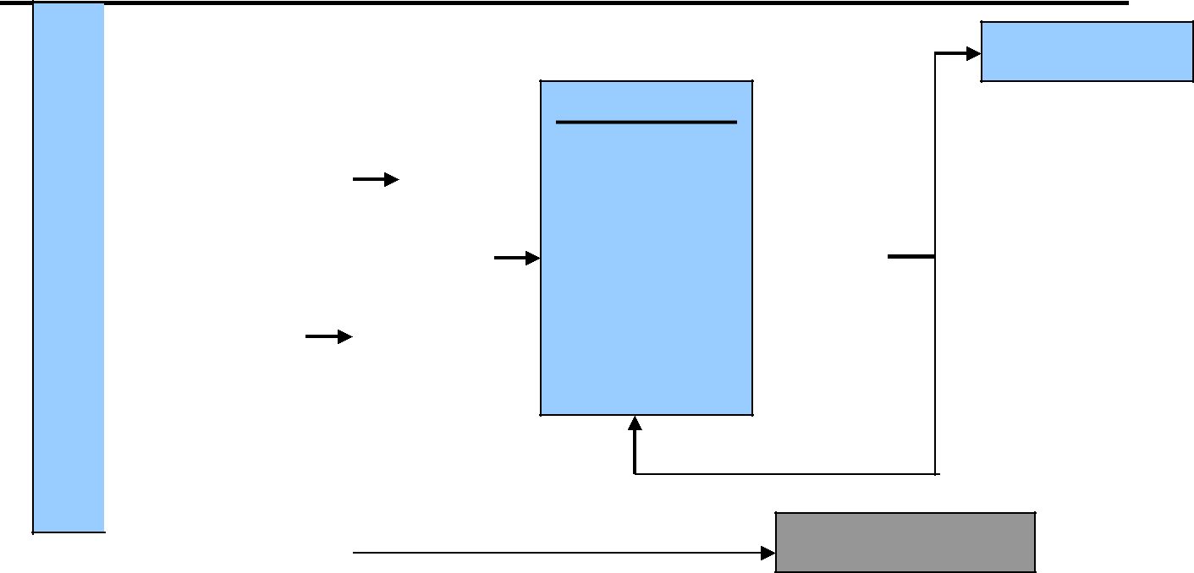

Present
Approval
RF submitted
for sub-

project

Screening Process

Land/ structure
acquisition/ access

restriction resulting in impact identified

Submit to Resettlement and Compensation Committee
YES
NO

Develop RAP

RAP Process

- Census

- Inventory & Valuation

- Agree Resettlement Measures

- Consultation
- Grievance
- Monitoring

Implementation

YES

RAP

Approved?

NO

No Action Required

Annex 2: Screening report form of expected social impacts
(The report should be brief)
Sub-project_______________________________
Sub-project implementation location_____________
(Indicate location of implementation with the designation on the map-scheme with photos)
Kind of activity:________________________________________
(new construction, reconstruction, rehabilitation, maintenance)
Estimated cost ____________
Estimated start date: _______________________________
Technical drawings / specifications discussed: ____________________
Checklist:
№ | Possible impact factor | Availability (Yes/ No) | Comments
1. | Does the sub-project fall into private land?
2. | Is it necessary to physically or economically relocation of residents or businesses? Will there be involuntary acquisition of land? Will there be impact on assets?
3. | Are social impacts potentially significant?
4. | Is it required to determine the level of assessment of institutional resources necessary for protection measures?
5. | Are there any third-party assets at the project site?
6. | Are there any disputed territories?
7. | Will there be access roads and pedestrian paths to residential buildings and commercial structures during construction?
8. | Will the construction lead to changes in social environment, will the incomes of commercial structures and the population decrease?
9. | Will the planned construction affect the health of the population and harm somebody?
10. | Will the sub-project cause protests and concerns among residents?
11. | Will activities cause unfavorable impact on the living conditions of the population, its values, and way of life?
12. | Will the sub-project cause inequality between population groups?
13. | Is the degree of public interest in the sub-project high?
14. | Are there any facts of the past impact of involuntary resettlement in a given territory, which require corrective actions for not mitigated past relocations?
15 | Is this subproject linked with any other infrastructure development project

Based on the above checklist it will be determined if a RAP is required.
Recommendations:
Taking into account responses to monitoring questions, it will be determined whether further actions are required or not to apply procedures of the WB ESS5 ______________
Completed by (full name and contacts): _____________________________________
Signature: _________Date:________________________

Annex 3: PAP census form and inventory of the land fund
Household interviews
 | Name | gender |  | age | Marital status and educational level | supporter |  | employment |  | family income level | Rented or own housing | Does the family receive social assistance?
 |  | m | f |  |  | yes | no | yes | no
1.
2.
3.
Consultant’s full name: ________________________________Signature: _______________________Date:___________

Annex 4: Inventory of PAP’s land assets
Location_________________________________________________ Date: _________________
#  of interview | Full name of household head | Number of  household members | Total land area owned by the family, incl. with the right of ownership, irrigated or bogharic | Land area to be seized m2 / ha | Total loss % | % Loss of assets, (m², m, pcs, etc.) (specify type and number of assets: structures, fences, wells, etc.) |  | Loss of housing stock, (m²) | Loss of harvest |  |  | Other losses, (specify type of loss: rented housing, building, etc.)
 |  |  |  |  |  | Permanent | Temporary |  | Fruit trees, species and quantity, (pcs.) | Loss of crops | Other (specify)
1.
2.
INTERVIEWER NAME ________________________Signature____________________/ Date__________________________/

Annex 5: PAP rights for compensation
#  Of interview | Full name of household head | Compensation for land |  |  | Compensation for construction |  |  | Compensation for crop and  trees |  |  | Compensation for other assets and losses (wells, business, etc.)
 |  | amount (m² or hectares) | Unit price per (m² or ha) | Land Title (Yes/ No) | Number (m² or ha) | Unit price per (m² or ha) | Title (Yes/ No) | Number (m² or ha) | Unit price per (m² or ha) | Title (Yes/ No) | Number (m² or ha) | Unit price per (m² or ha) | Title (Yes/ No)
INTERVIEWER NAME ___________________________Signature________________________/ Date __________________________/

Annex 6: Outline of the Resettlement Action Plan and Abbreviated Resettlement Action Plan

Table of content Resettlement Action Plan The scope and level of detail of the resettlement plan vary with the magnitude and complexity of resettlement. The plan is based on up-to-date and reliable information about (a) the proposed resettlement and its impacts on the displaced persons and other adversely affected groups, and (b) the legal issues involved in resettlement. The resettlement plan covers the elements below, as relevant. When any element is not relevant to project circumstances, it should be noted in the resettlement plan.

1. Description of the project. General description of the project and identification of the project area.

2. Potential impacts. Identification of
(a) the project component or activities that give rise to resettlement;
(b) the zone of impact of such component or activities;
(c) the alternatives considered to avoid or minimize resettlement; and
(d) the mechanisms established to minimize resettlement, to the extent possible, during project
implementation.

3. Objectives. The main objectives of the resettlement program.

4. Socioeconomic studies. The findings of socioeconomic studies to be conducted in the early stages of project preparation and with the involvement of potentially displaced people, including
(a) the results of a census survey covering
(i) current occupants of the affected area to establish a basis for the design of the resettlement
program and to exclude subsequent inflows of people from eligibility for compensation and
resettlement assistance;
(ii) standard characteristics of displaced households, including a description of production systems, labor, and household organization; and baseline information on livelihoods (including, as relevant, production levels and income derived from both formal and informal economic activities) and standards of living (including health status) of the displaced population;
(iii) the magnitude of the expected loss--total or partial--of assets, and the extent of displacement, physical or economic;
(iv) information on vulnerable groups or persons as provided for whom special provisions may have to be made; and
(v) provisions to update information on the displaced people's livelihoods and standards of living at regular intervals so that the latest information is available at the time of their displacement.
(b) Other studies describing the following:
(i) land tenure and transfer systems, including an inventory of common property natural resources from which people derive their livelihoods and sustenance, non-title-based usufruct systems (including fishing, grazing, or use of forest areas) governed by local recognized land allocation mechanisms, and any issues raised by different tenure systems in the project area;
(ii) the patterns of social interaction in the affected communities, including social networks and social support systems, and how they will be affected by the project;
(iii) public infrastructure and social services that will be affected; and
(iv) social and cultural characteristics of displaced communities, including a description of formal and informal institutions (e.g., community organizations, ritual groups, nongovernmental organizations (NGOs) that may be relevant to the consultation strategy and to designing and implementing the resettlement activities.

5. Legal framework. The findings of an analysis of the legal framework, covering
(a) the scope of the power of eminent domain and the nature of compensation associated with it, in terms of both the valuation methodology and the timing of payment;
(b) the applicable legal and administrative procedures, including a description of the remedies available to displaced persons in the judicial process and the normal timeframe for such procedures, and any available alternative dispute resolution mechanisms that may be relevant to resettlement under the project;
(c) relevant law (including customary and traditional law) governing land tenure, valuation of assets and losses, compensation, and natural resource usage rights; customary personal law related to displacement; and environmental laws and social welfare legislation;
(d) laws and regulations relating to the agencies responsible for implementing resettlement activities;
(e) gaps, if any, between local laws covering eminent domain and resettlement and the Bank's resettlement policy, and the mechanisms to bridge such gaps; and
(f) any legal steps necessary to ensure the effective implementation of resettlement activities under the project, including, as appropriate, a process for recognizing claims to legal rights to land--including claims that derive from customary law and traditional usage.

6. Institutional Framework. The findings of an analysis of the institutional framework covering
(a) the identification of agencies responsible for resettlement activities and NGOs that may have a role in
project implementation;
(b) an assessment of the institutional capacity of such agencies and NGOs; and
(c) any steps that are proposed to enhance the institutional capacity of agencies and NGOs responsible for
resettlement implementation.

7. Eligibility. Definition of displaced persons and criteria for determining their eligibility for compensation and other resettlement assistance, including relevant cut-off dates.

8. Valuation of and compensation for losses. The methodology to be used in valuing losses to determine their replacement cost; and a description of the proposed types and levels of compensation under local law and such supplementary measures as are necessary to achieve replacement cost for lost assets.

9. Resettlement measures. A description of the packages of compensation and other resettlement
measures that will assist each category of eligible displaced persons to achieve the objectives of the
policy (see ESS5). In addition to being technically and economically feasible, the resettlement
packages should be compatible with the cultural preferences of the displaced persons, and prepared in
consultation with them.
10. Site selection, site preparation, and relocation. Alternative relocation sites considered and explanation
of those selected, covering
(a) institutional and technical arrangements for identifying and preparing relocation sites, whether
rural or urban, for which a combination of productive potential, locational advantages, and other
factors is at least comparable to the advantages of the old sites, with an estimate of the time needed to acquire and transfer land and ancillary resources;
(b) any measures necessary to prevent land speculation or influx of ineligible persons at the
selected sites;
(c) procedures for physical relocation under the project, including timetables for site preparation and transfer; and
(d) legal arrangements for regularizing tenure and transferring titles to resettlers.
11. Housing, infrastructure, and social services. Plans to provide (or to finance resettlers' provision of)
housing, infrastructure (e.g., water supply, feeder roads), and social services (e.g., schools, health
services); plans to ensure comparable services to host populations; any necessary site development,
engineering, and architectural designs for these facilities.
12. Environmental protection and management. A description of the boundaries of the relocation area; and an assessment of the environmental impacts of the proposed resettlement3and measures to mitigate and manage these impacts (coordinated as appropriate with the environmental assessment of the main investment requiring the resettlement).
13. Community participation. Involvement of resettlers and host communities,
(a) a description of the strategy for consultation with and participation of resettlers and hosts in the design and implementation of the resettlement activities;
(b) a summary of the views expressed and how these views were taken into account in preparing
the resettlement plan;
(c) a review of the resettlement alternatives presented, and the choices made by displaced persons
regarding options available to them, including choices related to forms of compensation and
resettlement assistance, to relocating as individuals, families or as parts of preexisting communities or kinship groups, to sustaining existing patterns of group organization, and to retaining access to cultural property (e.g. places of worship, pilgrimage centers, cemeteries); and
(d) institutionalized arrangements by which displaced people can communicate their concerns to project authorities throughout planning and implementation, and measures to ensure that such vulnerable groups as indigenous people, ethnic minorities, the landless, and women are adequately represented.
14. Integration with host populations. Measures to mitigate the impact of resettlement on any host communities, including
(a) consultations with host communities and local governments;
(b) arrangements for prompt tendering of any payment due the hosts for land or other assets provided to resettlers;
(c) arrangements for addressing any conflict that may arise between resettlers and host communities; and
(d) any measures necessary to augment services (e.g., education, water, health, and production services) in host communities to make them at least comparable to services available to resettlers.
15. Grievance procedures. Affordable and accessible procedures for third-party settlement of disputes arising from resettlement; such grievance mechanisms should take into account the availability of judicial recourse and community and traditional dispute settlement mechanisms.
16. Organizational responsibilities. The organizational framework for implementing resettlement, including identification of agencies responsible for delivery of resettlement measures and provision of services; arrangements to ensure appropriate coordination between agencies and jurisdictions involved in implementation; and any measures (including technical assistance) needed to strengthen the implementing agencies' capacity to design and carry out resettlement activities; provisions for the transfer to local authorities or resettlers themselves of responsibility for managing facilities and services provided under the project and for transferring other such responsibilities from the resettlement implementing agencies, when appropriate.
17. Implementation schedule. An implementation schedule covering all resettlement activities from preparation through implementation, including target dates for the achievement of expected benefits to resettlers and hosts and terminating the various forms of assistance. The schedule should indicate how the resettlement activities are linked to the implementation of the overall project.
18. Costs and budget. Tables showing itemized cost estimates for all resettlement activities, including allowances for inflation, population growth, and other contingencies; timetables for expenditures; sources of funds; and arrangements for timely flow of funds, and funding for resettlement, if any, in areas outside the jurisdiction of the implementing agencies.
19. Monitoring and evaluation. Arrangements for monitoring of resettlement activities by the implementing agency, supplemented by independent monitors as considered appropriate by the Bank, to ensure complete and objective information; performance monitoring indicators to measure inputs, outputs, and outcomes for resettlement activities; involvement of the displaced persons in the monitoring process; evaluation of the impact of resettlement for a reasonable period after all resettlement and related development activities have been completed; using the results of resettlement monitoring to guide subsequent implementation.

Table of Content for Abbreviated RAP

An abbreviated plan covers the following minimum elements:
(a) a census survey of displaced persons and valuation of assets;
(b) description of compensation and any other resettlement assistance to be provided;
(c) consultations with displaced people about acceptable alternatives;
(d) institutional responsibility for implementation and procedures for grievance redress;
(e) arrangements for monitoring and implementation; and
(f) a timetable and budget.

Annex 7: Voluntary Land Donation Criteria and Form

Voluntary Land Donation Criteria
In case of small sections of land required for micro level subproject activities, the project may seek support from the community to donate lands. However, the community members have the right to make a contribution of their land or other assets without seeking or being given compensation at full replacement value. Voluntary contribution is an act of informed consent. Local Authorities must assure that voluntary contributions are made with the affected person’s full and prior knowledge of the availability of other options (including compensation at replacement cost) and are obtained without coercion or duress. Also, voluntary donations are allowed only if the affected people are direct beneficiaries of the investments that cause such impact. Proposals including voluntary contributions will not be submitted for approval where they would significantly harm incomes or living standards of individual owners or users (the size of land contributed on a voluntary basis should not exceed 5% of that individual’s total land holding).
Specifically, the following protocol will govern voluntary contributions under the project:

- Voluntary contributions are an act of informed consent and affected people are not forced to donate land or other assets with coercion or under duress or misled to believe that they are obliged to do so, without regard to the legal status of their land occupancy.
- Land alienation should not result in physical or economic displacement.
- The impacts must be minor. The households contributing land or other assets are direct beneficiaries of the subproject; the impact is less than 5% of the total productive assets owned by said household.
- The facilities requiring land should not be site specific.
- The land in question must be free of squatters, encroachers, or other claims or encumbrances.
- The land must be identified by district khukumat/land management department, not by the TSG or other line agencies or project authorities. However, the project technical authorities should ensure that the land is appropriate for subproject purposes and that the subproject will not have any adverse health or environmental safety hazards.
- Voluntariness will be ascertained by the TSG with due signing by a higher-level official. A process to this effect will be formulated by the TSG and shared with the Bank for approval.
- Verification of the voluntary nature of land donations must be obtained from each of the persons/ household donating land. This should be in the form of signed statements.
- The TSG will also create awareness among the community to devise mechanisms to express a sense of gratitude to those households donating lands. These will find a place in the statements.
- Other things being equal, land donations will not be accepted by female headed households and elderly people.
- The affected people are fully informed that they have the right to refuse to donate land or other private assets, and instead receive compensation at replacement cost, and that a grievance handling mechanism is available to them through which they can express their unwillingness to donate. Furthermore, people are encouraged to use the grievance handling mechanism if they have questions or inquiries, either in writing or verbally.

Voluntary Land Donation Form

Province:
Local Authority :
Village/Jamoat:
Sub-project name:
Date of Village/Public Meeting
Name of land title owner: |  | Land Title Number: |  |  | Beneficiary of the sub-project: Y/N
Sex: |  | Age: |  |  | Occupation:
Address:
Description of land that will be taken by the sub-project: |  | Area affected: | Total landholding area: |  |  | Ratio of land affected to total land held: | Map code, if available:
Description of annual crops growing on the land now and project impact:
 |  | Details |  | Number
- Trees that will be destroyed
- Fruit trees
- Trees used for other economic or household purposes
- Mature forest trees
- …
Describe any other assets that will be lost or must be moved to implement the project:
Value of donated assets:
Will the donated land/asset is less than 5% of the land/property owned?
Gratitude by the Mahalla:

By signing this form, the TSG representative here by affirm that land donations are voluntary and that it confirms to the protocol agreed with the World Bank.
By Signing this form, Mahalla committee (representative) hereby affirm that land donations are acknowledged and agreed on extending the gratitude as described above.
By signing this form, the land user or owner agrees to contribute assets to the project. The contribution is voluntary. If the land user or owner does not want to contribute his/ her assets to the project, he or she should refuse to sign, and ask for compensation instead.
Date:............................  The TSG representative’s signature  Date:............................  Mahalla representative’s signature | Date:.........................  Affected persons’ signatures (both husband and wife)

Annex 8: Minutes of Public Consultations

Minutes of Stakeholder Consultations on E&S instruments in Gazantarak Jamoat, Devashtich District, Sughd Region
Hosted by: HSIP
Date: February 15, 2023
Venue: Gazantarak Jamoat, Devashtich District, Sughd Region
Number of attendants: 15 persons (9 women) consumers of medical services
Objective:
- To inform key stakeholders about the expected activities under the Millati Solim Project and the measures taken to ensure environmental and social security. Disclosure of drafts of social and environmental assessment reports.
- To obtain stakeholders comments and feedback on the entire package of documents to be disclosed.

Agenda:
- Welcome speech, Deputy Head of the Primary Health Care Network of Devashtich District, Project Implementation Specialist in Sughd Region
- Basic information about the scheduled activities under the Millati Solim Project. (Speech by Shokirov F.);
- Participants polling (Pulatova G.).

Familiarization with the Millati Solim Project was organized for key stakeholders and provided at the level of representatives of the district health center, citizens having access to PHC services.
The event was opened by Tuychiev K., Deputy Head of the Devashtich PHC Network, he welcomed all the participants, expressed gratitude to the Health Services Improvement Project for the support provided to the healthcare sector and briefly informed attendants about the HSIP activities carried out in this sector.
In his speech, Shokirov F., Implementation Specialist, HSIP in the Sughd Region, noted that the purpose of public consultations is to provide basic information about the expected activities under the Millati Solim Project and review key project documents prepared as the basic warranties of the social and environmental safety under the project. In his speech, Shokirov F. noted the WB environmental and social safeguards, the construction and institutional focuses.
Further, the participants were briefed on topics such as resettlement information, Grievance Redress Mechanism (GRM), Electronic Patient Register, health emergency preparedness and response. Then, the participants were given a questionnaire.
Question 1. Do you agree to resettlement if a hospital or an RHC will be constructed at the place of your residence or your house?
Yes - 12 persons, No - 5 persons
Question 2. Do you have information about the procedure for citizens appeals?
Yes - 0 persons, no - 15 persons
Question 3. If you have any complaints or suggestions, where would you like to apply?
– Box of complaints and suggestions - 6 persons, in the DHC - 12 persons
Question 4. Do you have information about the "electronic register" or not?
No - 15 persons
Question 5. Do your health facilities have the proper conditions, satisfying or not satisfying you? Does your health facility have a washbasin, water supply, toilet and is everything operational or not?
Yes – 12 pers., No – 3 persons
Khidoyatova M., a resident of the Kalachai Rais village put a question - What is an electronic register? Avyasov T., PBF MIS Data Monitoring Specialist explained that it is scheduled to implement special Software where medical data on patient diseases, treatment, and vaccinations will be entered.
At the end of the event, the participants were asked to provide their comments on the presented materials in writing.
All parties involved were satisfied with public hearings and expressed their hope that the implementation of the Millati Solim Project would make a positive contribution to strengthening the district PHC.
Sample questionnaire and a list of participants are below.

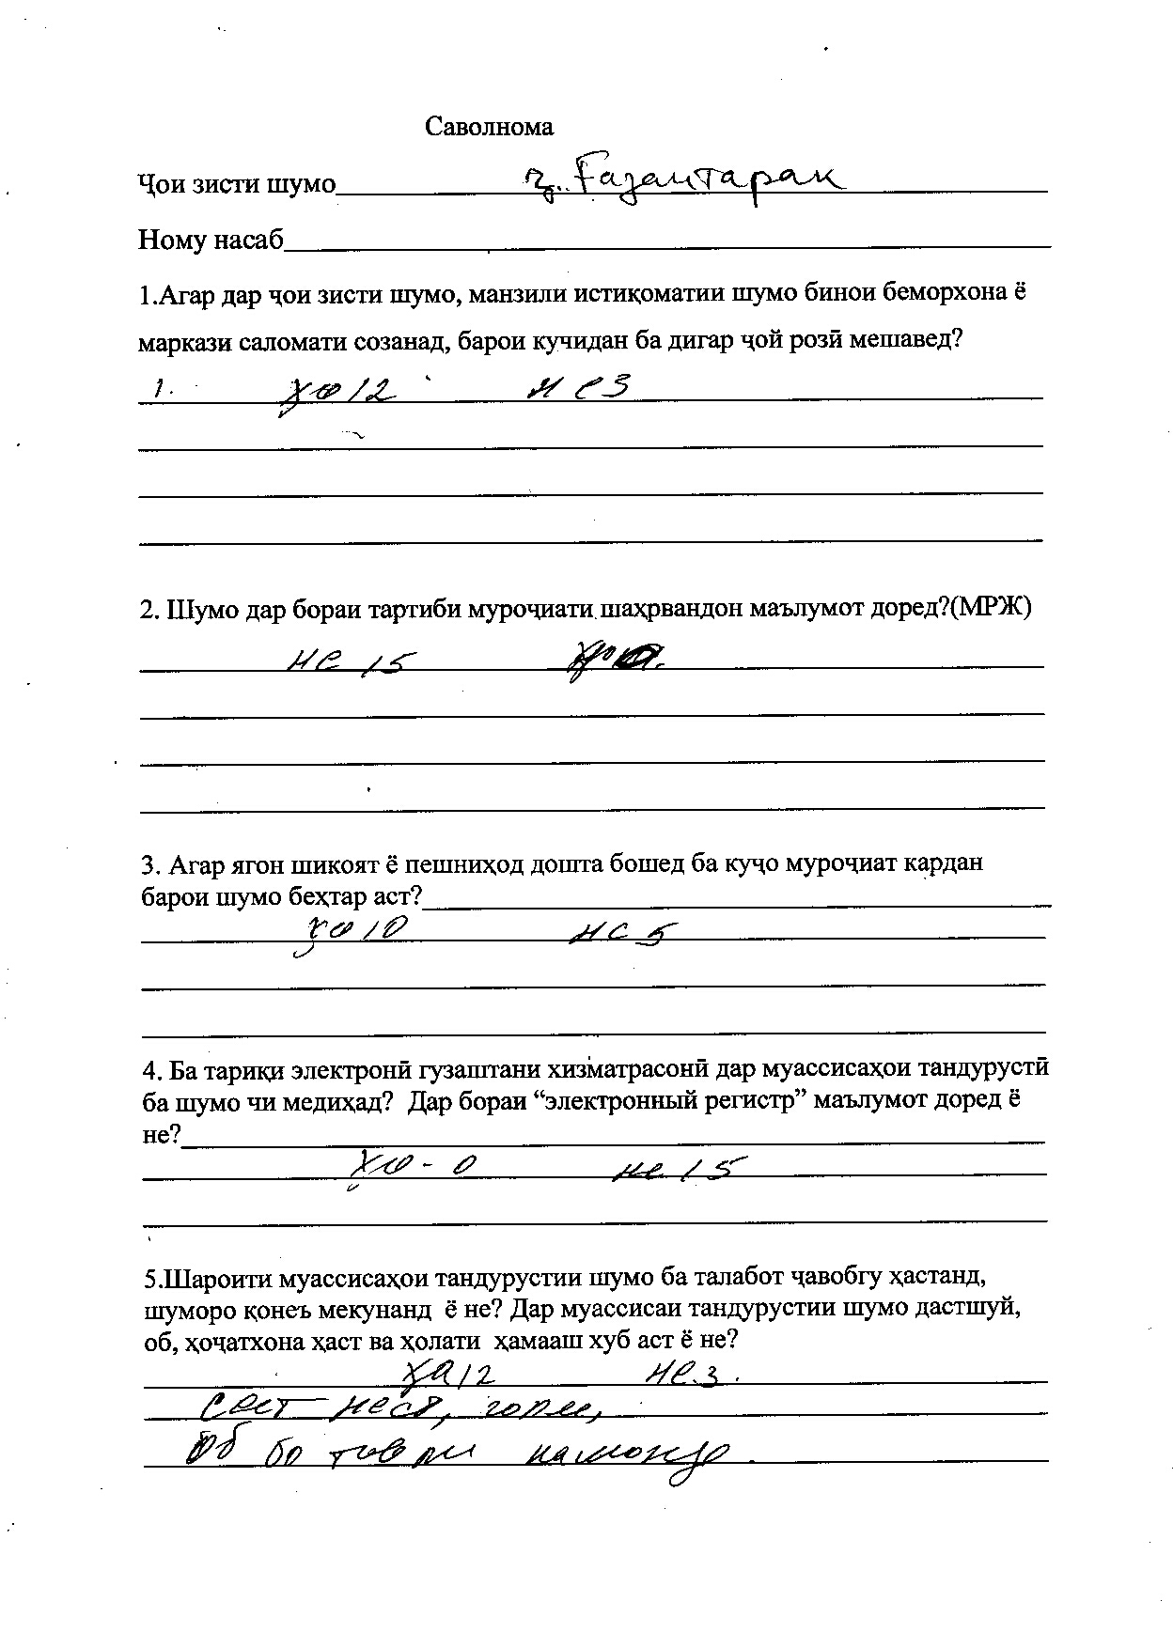
List of participants of Gazantarak Jamoat, Devashtich District, Sughd Region

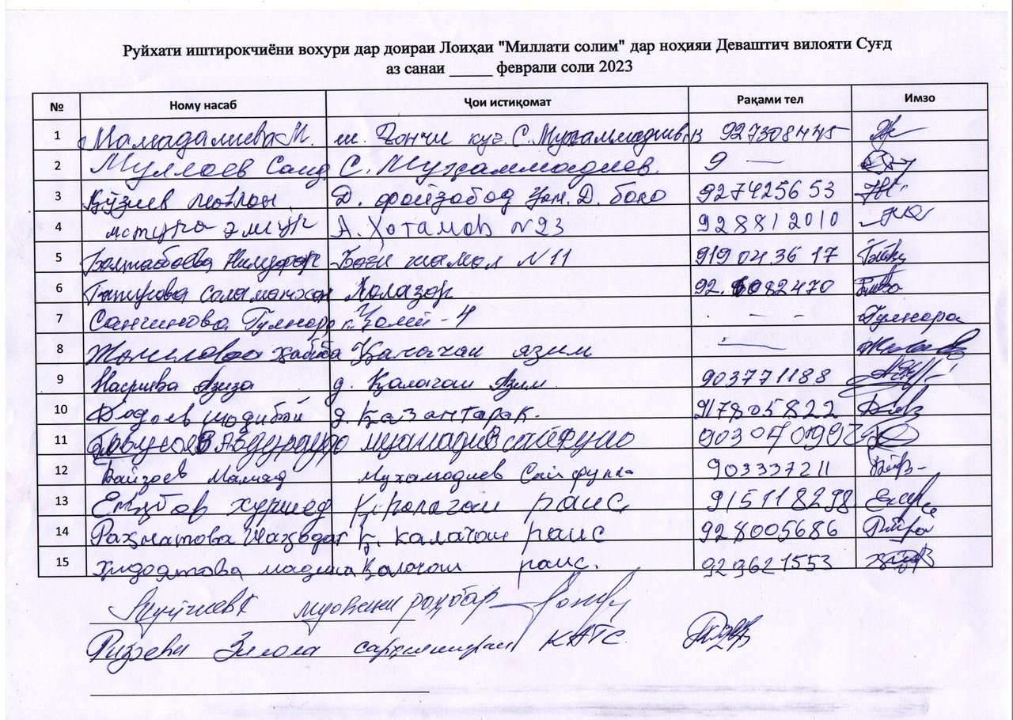

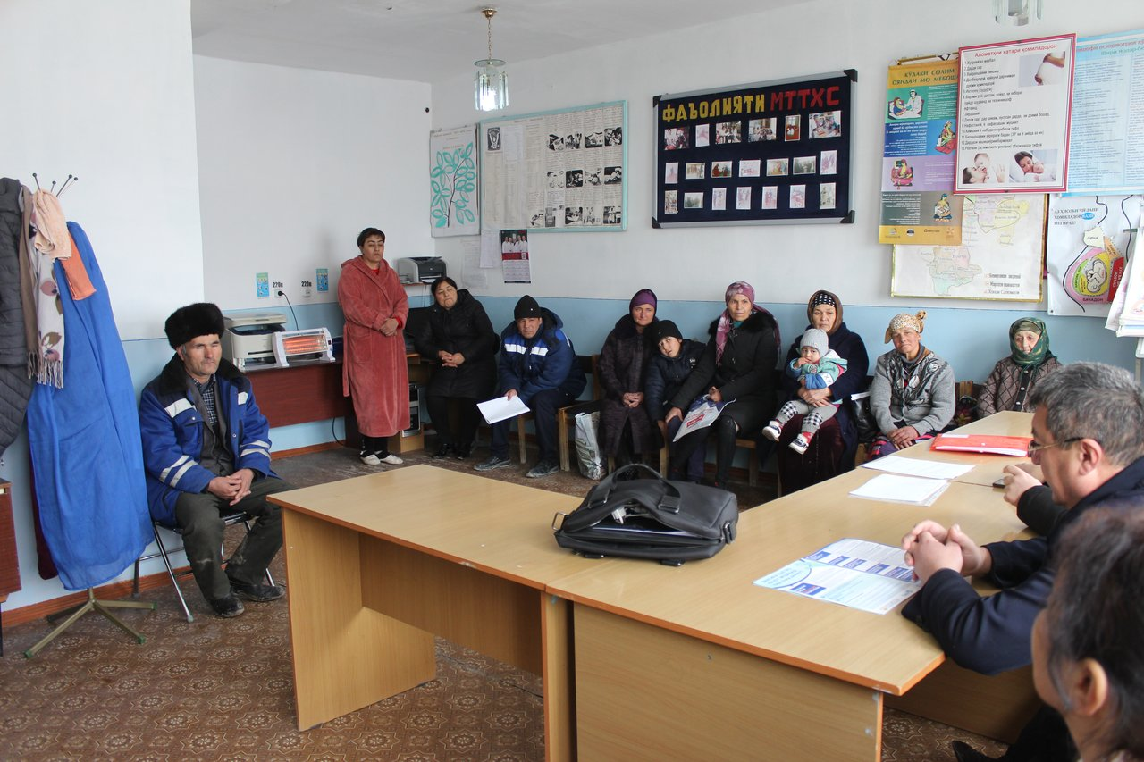
Figure 1. Consultations in Gazantarak Jamoat, Devashtich District, Sughd Region

Minutes of Stakeholder Consultations on E&S instruments Yakhtan Jamoat, Devashtich District, Sughd Region
Hosted by: HSIP
Date: February 15, 2023
Venue: Yakhtan Jamoat, Devashtich District, Sughd Region
Number of attendants: 16 persons (11 women)
Objective:
- To inform key stakeholders about the expected activities under the Millati Solim Project and the measures taken to ensure environmental and social security. Disclosure of drafts of social and environmental assessment reports.
- To obtain stakeholders comments and feedback on the entire package of documents to be disclosed.

Agenda:
- Welcome speech, Deputy Head, PHC Network, Devashtich District, Project Implementation Specialist in Sughd Region
- Basic information about the scheduled activities under the Millati Solim Project. (Speech by Shokirov F.);
- Participants polling (Pulatova G.).

Familiarization with the Millati Solim Project was organized for key stakeholders and provided at the level of representatives of the district health center, citizens having access to PHC services.
The event was opened by Tuichiev K., Deputy Head, PHC Network, Devashtich District, he welcomed all the participants and expressed gratitude to the Health Services Improvement Project for the support provided to the healthcare sector and briefly informed attendants about the HSIP activities carried out in this sector.
In his speech, Shokirov F., Implementation Specialist, HSIP in the Sughd Region, noted that the purpose of public consultations is to provide basic information about the expected activities under the Millati Solim Project and review key project documents prepared as the basic warranties of the social and environmental safety under the project. In his speech, Shokirov F. noted the WB environmental and social safeguards, the construction and institutional focuses.
Further, the participants were briefed on topics such as resettlement information, Grievance Redress Mechanism (GRM), Electronic Patient Register, health emergency preparedness and response. Then, the participants were given a questionnaire.
Question 1. Do you agree to resettlement if a hospital or an RHC will be constructed at the place of your residence or your house?
Yes - 11 persons, No - 5 persons
Question 2. Do you have information about the procedure for citizens appeals?
Yes - 2 persons, no - 14 persons
Question 3. If you have any complaints or suggestions, where would you like to apply?
– Complaints and Suggestions Box - 4 persons, in the DHC - 12 persons
Question 4. Do you have information about the "electronic register" or not?
No - 16 persons
Question 5. Do your health facilities have the proper conditions, satisfying or not satisfying you? Does your health facility have a washbasin, water supply, toilet and is everything operational or not?
Yes – 16 persons
Ergashev R., a Khushtoiri Mughlon Village resident thanked the HSIP for the support provided in equipping, improving the RHC sanitary and hygienic conditions and improving the quality of health services provided in this Jamoat.
At the end of the event, the participants were asked to provide their comments on the presented materials in writing.
Yakhtan Jamoat Chairman assured that the local population would support the project implementation.
All parties involved were satisfied with public hearings and expressed their hope that the implementation of the Millati Solim Project would make a positive contribution to strengthening the district PHC.

List of participants of the meeting is below.

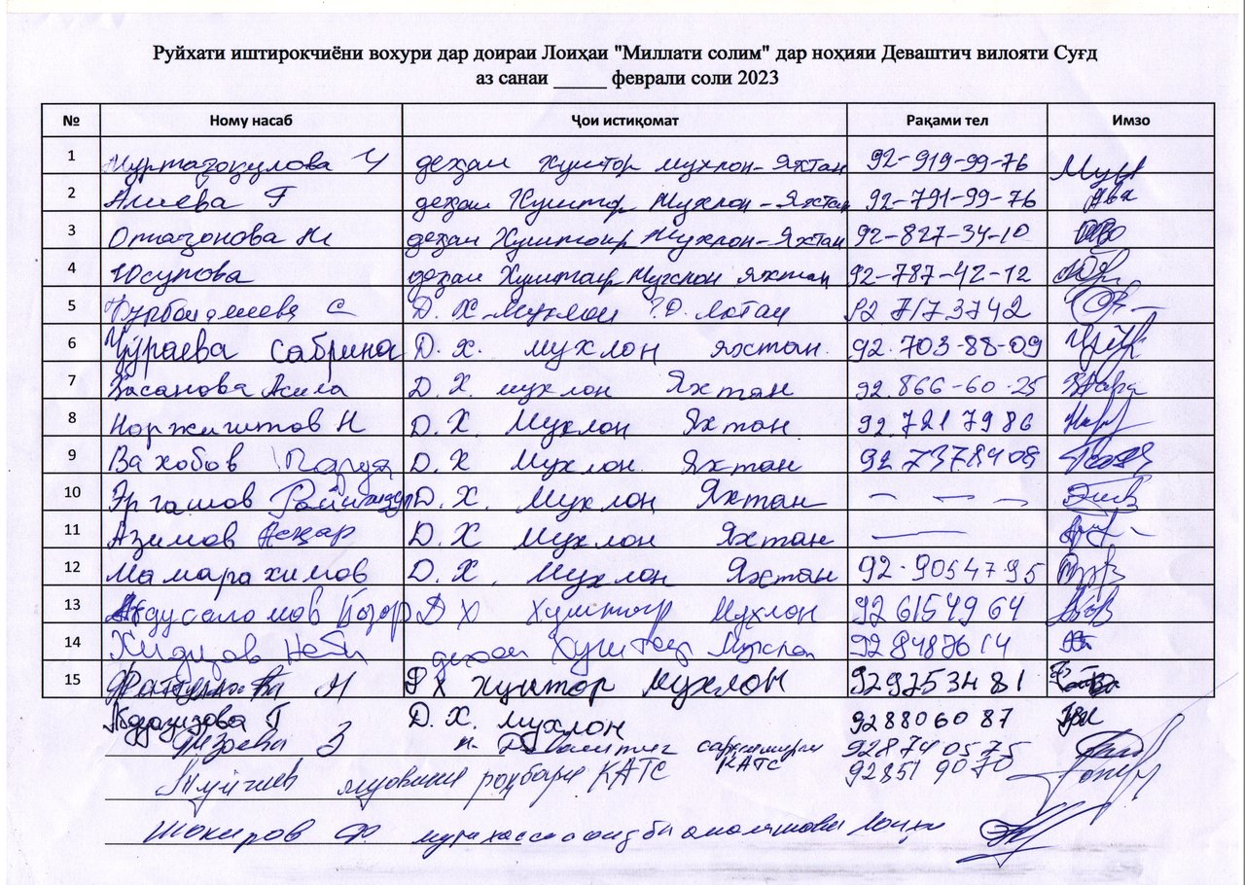

Minutes of Stakeholder Consultations on E&S instruments Kurush Jamoat, Spitamen District, Sughd Region

Hosted by: HSIP
Date: February 16, 2023
Venue: Kurush Jamoat, Spitamen District, Sughd Region
Number of attendants: 16 persons (13 women)
Objective:
- To inform key stakeholders about the expected activities under the Millati Solim Project and the measures taken to ensure environmental and social security. Disclosure of drafts of social and environmental assessment reports.
- To obtain stakeholders comments and feedback on the entire package of documents to be disclosed.

Agenda:
- Welcome speech, Head Physician, Kurkat RHC, Spitamen District, Project Implementation Specialist in Sughd Region
- Basic information about the scheduled activities under the Millati Solim Project. (Speech by Shokirov F.);
- Participants polling (Pulatova G.).

Familiarization with the Millati Solim Project was organized for key stakeholders and provided at the level of representatives of the district health center, citizens having access to PHC services.
The event was opened by Karaboeva Kh., Head Physician, Kurkat RHC, Spitamen District, she welcomed all the participants, expressed gratitude to the Health Services Improvement Project for the support provided to the healthcare sector and briefly informed attendants about the HSIP activities carried out in this sector.
In his speech, Shokirov F., Implementation Specialist, HSIP in the Sughd Region, noted that the purpose of public consultations is to provide basic information about the expected activities under the Millati Solim Project and review key project documents prepared as the basic warranties of the social and environmental safety under the project. In his speech, Shokirov F. noted the WB environmental and social safeguards, the construction and institutional focuses.
Further, the participants were briefed on topics such as resettlement information, Grievance Redress Mechanism (GRM), Electronic Patient Register, health emergency preparedness and response. Then, the participants were given a questionnaire.
Question 1. Do you agree to resettlement if a hospital or an RHC will be constructed at the place of your residence or your house?
Yes - 1 persons, No - 15 persons
Question 2. Do you have information about the procedure for citizens appeals?
Yes - 0 persons, no - 15 persons
Question 3. If you have any complaints or suggestions, where would you like to apply? – Complaints and Suggestions Box - 3 persons, in the DHC - 13 persons
Question 4. Do you have information about the "electronic register" or not?
No - 16 persons
Question 5. Do your health facilities have the proper conditions, satisfying or not satisfying you? Does your health facility have a washbasin, water supply, toilet and is everything operational or not?
Yes – 16 pers., No – 0 persons
Kurbanova M., a Kurush Jamoat resident put a question – Where complaints can be submitted, if arise? She was given the answer that in all RHCs of the district there are boxes for receiving complaints from citizens, and there are also booklets with phone numbers and the GRM website link.
At the end of the event, the participants were asked to provide their comments on the presented materials in writing.
All parties involved were satisfied with public hearings and expressed their hope that the implementation of the Millati Solim Project would make a positive contribution to strengthening the district PHC.

The list of participants is below

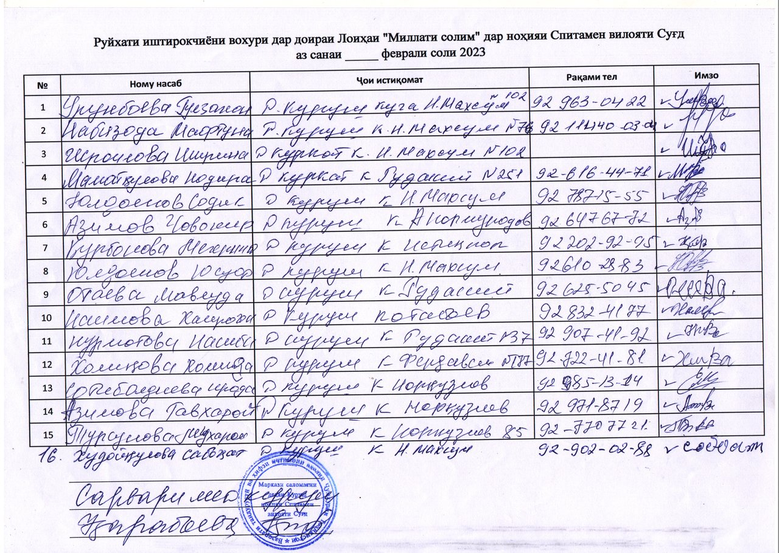

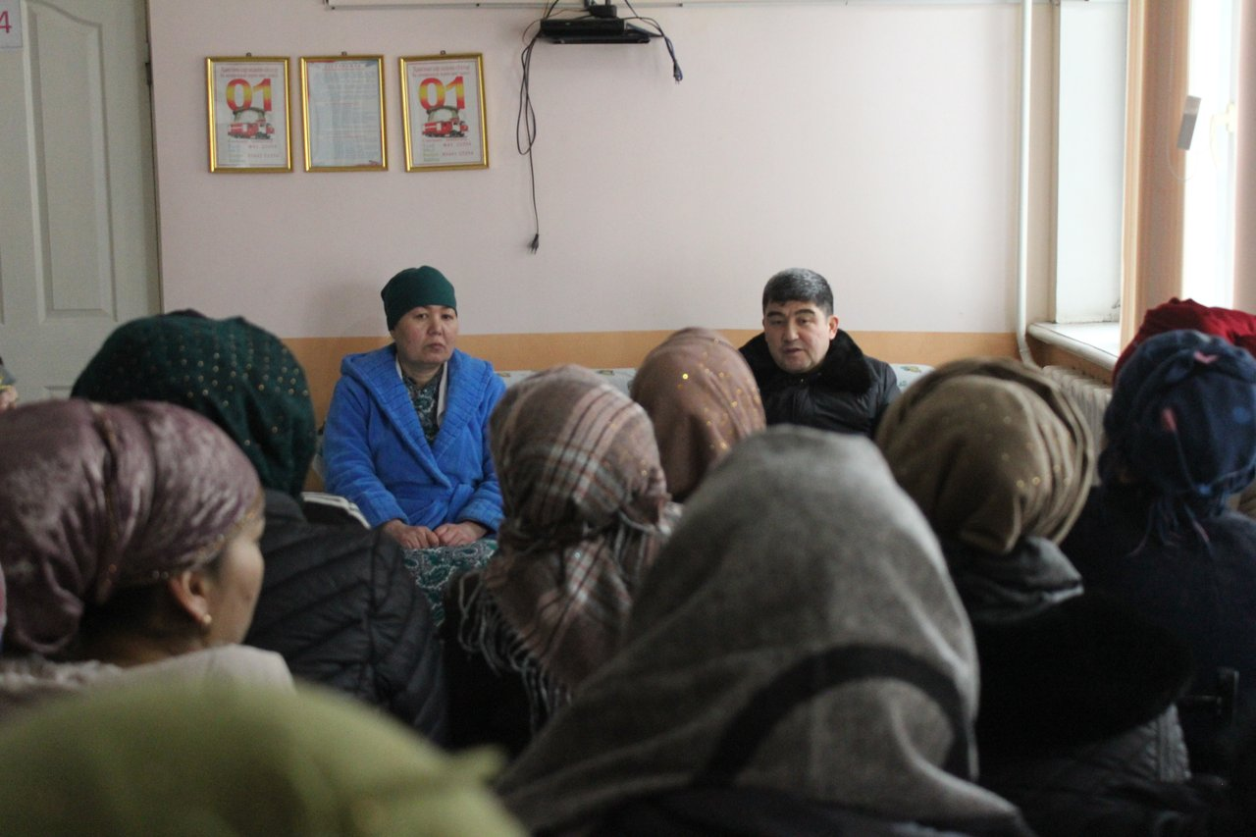
Figure 2. Consultations in Kurush Jamoat, Spitamen District, Sughd Region

Minutes of Stakeholder Consultations on E&S instruments Yangiobod Jamoat, Spitamen District, Sughd Region
Hosted by: HSIP
Date: February 16, 2023
Venue: Yangiobod Jamoat, Spitamen District, Sughd Region
Number of attendants: 11 persons (8 women)
Objective:
- To inform key stakeholders about the expected activities under the Millati Solim Project and the measures taken to ensure environmental and social security. Disclosure of drafts of social and environmental assessment reports.
- To obtain stakeholders comments and feedback on the entire package of documents to be disclosed.

Agenda:
- Welcome speech, Acting Head Physician, Andarsoy RHC, Spitamen District, Project Implementation Specialist in Sughd Region
- Basic information about the scheduled activities under the Millati Solim Project. (Speech by Shokirov F.);
- Participants polling (Pulatova G.).

Familiarization with the Millati Solim Project was organized for key stakeholders and provided at the level of representatives of the district health center, citizens having access to PHC services.
The event was opened by Kholmatova M., Acting Head Physician, Andarsoy RHC, Spitamen District, she welcomed all the participants, expressed gratitude to the Health Services Improvement Project for the support provided to the healthcare sector.
In his speech, Shokirov F., Implementation Specialist, HSIP in the Sughd Region, noted that the purpose of public consultations is to provide basic information about the expected activities under the Millati Solim Project and review key project documents prepared as the basic warranties of the social and environmental safety under the project. In his speech, Shokirov F. noted the WB environmental and social safeguards, the construction and institutional focuses.
Further, the participants were briefed on topics such as resettlement information, Grievance Redress Mechanism (GRM), Electronic Patient Register, health emergency preparedness and response. Then, the participants were given a questionnaire.
Question 1. Do you agree to resettlement if a hospital or an RHC will be constructed at the place of your residence or your house?
Yes - 0 persons, No - 11 persons
Question 2. Do you have information about the procedure for citizens appeals?
Yes - 4 persons, no - 7 persons
Question 3. If you have any complaints or suggestions, where would you like to apply?
– DHC, SHSPSS - 1 person, in RHC - 10 persons
Question 4. Do you have information about the "electronic register" or not?
No - 10 persons, Yes – 1 person
Question 5. Do your health facilities have the proper conditions, satisfying or not satisfying you? Does your health facility have a washbasin, water supply, toilet and is everything operational or not?
Yes – 11 persons, No – 0 persons
Zikriyoev M., a Yangiobod Jamoat resident thanked the HSIP for the support provided in equipping, improving the RHC sanitary and hygienic conditions and improving the quality of health services provided in this Jamoat.
At the end of the event, the participants were asked to provide their comments on the presented materials in writing.
All parties involved were satisfied with public hearings and expressed their hope that the implementation of the Millati Solim Project would make a positive contribution to strengthening the district PHC.
Sample questionnaire is attached.
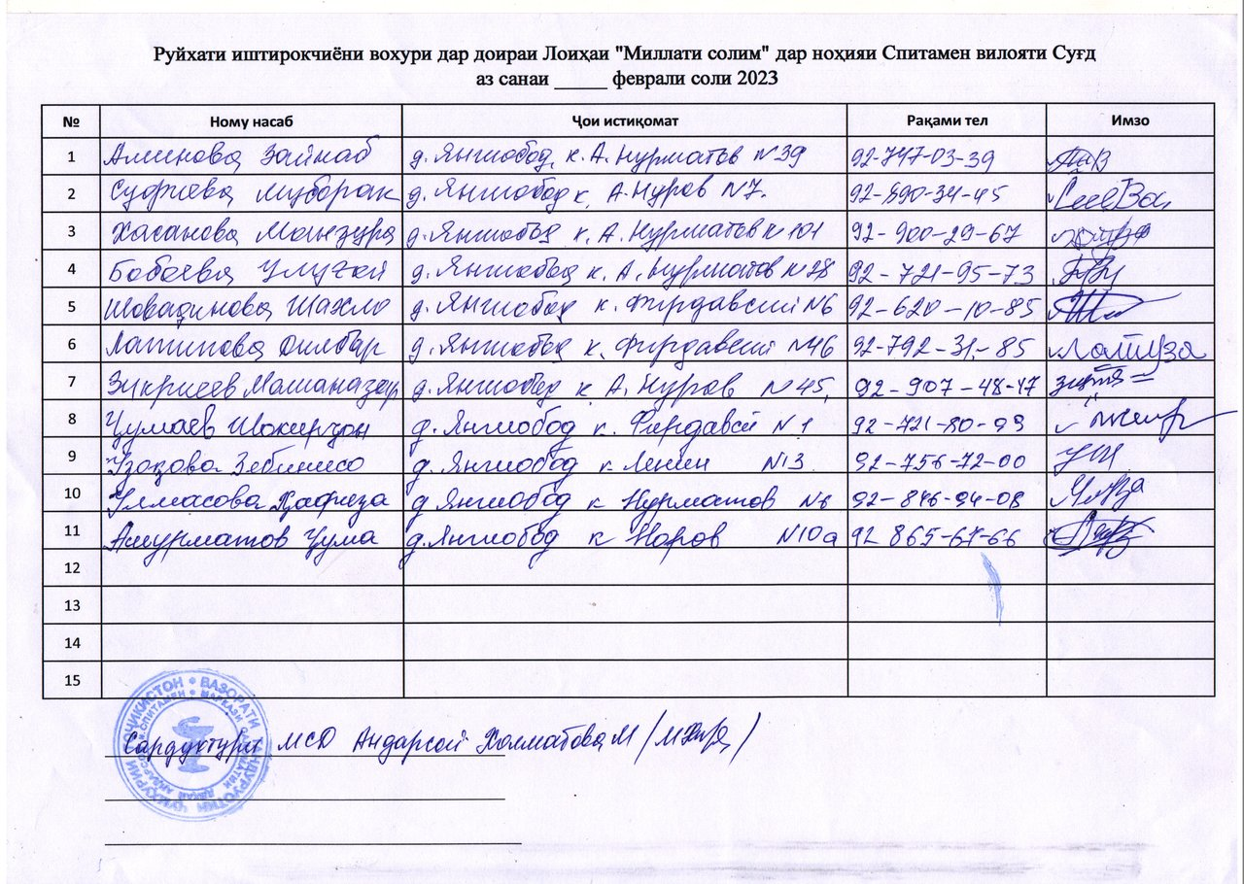

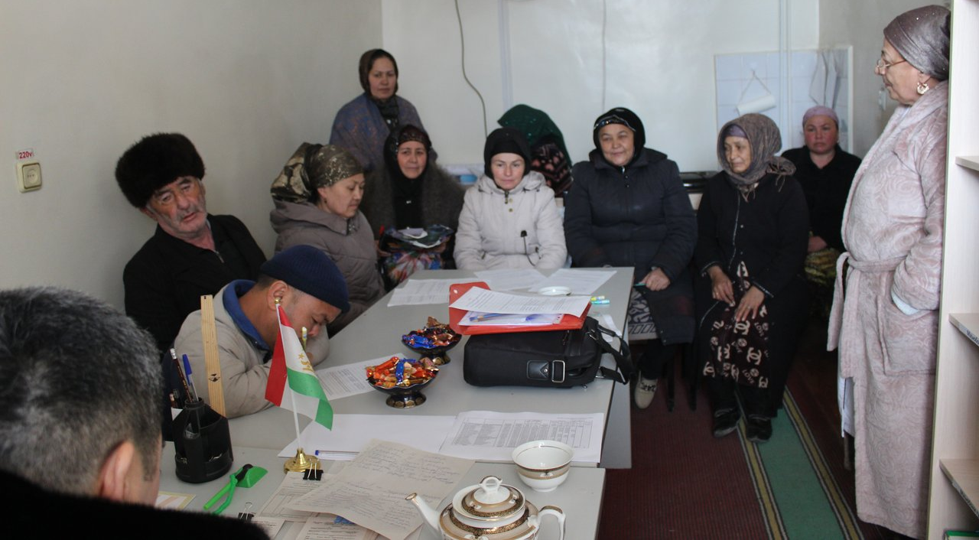
Figure 3 Consultation in Yangiobod Jamoat, Spitamen District, Sughd Region

Minutes of Stakeholder Consultations on E&S instruments Navobod Jamoat, J. Balkhi District, Khatlon region
Hosted by: HSIP
Date: February 15, 2023, 9:00- 12:00
Venue: Navobod RHC hall, Navobod Jamoat, J. Balkhi District
Number of attendants: 53 persons (47 women)
Working language: official language (Tajik)
Objective:
- To inform key stakeholders about the expected activities under the Millati Solim Project and the measures taken to ensure environmental and social safeguards. Disclosure of drafts of social and environmental assessment reports.
- To obtain beneficiary comments and feedback on all components under the Millati Solim Project: Tajikistan – healthy nation.

Agenda:
- Welcome speech, Doliev S.R., HSIP Implementation Specialist in Khatlon Region;
- Basic information about the scheduled activities under the Millati Solim Project: Tajikistan – healthy nation (Doliev S.R., HSIP Implementation Specialist in Khatlon Region);
- Presentation, Social and Environmental Commitment Plan; (Asrorov D.R., PBF HMIS Data Monitoring Specialist in Khatlon Region);
- Presentation, Procedures Regulations of Labor-Management Relations (Shukurov M.N. – PBF Specialist in Khatlon Region);
- Presentation document: Stakeholder Engagement Plan, (Doliev S. R., HSIP Implementation Specialist in Khatlon Region);
- Presentation: Environmental and Social Management Framework (Asrorov D. R., PBF HMIS Data Monitoring Specialist in Khatlon Region);
- Presentation: Resettlement Framework (Asrorov D.R., PBF HMIS Data Monitoring Specialist in Khatlon Region);
- Beneficiaries key takeaways and comments.

Meeting with citizens was organized for beneficiaries of the Project's services both for citizens and the PHC health staff.
The event was opened by Doliev S.R., HSIP Implementation Specialist in Khatlon Region, he welcomed all the participants, expressed gratitude to the Government of the Republic of Tajikistan, WB and MOHSP for the support provided to the Tajikistan health sector and briefly informed attendants about activities of the Government of the Republic of Tajikistan carried out in the health sector. In particular, it was said that the purpose of this meeting is to provide basic information about the expected activities under the Millati Solim: Tajikistan - healthy nation Project and review key project documents prepared as the basic environment and social safeguards of the project. Further, Doliev S. R. noted about the environmental and social safeguard policy, about the construction and institutional orientation of the project in strengthening the primary health care system. It was suggested that the meeting participants take an active part and provide their proposals on the presented materials.
In his speech, he noted that the purpose of public consultations is to provide basic information about the expected activities under the Millati Solim: Tajikistan – Healthy Nation Project and Project goals, objectives and components, phased WB support to Tajikistan health sector, main project beneficiaries and pilot districts to be supported under the Project.
D. R. Asrorov, PBF HMIS Data Monitoring Specialist in Khatlon Region presented information on the environmental and social aspects of the Project. He mentioned the WB requirements for the identification and assessment of social and environmental risks and impacts associated with projects. It was noted that the main purpose of this event is to inform population about the expected project activities, to get feedback and proposals on the presented project materials.
Further, Doliev S.R., HSIP Implementation Specialist in Khatlon Region, in his speech on the Stakeholder Engagement Plan, noted that this document was prepared in order to identify all parties interested in the project, to establish close and constructive interaction with them and develop an appropriate engagement framework, taking into account their views and needs. It was noted that the introduction of this mechanism under the project, as well as the feedback mechanism, will improve transparency and accountability in the sector.
Asrorov D. R., PBF HMIS Data Monitoring Specialist in Khatlon Region, presented the Environmental and Social Management Framework. He provided information on WB requirements and legal regulations of the Republic of Tajikistan requiring environmental and social assessment. It was said that the document sets out the expected environmental and social risks and impacts associated with the project, defines measures to prevent risks and manage negative impacts.
Shukurov M.N., PBF Specialist in Khatlon Region, in his presentation on Procedures Regulations of Labor-Management Relations said that this document is as a tool to manage the risks that may arise in relation to the recruitment and working conditions of project employees. Speaker told that the document was developed in accordance with the requirements of SES 2. "Labor and working conditions" and defines the main requirements in the field of labor legislation and the risks associated.
Asrorov D. R., PBF HMIS Data Monitoring Specialist in Khatlon Region provided listeners with information about the Resettlement Framework with an overview of the WB and the Republic of Tajikistan policies and procedures related to the issues of land acquisition, restriction of land use rights and involuntary resettlement.
It should be noted that all the materials provided to the participants of the event were presented as slides in Power Point format in a compressed form.
At the end of the event, the participants were asked to provide their feedback on the presented materials in writing.
Participants put the following questions:
1. What is the citizen engagement mechanism in the project implementation process?
2. How the health staff will be involved in the project implementation process?
3. In villages where there is no health facility or it is located at a remote distance from the nearest health facility, how the project will be implemented? Is it possible to construct there a health facility under the project, for example, in Kzyl Namuna village, Lenin Yul village, Urtabuz, Chorbog, Karaboy, 1 brigade village?
4. In Pushkin village, the Health House is in critical condition and even is not subject to rehabilitation. Will a new building of the Health House be constructed under the project?
5. In presentation, it was mentioned payment of compensation in case of natural disaster, how it works?

Satisfactory answers were given to the questions received by speakers. Discussions took place in a lively atmosphere.
All parties involved were satisfied with public hearings and expressed their hope that the project implementation would make a positive contribution to improving the level, quality and volume of healthcare provided to the population at the primary health care level and strengthening their physical infrastructure.
List of participants and photos are attached.
Doliev S.R., HSIP Implementation Specialist
Asrorov D.R., PBF MIS Data Monitoring Specialist
Shukurov M.N., PBF Specialist
List of participants
# | Navobod Jamoat
1 | Aliev Manon
2 | Sattorova Khairiniso
3 | Bokiyeva Oybibi
4 | Saidaliev Shamsuddin
5 | Hasanova Shahlo
6 | Raqabova Khairi
7 | Zoirova Halima
8 | Gulmakhmadova Zebo
9 | Abdukhamidova Zamira
10 | Nazrieva Farzona
11 | Kamolova Dilraba
12 | Yusupova Gulobru
13 | Alisher Abdumirzo
14 | Saidova Mohpari
15 | Rakhimova Rano
16 | Rasulova Safarmo
17 | Kurbonova Mayram
17 | Zubaidova G
19 | Mahmadalieva Z
20 | Zubaydova Sharif
21 | Holova S
22 | Saidova K
23 | Nazrieva R
24 | Gulomova Sh
25 | Nosirova D
26 | Turaeva M
27 | Holova h
28 | Kurbonov X
29 | Sharipov Z
30 | Narzulloeva U
31 | Boeva A
32 | Saidova D
33 | Makhmaraqabova Sh
34 | Saidova F
35 | Azizova F
36 | Saidova M
37 | Zokirova M
38 | Fayzulloeva X
39 | Saidova R
40 | Sharipova Sh
41 | Halimova O
42 | Rahimov X
43 | Turaeva M
44 | Salimova M
45 | Hamidova Sh
46 | Hamidova G
47 | Uzbekova S
48 | Rakhimova F
49 | Holmurodova S
50 | Holmurodova M
51 | Mirzoeva Tuti
52 | Turaeva Farzona
53 | Nazarova Nasiba

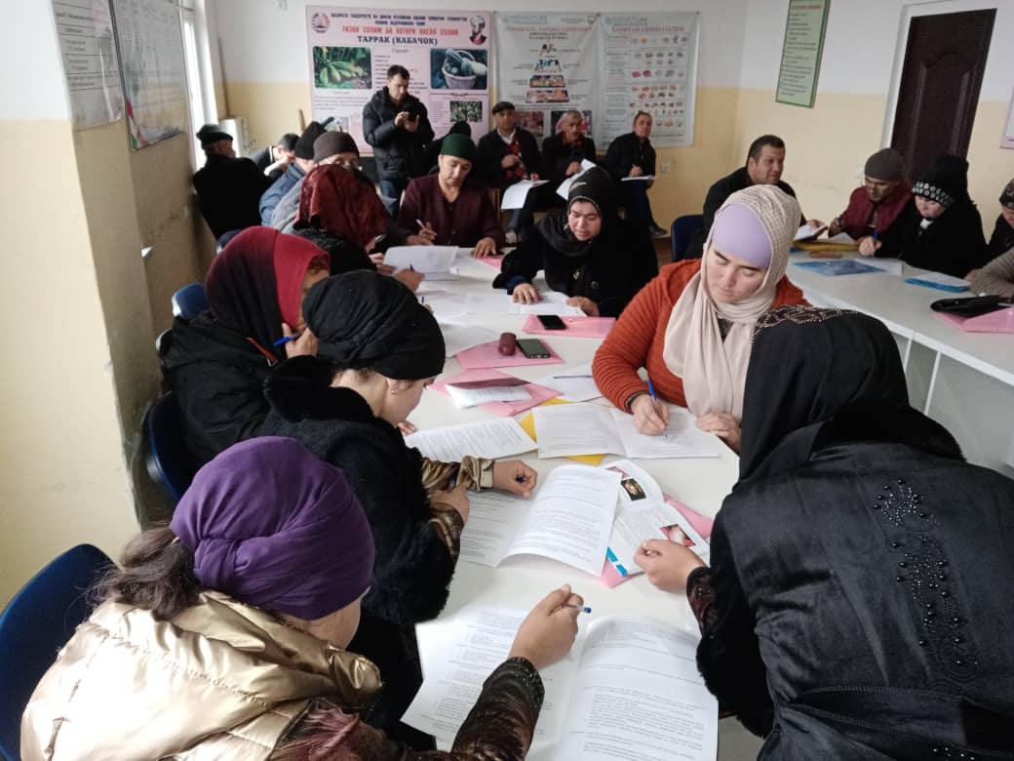
Figure 4. Consultation in Navobod Jamoat, J. Balkhi District

Minutes of Stakeholder Consultations on E&S instruments Guliston Jamoat, J. Balkhi District, Khatlon region
Hosted by: HSIP
Date: February 15, 2023, 14:00- 17:00
Venue: Guliston RHC hall, Guliston Jamoat, J. Balkhi District
Number of attendants: 39 persons (26 women)
Working language: official language (Tajik)
Objective:
- To inform key stakeholders about the expected activities under the Millati Solim Project and the measures taken to ensure environmental and social safeguards. Disclosure of drafts of social and environmental assessment reports.
- To obtain beneficiary comments and feedback on all components under the Millati Solim Project: Tajikistan – healthy nation.

Agenda:
- Welcome speech, Doliev S.R., HSIP Implementation Specialist in Khatlon Region;
- Basic information about the scheduled activities under the Millati Solim Project: Tajikistan – healthy nation (Doliev S.R., HSIP Implementation Specialist in Khatlon Region);
- Presentation, Social and Environmental Commitment Plan; (Asrorov D.R., PBF HMIS Data Monitoring Specialist in Khatlon Region);
- Presentation, Procedures Regulations of Labor-Management Relations (Shukurov M.N. – PBF Specialist in Khatlon Region);
- Presentation document: Stakeholder Engagement Plan, (Doliev S. R., HSIP Implementation Specialist in Khatlon Region);
- Presentation: Environmental and Social Management Framework (Asrorov D. R., PBF HMIS Data Monitoring Specialist in Khatlon Region);
- Presentation: Resettlement Framework (Asrorov D.R., PBF HMIS Data Monitoring Specialist in Khatlon Region);
- Beneficiaries key takeaways and comments.

Meeting with citizens was organized for beneficiaries of the Project's services both for citizens and the PHC health staff.
The event was opened by Doliev S.R., HSIP Implementation Specialist in Khatlon Region, he welcomed all the participants, expressed gratitude to the Government of the Republic of Tajikistan, WB and MOHSP for the support provided to the Tajikistan health sector and briefly informed attendants about activities of the Government of the Republic of Tajikistan carried out in the health sector. In particular, it was said that the purpose of this meeting is to provide basic information about the expected activities under the Millati Solim: Tajikistan - healthy nation Project and review key project documents prepared as the basic environment and social safeguards of the project. Further, Doliev S. R. noted about the environmental and social safeguard policy, about the construction and institutional orientation of the project in strengthening the primary health care system. It was suggested that the meeting participants take an active part and provide their proposals on the presented materials.
In his speech, he noted that the purpose of public consultations is to provide basic information about the expected activities under the Millati Solim: Tajikistan – Healthy Nation Project and Project goals, objectives and components, phased WB support to Tajikistan health sector, main project beneficiaries and pilot districts to be supported under the Project.
D. R. Asrorov, PBF HMIS Data Monitoring Specialist in Khatlon Region presented information on the environmental and social aspects of the Project. He mentioned the WB requirements for the identification and assessment of social and environmental risks and impacts associated with projects. It was noted that the main purpose of this event is to inform population about the expected project activities, to get feedback and proposals on the presented project materials.
Further, Doliev S.R., HSIP Implementation Specialist in Khatlon Region, in his speech on the Stakeholder Engagement Plan, noted that this document was prepared in order to identify all parties interested in the project, to establish close and constructive interaction with them and develop an appropriate engagement framework, taking into account their views and needs. It was noted that the introduction of this mechanism under the project, as well as the feedback mechanism, will improve transparency and accountability in the sector.
Asrorov D. R., PBF HMIS Data Monitoring Specialist in Khatlon Region, presented the Environmental and Social Management Framework. He provided information on WB requirements and legal regulations of the Republic of Tajikistan requiring environmental and social assessment. It was said that the document sets out the expected environmental and social risks and impacts associated with the project, defines measures to prevent risks and manage negative impacts.
Shukurov M.N., PBF Specialist in Khatlon Region, in his presentation on Procedures Regulations of Labor-Management Relations said that this document is as a tool to manage the risks that may arise in relation to the recruitment and working conditions of project employees. Speaker told that the document was developed in accordance with the requirements of SES 2. "Labor and working conditions" and defines the main requirements in the field of labor legislation and the risks associated.
Asrorov D. R., PBF HMIS Data Monitoring Specialist in Khatlon Region provided listeners with information about the Resettlement Framework with an overview of the WB and the Republic of Tajikistan policies and procedures related to the issues of land acquisition, restriction of land use rights and involuntary resettlement.
It should be noted that all the materials provided to the participants of the event were presented as slides in Power Point format in a compressed form.
At the end of the event, the participants were asked to provide their feedback on the presented materials in writing.
Participants put the following questions:
- It was said about providing assistance to poor citizens, large families, orphans and widows under the project, in what kind it would be provided and what is the amount of assistance?
- It is not clear, it was said that citizens will be incentivized and interested in project implementation, under the project. What does it mean?
- As for questions related to medical care or healthcare, we certainly apply to the health facility and get some answer, at least. And regarding issues related to the standard of living, land management, utilities, and natural disasters consequences, whom we can contact, who can provide assistance or solve these problems?
- What is the citizen engagement mechanism in the project implementation process?
- How the health staff will be involved in the project implementation process?
- In presentation, it was mentioned payment of compensation in case of natural disaster, how it works?

Satisfactory answers were given to the questions received by speakers. Discussions took place in a lively atmosphere.
All parties involved were satisfied with public hearings and expressed their hope that the project implementation would make a positive contribution to improving the level, quality and volume of healthcare provided to the population at the primary health care level and strengthening their physical infrastructure.
List of participants and photos are attached.
Doliev S.R., HSIP Implementation Specialist
Asrorov D.R., PBF MIS Data Monitoring Specialist
Shukurov M.N., PBF Specialist

List of the meeting participants:
# | Guliston Jamoat
1 | Ubaydov Ahliddin
2 | Begova Shukron
3 | Zokirova Savri
4 | Sattorova Muhabbat
5 | Eshonkulova Zulfiya
6 | Islomova Nigina
7 | Kosimova Kurbonbi
8 | Eshmirzoev Saifiddin
9 | Yodgorov Dustmurod
10 | Khudchanova Early
11 | Sharipova Shakhnoza
12 | Kholmatova Rohila
13 | Toirova Gulsanam
14 | Rahmonbekova Zamira
15 | Abdurakhimova Sanavbar
16 | Tilloev Ravshan
17 | Holmuminov Murtazokul
18 | Mahmudov to Mehrubon
19 | Rakhmatov Barotali
20 | Berdiyeva Safargulmakh
21 | Hukmatova Shamsia
22 | Sufiev Muhammad
23 | Turakhonova Gulchehra
24 | Odinaeva Rukia
25 | Durmanov Nazarali
26 | Chutova Fotima
27 | Boltaev Shermahmad
28 | Mustafokulova Momogul
29 | Markaev Zhumanazar
30 | Allaberdieva Mahbuba
31 | Kosimova Muhabbat
32 | Allaberdiev Muzaffar
33 | Arapova Mukhabbathon
34 | Ravshanova Lobar
35 | Khamzaev Ergash
36 | Kurbonova Adolathon
37 | Allaberdieva Chamila
38 | Allaberdiev Muzaffar
39 | Amonkulova Mohira

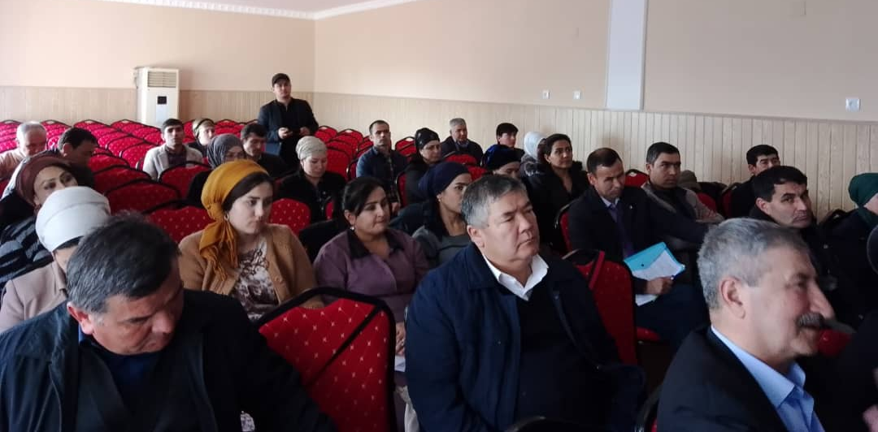
Figure 5. Consultation in Guliston Jamoat, J. Balkhi District

Minutes of Stakeholder Consultations on E&S instruments Fakhrobod Jamoat, Khuroson District, Khatlon region
Hosted by: HSIP
Date: February 17, 2023
Venue: hall of the Fakhrobod HH, Fakhrobod Jamoat, Khuroson District
Number of attendants: 32 persons (23 women)
Working language: official language (Tajik)
Objective:
- To inform key stakeholders about the expected activities under the Millati Solim Project and the measures taken to ensure environmental and social security. Disclosure of drafts of social and environmental assessment reports.
- To obtain beneficiary comments and feedback on all components under the Millati Solim Project: Tajikistan – healthy nation.

Agenda:
- Welcome speech, Doliev S.R., HSIP Implementation Specialist in Khatlon Region;
- Basic information about the scheduled activities under the Millati Solim Project: Tajikistan – healthy nation (Doliev S.R., HSIP Implementation Specialist in Khatlon Region);
- Presentation, Social and Environmental Commitment Plan; (Asrorov D.R., PBF HMIS Data Monitoring Specialist in Khatlon Region);
- Presentation, Procedures Regulations of Labor-Management Relations (Shukurov M.N. – PBF Specialist in Khatlon Region);
- Presentation document: Stakeholder Engagement Plan, (Doliev S. R., HSIP Implementation Specialist in Khatlon Region);
- Presentation: Environmental and Social Management Framework, (Asrorov D. R., PBF HMIS Data Monitoring Specialist in Khatlon Region);
- Presentation: Resettlement Framework (Asrorov D.R., PBF HMIS Data Monitoring Specialist in Khatlon Region);
- Beneficiaries key takeaways and comments;

Meeting with citizens was organized for beneficiaries of the Project's services both for citizens and the PHC health staff.
The event was opened by Doliev S.R., HSIP Implementation Specialist in Khatlon Region, he welcomed all the participants, expressed gratitude to the Government of the Republic of Tajikistan, WB and MoHSPP for the support provided to the Tajikistan health sector and briefly informed attendants about activities of the Government of the Republic of Tajikistan carried out in the health sector. In particular, it was said that the purpose of this meeting is to provide basic information about the expected activities under the Millati Solim: Tajikistan - healthy nation Project and review key project documents prepared as the basic environment and social safeguards of the project. Further, Doliev S. R. noted about the environmental and social safeguard policy, about the construction and institutional orientation of the project in strengthening the primary health care system. It was suggested that the meeting participants take an active part and provide their proposals on the presented materials.
In his speech, he noted that the purpose of public consultations is to provide basic information about the expected activities under the Millati Solim: Tajikistan – Healthy Nation Project and Project goals, objectives and components, phased WB support to Tajikistan health sector, main project beneficiaries and pilot districts to be supported under the Project.
D. R. Asrorov, PBF HMIS Data Monitoring Specialist in Khatlon Region presented information on the environmental and social aspects of the Project. He mentioned the WB requirements for the identification and assessment of social and environmental risks and impacts associated with projects. It was noted that the main purpose of this event is to inform population about the expected project activities, to get feedback and proposals on the presented project materials.
Further, Doliev S.R., HSIP Implementation Specialist in Khatlon Region, in his speech on the Stakeholder Engagement Plan, noted that this document was prepared in order to identify all parties interested in the project, to establish close and constructive interaction with them and develop an appropriate engagement framework, taking into account their views and needs. It was noted that the introduction of this mechanism under the project, as well as the feedback mechanism, will improve transparency and accountability in the sector.
Asrorov D. R., PBF HMIS Data Monitoring Specialist in Khatlon Region, presented the Environmental and Social Management Framework. He provided information on WB requirements and legal regulations of the Republic of Tajikistan requiring environmental and social assessment. It was said that the document sets out the expected environmental and social risks and impacts associated with the project, defines measures to prevent risks and manage negative impacts.
Shukurov M.N., PBF Specialist in Khatlon Region, in his presentation on Procedures Regulations of Labor-Management Relations said that this document is as a tool to manage the risks that may arise in relation to the recruitment and working conditions of project employees. Speaker told that the document was developed in accordance with the requirements of SES 2. "Labor and working conditions" and defines the main requirements in the field of labor legislation and the risks associated.
Asrorov D. R., PBF HMIS Data Monitoring Specialist in Khatlon Region provided listeners with information about the Resettlement Framework with an overview of the WB and the Republic of Tajikistan policies and procedures related to the issues of land acquisition, restriction of land use rights and involuntary resettlement.
It should be noted that all the materials provided to the participants of the event were presented as slides in Power Point format in a compressed form.
At the end of the event, the participants were asked to provide their feedback on the presented materials in writing.
Participants asked the following questions:
1. What is the citizen engagement mechanism in the project implementation process?
2. How the health staff will be involved in the project implementation process?
3. It is not clear, it was said that citizens will be incentivized and interested in project implementation, under the project. What does it mean?
4. As for questions related to medical care or healthcare, we certainly apply to the health facility and get some answer, at least.
5. On urgent issues related to the standard of living, land management, utilities, and natural disasters consequences, whom we can contact, who can provide assistance or solve these problems?
6. In presentation, it was mentioned payment of compensation in case of natural disaster, how it works?

Satisfactory answers were given to the questions received by speakers. Discussions took place in a lively atmosphere.
All parties involved were satisfied with public hearings and expressed their hope that the project implementation would make a positive contribution to improving the level, quality and volume of healthcare provided to the population at the primary health care level and strengthening their physical infrastructure.
List of participants and photos are attached.
Doliev S.R., HSIP Implementation Specialist
Asrorov D.R., PBF MIS Data Monitoring Specialist
Shukurov M.N., PBF Specialist

List of participants:

Imomberdieva Parda
Sangaliyev Michgona
Khakimova Sanahvar
Rajabova Arafamokh
Shaimonova Shakhnoza
Kayumova Oimoma A
Namozova Bibisanam
Khanzharova Bibiraykha
Kulaeva Khazhara
Sharipov Khomid
Tagoykulov Mozhid
Gulmurodov Urozali
Ibodullova Salima
Babamuratov Mukhmaddavud
Shoymonova Zamira
Azimova Dilafruz
Yunusova Shoira
Chamshetova Mukaramma
Shirinova Mavludakhon
Tashtemurova Marziya
Samatov Sherali
Chaborova Idigul
Yarboboeva Manzura
Abduloeva Hosiyat
Imomov Khudoynazar
Mamadalieva Komila
Imomov Khursandkul
Tagaynazarova Malohat
Kukiev Almuhammad
Erdanov Tilavmurod
Kuganova Farida
Abduzoirova Bibisoro
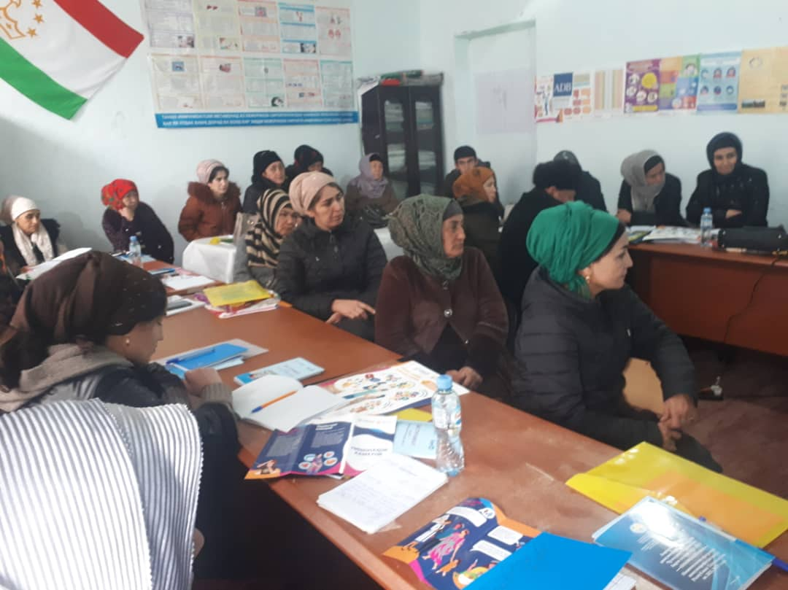
Figure 6Consultation in Fakhrobod Jamoat, Khuroson District

Minutes of Stakeholder Consultations on E&S instruments Kyzyl Kala Jamoat, Khuroson District
Hosted by: HSIP
Date: February 17, 2023, 8:30 a.m.- 11:50 a.m
Venue: RFMCTC hall, Kyzyl Kala Jamoat, Khuroson District
Number of attendants: 37 persons (31 women)
Working language: official language (Tajik)
Objective:
- To inform key stakeholders about the expected activities under the Millati Solim Project and the measures taken to ensure environmental and social safeguards. Disclosure of drafts of social and environmental assessment reports.
- To obtain beneficiary comments and feedback on all components under the Millati Solim Project: Tajikistan – healthy nation.

Agenda:
- Welcome speech, Doliev S.R., HSIP Implementation Specialist in Khatlon Region;
- Basic information about the scheduled activities under the Millati Solim Project: Tajikistan – healthy nation (Doliev S.R., HSIP Implementation Specialist in Khatlon Region);
- Presentation, Social and Environmental Commitment Plan; (Asrorov D.R., PBF HMIS Data Monitoring Specialist in Khatlon Region);
- Presentation, Procedures Regulations of Labor-Management Relations (Shukurov M.N. – PBF Specialist in Khatlon Region);
- Presentation document: Stakeholder Engagement Plan (Doliev S. R., HSIP Implementation Specialist in Khatlon Region);
- Presentation: Environmental and Social Management Framework (Asrorov D. R., PBF HMIS Data Monitoring Specialist in Khatlon Region);
- Presentation: Resettlement Framework (Asrorov D.R., PBF HMIS Data Monitoring Specialist in Khatlon Region);
- Beneficiaries key takeaways and comments.

Meeting with citizens was organized for beneficiaries of the Project's services both for citizens and the PHC health staff.
The event was opened by Doliev S.R., HSIP Implementation Specialist in Khatlon Region, he welcomed all the participants, expressed gratitude to the Government of the Republic of Tajikistan, WB and MOHSP for the support provided to the Tajikistan health sector and briefly informed attendants about activities of the Government of the Republic of Tajikistan carried out in the health sector. In particular, it was said that the purpose of this meeting is to provide basic information about the expected activities under the Millati Solim: Tajikistan - healthy nation Project and review key project documents prepared as the basic environment and social safeguards of the project. Further, Doliev S. R. noted about the environmental and social safeguard policy, about the construction and institutional orientation of the project in strengthening the primary health care system. It was suggested that the meeting participants take an active part and provide their proposals on the presented materials.
In his speech, he noted that the purpose of public consultations is to provide basic information about the expected activities under the Millati Solim: Tajikistan – Healthy Nation Project and Project goals, objectives and components, phased WB support to Tajikistan health sector, main project beneficiaries and pilot districts to be supported under the Project.
D. R. Asrorov, PBF HMIS Data Monitoring Specialist in Khatlon Region presented information on the environmental and social aspects of the Project. He mentioned the WB requirements for the identification and assessment of social and environmental risks and impacts associated with projects. It was noted that the main purpose of this event is to inform population about the expected project activities, to get feedback and proposals on the presented project materials.
Further, Doliev S.R., HSIP Implementation Specialist in Khatlon Region, in his speech on the Stakeholder Engagement Plan, noted that this document was prepared in order to identify all parties interested in the project, to establish close and constructive interaction with them and develop an appropriate engagement framework, taking into account their views and needs. It was noted that the introduction of this mechanism under the project, as well as the feedback mechanism, will improve transparency and accountability in the sector.
Asrorov D. R., PBF HMIS Data Monitoring Specialist in Khatlon Region, presented the Environmental and Social Management Framework. He provided information on WB requirements and legal regulations of the Republic of Tajikistan requiring environmental and social assessment. It was said that the document sets out the expected environmental and social risks and impacts associated with the project, defines measures to prevent risks and manage negative impacts.
Shukurov M.N., PBF Specialist in Khatlon Region, in his presentation on Procedures Regulations of Labor-Management Relations said that this document is as a tool to manage the risks that may arise in relation to the recruitment and working conditions of project employees. Speaker told that the document was developed in accordance with the requirements of SES 2. "Labor and working conditions" and defines the main requirements in the field of labor legislation and the risks associated.
Asrorov D. R., PBF HMIS Data Monitoring Specialist in Khatlon Region provided listeners with information about the Resettlement Framework with an overview of the WB and the Republic of Tajikistan policies and procedures related to the issues of land acquisition, restriction of land use rights and involuntary resettlement.
It should be noted that all the materials provided to the participants of the event were presented as slides in Power Point format in a compressed form.
At the end of the event, the participants were asked to provide their feedback on the presented materials in writing.
Participants put the following questions:
- It was said about providing assistance to poor citizens, large families, orphans and widows under the project, in what kind it would be provided and what is the amount of assistance?
- It is not clear, it was said that citizens will be incentivized and interested in project implementation, under the project. What does it mean?
- As for questions related to medical care or healthcare, we certainly apply to the health facility and get some answer, at least. And regarding issues related to the standard of living, land management, utilities, and natural disasters consequences, whom we can contact, who can provide assistance or solve these problems?
- Will there be representatives of the project on place at the local or at least the regional level, as citizens do not have the opportunity to apply and go to the capital on vital issues?
- No one has ever seriously dealt with issues of sanitation and ecology on the ground, even household waste is not taken out and disposed, to say nothing of solid or construction waste. What is the mechanism for managing this problem?

Satisfactory answers were given to the questions received by speakers. Discussions took place in a lively atmosphere.
All parties involved were satisfied with public hearings and expressed their hope that the project implementation would make a positive contribution to improving the level, quality and volume of healthcare provided to the population at the primary health care level and strengthening their physical infrastructure.
List of participants and photos are attached.
Doliev S.R., HSIP Implementation Specialist
Asrorov D.R., PBF MIS Data Monitoring Specialist
Shukurov M.N., PBF Specialist

List of participants

# | Kyzyl Kala Jamoat
1 | Rakhmonov Safar
2 | Tagikhonov Alisher
3 | Sharipova Sailigul
4 | Boboeva Zulfiya
5 | Yuldosheva Fayzigul
6 | Sangova Bibioisha
7 | Tagoeva Malika
8 | Ganieva Gulrukhsor
9 | Rahmonova Safarbi
10 | Rakhimova Gulbegim
11 | Farzonai Shodi
12 | Rakhimova Mahfirat
13 | Nodiray Nurali
14 | Holova Parvina
15 | Raqabova Latofat
16 | Nazifova Shamsia
17 | Nazarova Gulrukhsor
18 | Latifai Jamoliddin
19 | Boboeva Matluba
20 | Khidirova Kurbongul
21 | Berganova Maidagul
22 | Rakhimova Mavluda
23 | Faizalieva Adiba
24 | Mirzoeva Mastona
25 | Rakhimova Saida
26 | Sunatulloeva Gulafzo
27 | Tavakalova Firuza
28 | Mirzoeva Mavluda
29 | Nuralieva Mavkuda
30 | Nazarova Sayyora
31 | Ziyovudinzoda Toshkuvat
32 | Rasulov Rustam
33 | Mirzoev Orif
34 | Saidova Malika
35 | Mahmadaliev Mohira
36 | Zugurova Umada
37 | Bobobekov Khairullo

Figure 7. Consultation in Kyzyl Kala Jamoat, Khuroson District

Improved efficiency of primary healthcare services will be achieved in pioneer areas (Sughd region and Dushanbe City) under Component 2, while improved quality will be achieved in selected districts under Component 1.
Mobile Engage is an SMS-based platform, initially supported by the World Bank through the Korea Trust Fund for Economic and Peace-Building Transitions, for broad communication to the citizen that was successfully used during the COVID-19 pandemic to inform the public about COVID-19 risks. Mobile phone coverage rates are above 90% even in rural areas of Tajikistan.
IEG (2014) The World Bank Group Support to Health Financing. An Independent Evaluation. https://ieg.worldbankgroup.org/sites/default/files/Data/reports/chapters/health_finance_evaluation_w_appendix_updated_0.pdf
This includes staff that will work in the purchasing structure of purchaser and excludes health workers.
Through the Disbursement-Linked Indicators in the ECDP, supported by the GFF and the World Bank, the MoF is introducing program-based budgeting (PBB) in district and urban PHC facilities as well as a single program budget line for PHC to allow for more flexibility by PHC managers to move expenditures across expenditures categories, which is needed to implement PBB. To date the regulatory and legal changes needed for these alterations to the public financial management system have been introduced. Yet the implementation of the new changes at the facility level is still work in progress.
To ensure the sustainability of strategic purchasing and digitalization, there are plans to include a policy action related to increasing the share of total government expenditure (without external funding) spent on the health sector, in a future Development Policy Operation in Tajikistan.
These provisions concern the hampering of gatherings (Article 106); disorderly conduct (Article 460); disobedience to police (Article 479); and violation of rules of conducting gatherings (Article 480).
This includes people who have not yet completed registration and who are considered as "legalizable" users (this will be identified as a form of land tenure in the IOL), they will be entitled to compensation as if they are legal/titled owners of land. The RAPs prepared will establish that continued facilitation of the registration process will be undertaken as part of livelihoods/wellbeing restoration under the Project's resettlement process.
Forced labor means all work or service, not voluntarily performed, that is extracted from an individual under threat of force or penalty
Articles 113, 67, and 174 of Labor Code set the minimum employment age as 15. In addition, there are some labor restrictions on what type of work can be done, and how many working hours are permissible by workers under the age of 18. Examples of labor restrictions include: age of 15 cannot work more than 24 hours per week while those under 18 cannot work more than 35 hours per week; during the academic year, the maximum number of hours is half of this, 12 and 17.5 hours, respectively. These limitations are consistent with the ILO Convention on Minimum Age.
In case some of the displaced persons lose more than 10% of their productive assets or require physical relocation, the plan also covers a socioeconomic survey and income restoration measures.

