REPUBLIC OF TAJIKISTAN
MINISTRY OF HEALTH AND SOCIAL PROTECTION

TAJIKISTAN MILLATI SOLIM PROJECT

STAKEHOLDER ENGAGEMENT PLAN

August 2023
ABBREVIATIONS AND ACRONYMS

ADB | Asian Development Bank
CERC | Contingent Emergency Response Component
CHC | City Health Center
CME | Continuous Medical Education
COVID-19 | Coronavirus disease
DHC | District Health Center
ECDP | Early Childhood Development Project
EMR | Electronic Medical Record
EPR | Electronic Patient Registry
ESMP | Environmental and Social Management Plan
ESMF | Environmental and Social Management Framework
ESS | Environmental and Social Standards
FM | Family Medicine
FMD | Family Medicine Doctors
GBV | Gender Based Violence
GM | Grievance Mechanism
GRS | Grievance Redress Service (of the World Bank)
HEPR | Health Emergency Preparedness and Response
HPAU | Health Policy and Analysis Unit
HSIP | Health Services Improvement Project
HCF | Health Care Facility
IC | Inter-sectorial Committee
IVA | Independent Verification Agency
Khadamot | State Health and Social Protection Supervision Services
LAN | Local area networks
MoHSPP | Ministry of Health and Social Protection of Population
NGO | Non-governmental Organizations
NHF | National Health Fund
OHS | Occupational Health and Safety
PAP | Project Affected Parties
PBC | Performance Based Conditions
PDO | Project Development Objective
PFM | Public Finance Management
PHC | Primary Health Care
POM | Project Operational Manual
PPE | Personal Protective Equipment
PPG | Project Preparation Group
RHC | Rural Health Center
RPHCIRD | Reforms, Primary Healthcare, and International Relations Department
SASP | State Agency of Social Protection
SDI | Service Delivery Indicator
SEA/SH | Sexual Exploitation and Abuse/Harassment
SEP | Stakeholder Engagement Plan
SMS | Short Messaging System
TEC-19 | Tajikistan Emergency COVID-19 Project
TSG | Technical Support Group
USD | American dollar
USAID | US Agency of International Development
UNICEF | United Nation Children’s Fund
WB | The World Bank
WHO | World Health Organization
Contents
INTRODUCTION 5
1. PROJECT DESCRIPTION 6
2. REGULATORY FRAMEWORK 11
3. PREVIOUS STAKEHOLDER ENGAGEMENT 13
3.1Summary of stakeholder engagement done during project preparation 13
4. STAKEHOLDER IDENTIFICATION AND ANALYSIS 14
4.1 Project Affected Parties 15
4.2 Other Interested Parties 16
5. STAKEHOLDER ENGAGEMENT PROGRAM 20
5.1 Summary of project stakeholder needs and methods, tools and techniques for stakeholder engagement 20
5.2 Proposed strategy for information disclosure and consultation process 22
6. RESOURCES AND RESPONSIBILITIES FOR IMPLEMENTING STAKEHOLDER ENGAGEMENT ACTIVITIES 26
6.1 Resources 26
6.2 Management functions and responsibilities 26
6.3 Estimated Budget 26
7. GRIEVANCE MECHANISM 27
7.1 Description of GM 27
7.2 GM Structure 27
7.3 Grievance Resolution Process 29
7.4 Grievance Logs 30
7.5 Monitoring and Reporting on Grievances 30
7.6 World Bank Grievance Redress System 31
8. MONITORING AND REPORTING 32
Annex 1. Notes of preliminary discussion on Millati Solim project with potential beneficiaries 33
Annex 2. Minutes of Stakeholder Consultations on E&S instruments in Gazantarak Jamoat, Devashtich District, Sughd Region 36
Annex 3. Minutes of Stakeholder Consultations on E&S instruments Yakhtan Jamoat, Devashtich District, Sughd Region 39
Annex 4. Minutes of Stakeholder Consultations on E&S instruments Kurush Jamoat, Spitamen District, Sughd Region 41
Annex 5. Minutes of Stakeholder Consultations on E&S instruments Yangiobod Jamoat, Spitamen District, Sughd Region 43
Annex 6. Minutes of Stakeholder Consultations on E&S instruments Navobod Jamoat, J. Balkhi District, Khatlon region 45
Annex 7. Minutes of Stakeholder Consultations on E&S instruments Guliston Jamoat, J. Balkhi District, Khatlon region 48
Annex 8. Minutes of Stakeholder Consultations on E&S instruments Fakhrobod Jamoat, Khuroson District, Khatlon region 51
Annex 9. Minutes of Stakeholder Consultations on E&S instruments Kyzyl Kala Jamoat, Khuroson District 54

INTRODUCTION

- The Ministry of Health and Social Protection of Population (MoHSPP) of Tajikistan is preparing the Tajikistan Millati Solim Projectwith the World Bank’s Health, Nutrition and Population Global Practice assistance. Tajikistan Millati Solim Project will support Tajikistan’s ambitious plan to implement a revised version of the Mandatory Health Insurance Law and take necessary steps towards achieving Universal Health Coverage.

- The project will have positive social impacts, as it will contribute to (i) improved quality and equity of PHC services in selected districts/regions and (ii) strengthened national capacity to respond to health emergencies. Social risks could emanate from the following planned investments: (i) investments in PHC service delivery capacity (human resources, infrastructure, and equipment) at the PHC level in selected districts and at the national level, and (ii) national capacity and physical infrastructure enhancement to improve response to various emergencies, including: training of health workers; repairing, equipping, and modernizing public health workplaces; construction of warehouses for emergency medical equipment and goods at the regional level; procurement of medical goods to stockpile for future emergencies; and investment in biosecurity and transportation arrangement to improve regionally coordinated research into pathogens and other potential causes of health emergencies.

- One of the key challenges for the project will be to ensure social ‘inclusion’. Exclusion may happen due to differentials in: (i) geography – given the vast expanse of the PHC facilities throughout the country and the fact that some of the terrain is mountainous and remote, particularly near the Afghanistan border, it is likely that some areas (regions, districts and villages) may not be covered by the project; (ii) scale of investments – large and richer districts/regions may receive preferential investments; (iii) absorption capacity - technologies developed should be more friendly to health workers at large, and (iv) administrative expediency and economy in reaching out to rural health workers and vulnerable households in remote and poor areas across the country.

- Both the environmental and social (E&S) risks for the Project are rated Moderate. The following Environmental and Social Standards (ESS) are relevant to the Project: ESS 1 – Assessment and Management of Environmental and Social Risks and Impacts; ESS 2 – Labor and Working Conditions; ESS 3 – Resource Efficiency and Pollution and Management; ESS 4 – Community Health and Safety; ESS 5 - Land Acquisition, Restrictions on Land Use, and Involuntary Resettlement; and ESS 10 – Stakeholders Engagement and Information Disclosure.

- The present SEP outlines the ways in which the implementing agency (IA) will communicate with stakeholders and includes a mechanism by which people can raise concerns, provide feedback, or make complaints about project and any activities related to the project. The involvement of the local population is essential to the success of the project in order to ensure smooth collaboration between IA staff and local communities and to minimize and mitigate environmental and social risks related to the proposed project activities.

PROJECT DESCRIPTION

The objectives of the Project are to (i) improve the quality and efficiency of primary healthcare services in Selected Districts and (ii) strengthen the national capacity to respond to public health emergencies.

Component 1 (Primary Healthcare [PHC] Strengthening) will be implemented in selected districts to be defined by the MoHSPP. Components 2, 3 and 4 will have a national scope. However, activities under Component 2 (Digitalization and Strategic Purchasing of PHC services) will be designed for national scale up but will first be implemented in Sughd Oblast and Dushanbe City.

The proposed project will have the following components:
Component 1: Quality Improvements of Primary Care through Primary Healthcare Strengthening
The objective of this component is to improve the conditions for delivering quality PHC services by making PHC facilities service ready. This will be achieved through investments in service delivery capacity (human resources, infrastructure, and equipment) in the 16 selected districts representing all regions in the country and in interventions to ignite the demand for PHC services among the population.
Subcomponent 1.1: Quality Improvements of Primary Care through Investments in Human Resources and Demand Stimulation
will address the pressing need to invest in human resources working at the PHC level in 16 selected districts. This will be achieved by developing sustainable national policy options for retaining family medicine doctors and nurses and other specialists working at the PHC level in rural areas (which are also most sensitive to climate change impacts) through the development of a human resource strategy for retention of these cadres. The subcomponent will support the implementation of identified retention strategies in the 16 target districts. With support of this subcomponent, knowledge and management of PHC providers will be improved through: (i) in-person training of doctors and nurses in family medicine in the 16 target districts, (ii) PHC management training in the 16 target districts, (iii) development and establishment of a national online platform for delivery of continuous medical education (CME) to PHC providers, which will also allow them to access the latest evidence-based clinical guidelines and climate change knowledge, (iv) technical assistance to revise the specialty standards and curricula for specialists working at the PHC level. To allow for the delivering of training, this sub-component will support the Republican Clinical Training Center, including their regional branches, with minor rehabilitation of their offices, and office equipment for their staff as well as simulation centers to improve training of doctors and nurses. This subcomponent will also support demand-side investments and citizen engagement (CE) to improve uptake of PHC services, including for reproductive maternal, newborn, child and adolescent health and nutrition (RMNCHA-N) services. Such demand-side interventions will include mobile outreach to citizens through Mobile Engage with health promotion, prevention, and behavioral change communication. This will also raise the citizen’s awareness of climate-sensitive diseases as well as MoHSPP’s online Grievance Redress Mechanism (GRM). Moreover, a yearly phone-based National Patient Survey to measure citizen’s view and satisfaction with healthcare services at the PHC level will be financed, to allow for MoHSPP to stay tuned to the needs and desires of the citizens. To prepare for the implementation of the amended Law on the Prevention of Domestic Violence, this subcomponent will support the integration of GBV services in the health sector with a particular focus on PHC level. This will be done through a three-pronged approach focused on the level of (i) national policy development (e.g. development of referral pathways, develop clinical guidelines etc.), (ii) interventions at the PHC level (e.g. training of healthcare workers in GBV response), and (iii) the individual (healthcare workers and citizens awareness about GBV through e.g. Mobile Engage).
This subcomponent will finance goods, minor rehabilitation, non-consulting services, international and local technical assistance, and training.
Subcomponent 1.2: Quality Improvements of Primary Care through Physical Infrastructure Improvements will support improvements in physical and digital infrastructure of PHC facilities through investments in rehabilitation of existing and, where needed, construction of new priority PHC facilities in 16 selected project districts, as well as provision of basic medical/laboratory and computer equipment. Support under this subcomponent will focus on RHCs and a limited number of DHC/CHC, which collectively cover predominant shares of population in their catchment areas. This subcomponent will aim to ensure uninterrupted basic functionality and capacity of selected PHC facilities to make facilities service ready to deliver quality PHC services and fulfill requirements for accreditation. By ensuring that PHC staff have good working conditions and basic medical/laboratory, office, and computer equipment and furniture to provide essential PHC services, it will contribute to improving quality of front-line PHC services and making it more attractive for health workers to work at the PHC level and for citizens to visit these facilities. It will also support development of an evidence-based concept of providing mobile PHC services to populations in remote areas and investments to implement recommendations outlined in the concept in the 16 districts.
This sub-component will finance civil works, goods, international and local technical assistance, and training.
Component 2: Efficiency enhancing reforms in the PHC network
Component 2 supports structural reforms related to strategic purchasing and digitalization of PHC to improve efficiency and quality of PHC services, and to drive enhanced spending efficiency, equity, and financial sustainability of the overall health sector. The activities financed under this component are designed to be implemented at national scale. Building on lessons learned, including from previous pilots in Tajikistan, the Project will be fully integrated in the public finance context and operate by making changes to national systems (e.g., public financial management (PFM) system) rather than relying on Project-specific parallel or temporary arrangements, which may be quicker to implement but less sustainable and effective in the long run. During the project period, the changes to national systems will be developed to allow for digitalization and strategic purchasing at the PHC level and these will be implemented in pioneer regions, Sughd region and Dushanbe city. By paying primary care providers based on a mix of capitation, fee-for-service and other output-based measures this component will introduce a new incentive environment with increased focus on performance, that in turn will drive efficiency in health spending.
PBCs are used under Component 2 to strengthen the Project’s results orientation and to incentivize structural reforms. Similar incentives have been used successfully to nudge structural reforms in Tajikistan under the ECDP Project. These additional conditions for disbursements will ensure that the necessary activities to develop policy and institutional changes needed to introduce strategic purchasing and digitalization are not only developed but also approved at the national level, enabling the Project to support their implementation. Furthermore, it is foreseen that additional incentives to nudge changes in the public financial management system important for strategic purchasing and to increase the share of public health expenditures in relation to total public expenditure will be introduced in the forthcoming development policy lending operation.

Subcomponent 2.1: Strategic Purchasing of PHC services
Subcomponent 2.1 will build the foundations for introducing strategic purchasing in the health sector and support the establishment of the purchasing structure of purchaser. Building on an ongoing pilot to establish strategic purchasing in 5 districts in Sughd region as well as the experience with PBF under HSIP, this component will first finance the establishment of the purchasing structure of purchaser, a semi-autonomous legal entity with regional branches that will act as a single purchaser of the health care services. This includes conception of the structure of purchasing structure of purchaser, the creation of the legal framework, as well as its establishment, initial staff costs and capacity building of the purchasing structure of purchaser. The purchasing structure of purchaser will be mainly staffed by relevant civil servants that will be transferred from the MoHSPP, MoF, and other relevant Government agencies (e.g., MedStat) at the national level and from the local administrations at the regional branches level. These transferred staff will continue to be paid as civil servants by the Government. In addition to this, new employees will be hired, and are estimated to reach 35 individuals by the end of the Project. The operating costs of the purchasing structure of purchaser, including the costs for the 35 new staff, will be transferred to the Government over the lifetime of the Project per the table below to ensure sustainability of the purchasing structure of purchaser beyond the end of the Project. The financing of recurrent expenditures for staff during the first years is motivated by the fact that the expenditures are transitional, as they are supporting a new institution not previously budgeted for by the Government. The establishment of the purchasing structure of purchaser and introduction of the strategic purchasing will change the flow of funds for the health sector. The funds from the state budget will be transferred to the purchasing structure of purchaser, and purchasing structure of purchaser will use these funds to pay for healthcare services. This change will be gradual and start with pioneer regions. A detailed assessment of the needed regulatory and legal changes to introduce strategic purchasing as the PHC level is currently being conducted and will inform this component.
The subcomponent will finance a number of national foundational activities needed for a sustainable introduction of strategic purchasing. This includes a domestic resource mobilization strategy for the health sector at the national level, which is essential for the sustainability of Component 2 and to eventually implement the Law on Health Insurance. Moreover, the subcomponent will finance the revision and costing of the national PHC benefit package to determine which services the purchasing structure of purchaser will purchase at the PHC level. At the national level, the subcomponent will finance the development of a service delivery network masterplan to optimize the service delivery network as well as the development and implementation of an accreditation program for PHC providers, as accreditation will eventually be a prerequisite for all providers for contracting with the purchasing structure of purchaser. In addition, it will finance the development and implementation of a national roadmap for the legal and regulatory changes needed to transition from the current, primarily input-based, PHC payment mechanism to payments based on capitation and outputs. A detailed assessment of needed regulatory and legal changes is currently being conducted to inform this roadmap. This will need to include revision of staffing norms and the deepening of the already initiated changes to the PFM systems to create more autonomy for PHC providers. The subcomponent will also finance the development of a national PHC contracting mechanism, a change management strategy for the structural reforms, and the implementation of strategic purchasing in pioneer areas (Sughd region and Dushanbe city), this includes training of healthcare workers and PHC managers in strategic purchasing.
This subcomponent will finance goods, non-consulting services, international and local technical assistance, training, and eligible expenditures linked to PBCs (see below).
The PBC listed below is linked to sub-component 2.1 and serves to incentivize reform implementation.
- PBC 1: Policy and institutional reforms for introducing strategic purchasing adopted. PBC 1 rewards the following five results: (i) health service delivery network masterplan developed and approved, (ii) purchasing structure of purchaser established and operational, (iii) regulatory framework to increase the PHC providers autonomy developed and approved, (iv) single state-guaranteed benefit package for PHC developed, costed and approved, and (v) staffing norms revised and approved. Disbursement of US$4 million in total will be linked to achievement of the targets defined for this PBC.
Subcomponent 2.2: Digitalization of PHC network
Subcomponent 2.2 will support the digitalization and infrastructure upgrades of the PHC network. To provide reliable and quality data for capitation formula and calculation of outcome indicators, this subcomponent will finance development and expansion of the EPR and basic EMR in PHC facilities. The EPR is necessary for implementation of capitation formula, while the EMR system is needed to provide reliable electronic data for calculation of outcome indicators by the purchasing structure of purchaser. Sub-component 2.2 will finance the implementation of the EPR and EMR in the two pioneer regions (however the EPR and EMR will be developed to allow for national level scale-up), this includes training of healthcare workers and PHC managers in these new systems.
This subcomponent will also finance infrastructure upgrades of priority PHC facilities to the level needed to meet accreditation criteria in pioneer regions. This includes renovation/extension of rural and urban PHC facilities, internet access/local area networks (LAN), procurement of PHC equipment, labs, computers/tablets/smartphones, and other goods required by the accreditation program. The difference between the infrastructure upgrades financed under this subcomponent and subcomponent 1.2 is that this subcomponent will only finance specific requests to make facilities in pioneer regions ready to meet accreditation criteria, while subcomponent 1.2 will make larger investments in infrastructure upgrades in the 16 target districts selected under Component 1. The PBC below is linked to subcomponent 2.2 and serves to incentivize reform implementation.
- PBC 2: PBC 2 rewards the following two results: (i) EPR is functional and integrated with the civil registry, and (ii) EMRs are functional. Disbursement of US$2 million in total will be linked to achievement of the targets defined for this PBC.
The PBCs will be linked to expenditures related to the achievement of the PDO. For PBC 1, the conditions will be linked to expenditures related to the establishment and operationalization of the purchasing structure of purchaser, including equipment and furniture for the MoHSPP new building where purchasing structure of purchaser will be hosted, as well as technical assistance related to the development of: the revised masterplan, the regulatory framework to increase the PHC provider autonomy, the revised and costed single state-guaranteed benefit package, and changes in staffing norms. For PBC 2 the conditions will be linked to expenditures related to the development and implementation of Electronic Medical Records (EMR) and Electronic Patient Registry (EPR). These expenditures linked to both PBCs are directly attributable to the activities defined under the PBCs in Component 2.
Verification of achievement of PBC targets will be conducted by an Independent Verification Agency. The MoHSPP will hire an Independent Verification Agency (IVA) that will verify the achievement of the PBC targets as well as their technical merit. Terms of Reference (TOR) for the IVA will also define technical criteria for each result that the IVA will verify. The contracted IVA, which will be an independent private, academic or international organization, will work together with local institutions such as Chamber of Accounts (internal auditor) to build their capacity to verify results during the project period. Thus, there will be a training and technical assistance component included in the TOR for the IVA. The timelines specified for achievement of PBC targets are indicative rather than strict time-bound conditions. On achievement of PBC targets, the MoHSPP will submit to the World Bank satisfactory evidence that the respective PBC targets have been achieved in accordance with respective provisions in the Project Operations Manual (POM), including corresponding eligible expenditure reports. In verifying eligible expenditures, attention will be paid to ensuring that there are no withdrawals against eligible expenditures that have already been financed by, or requested to be financed by, any other Bank-financed project. Such a mechanism will also provide the possibility to reconcile with any other possible financing of health expenditures by other donors. For more details, see PBC Verification Protocol Table.
This subcomponent will finance civil works, goods, international and local technical assistance, training, and eligible expenditures linked to PBCs.

Component 3: Health Emergency Preparedness and Response will strengthen the HEPR capabilities in Tajikistan to improve the capacity to prevent, prepare, and respond to health emergencies. It will finance the following: (i) technical assistance to conduct detailed assessment of the public health (SES) , and to build national capacity to prevent, detect and respond to emergencies, including updating national standard operating procedures (SOP) and protocols, and development of facility-based (PHC) emergency plans in 16 target districts of Component 1; (ii) training of PHC workers in infection prevention and control as well as antimicrobial resistance in 16 project districts and training of epidemiologists at the national level; (iii) providing technical assistance to strengthening the coordination of emergency response between the PHC network and SES; (iv) strengthening laboratory systems of SES regional branches through procurement of transportation of specimen and samples, procurement of basic lab equipment for prevention and detection of disease and minor rehabilitation of lab facilities; (v) training and technical assistance to strengthen community engagement on public health-focused risk communication, including procurement and rolling out of alert systems; (vi) technical assistance for costing of a National Action Plan for Introduction of IHR (2005) under Health Security (NAPHS) and implementation of priority activities , including dissemination and advocacy for implementation; (vii) upgrades of regional branches of SES and entry points, including minor rehabilitation, procurement of equipment; (viii) procurement of a limited stockpile of emergency goods as well as items for sanitary quarantine points at the border, as per government-approved lists to be defined in the POM, minor rehabilitation of two warehouses (one ware house of SES at the national level and one warehouse of SES of Khatlon branch) where the stockpile and items for sanitary quarantine points will be kept; (ix) annual simulation exercises of various types and scale to improve functionality of emergency coordination mechanism, and (x) technical assistance to increase capacity of the MoSHPP to lead, convene and coordinate assistance related to HEPR. In all activities, participation of women in the public health emergency management and decision-making will be enforced by ensuring gender balance among training participants, in working groups/decision-making bodies, in hiring of consultants, policy experts, and by reporting sex-disaggregated monitoring data.
This sub-component will finance civil works, goods, non-consulting services, international and local technical assistance, simulation exercises and training.
Component 4: Project Management, Coordination, and Results Monitoring. This component will finance project management and operating costs as well as project audits. To allow for capacity building of the MoHSPP and MoF, it will also provide technical assistance and training for the establishment of a Health Policy and Analysis Unit (HPAU) in the MoHSPP and in the area of health financing primarily targeting the social expenditure department in the MoF. In addition, it will support procurement of equipment and furniture for the new MoHSPP building, which will house all key MoHSPP-subordinated organizations and sectoral investment projects, to allow for improved stewardship of the MoHSPP and better coordination of DP assistance in the sector.
This component will also support nationally and sub-nationally representative health facility surveys to facilitate project monitoring and evaluation (M&E). The component will finance 8 biannual FASTR surveys staring in 2024 until the end of the Project period, which collect data on service-readiness, as well as one endline SDI survey in 2027, that gathers information on wide range of structural and process quality indicators. The baseline SDI survey in 2023 and the first two FASTR surveys, one in 2023 and one in 2024, are financed by Bank executed funding provided by the GFF. The endline SDI survey will be implemented by an independent third party (survey firm/organization), which will be selected jointly by the MoHSPP and the World Bank. While MoHSPP remains the implementing agency for the Project financed surveys, the MoHSPP and World Bank technical teams, will work closely together on all surveys to ensure high quality of survey data. This subcomponent will finance goods, non-consulting services, international and local technical assistance, and training.
Component 5: Contingent Emergency Response. The objective of this component is to improve Tajikistan’s capacity to respond to disasters. Following an eligible crisis or emergency, the Recipient may request the Bank to reallocate project funds to support emergency response and reconstruction. This component would draw from the uncommitted grant resources under the Project from other project components to cover emergency response. An emergency eligible for financing is an event that has caused or is likely imminently to cause, a major adverse economic and/or social impact to the Recipient, associated with a disaster. The POM will include a specific annex for the Contingent Emergency Response Component, which lays out the provisions for activating and implementing the component.

REGULATORY FRAMEWORK

This chapter describes the Environmental and Social Standard (ESS) 10 of the World Bank and the legislative and regulatory framework of the Republic of Tajikistan, covering similar aspects.

2.1. World Bank’s ESS 10

This Plan is developed in accordance with the requirements of the World Bank Environmental and Social Standard 10 "Stakeholder Engagement and Information Disclosure", which takes into account the importance of open and transparent interaction between the borrower and project stakeholders as an important element of international best practice "(World Bank SEP, 2017, p. 97). In particular, the requirements set out in ESS10 are as follows:
- The Borrower will engage with stakeholders throughout the project lifecycle, starting such engagement as soon as possible throughout the project development process and within a time frame that allows meaningful stakeholder consultation on project development issues. The nature, scope and frequency of stakeholder engagement will be proportional to the nature and scope of the project and its potential risks and impacts;
- The borrower will consult meaningfully with all stakeholders, provide timely, relevant, understandable and accessible information and consult with them in a culturally appropriate manner, without manipulation, interference, coercion, discrimination or intimidation.;
- The stakeholder engagement process includes the following: (i) identification and analysis of stakeholders; (ii) planning interaction; (iii) disclosure of information; (iv) consultations; (v) handling grievances and responding to them; and (vi) reporting to stakeholders;
- The Borrower will maintain and disclose, as part of the environmental and social assessment, a documented report of stakeholder engagement, including a description of the stakeholders consulted, a summary of the feedback received, and a brief explanation of how the feedback was taken into account or why they were not taken into account” (World Bank, 2017: 98);
In consultation with the Bank, the Borrower will develop a Stakeholder Engagement Plan (SEP) commensurate with the nature and scale of the project and its potential risks and impacts. The draft SEP should be made public as soon as possible before the project is evaluated. The Borrower will develop and implement a Grievance Redress Mechanism to ensure prompt and efficient resolution of grievances and problems related to the project activities. Detailed information on the World Bank's environmental and social standards is available at the following links:

- https://thedocs.worldbank.org/en/doc/8377215227620501080290022018/original/ESFFramework.pdf#page=111&zoom=80
- https://documents1.worldbank.org/curated/en/476161530217390609/ESF-Guidance-Note-10-Stakeholder-Engagement-and-Information-Disclosure-English.pdf

2.2. National legal framework
The current section provides abstracts from the current legislation regarding citizens' access to information and participation:

Law of the Republic of Tajikistan "On Freedom of Information" relies on Article 25 of the Constitution, which states that state bodies, public associations and officials are obliged to provide everyone with the opportunity to receive and familiarize themselves with documents Stakeholder Engagement Plan 2022 9 relating to his/her rights and interests, except in cases stipulated by law. The law applies to relations related to access to information contained in official documents and not classified as restricted information in the interests of ensuring national security in accordance with the legislation on state secrets and other regulatory legal acts regulating relations in the field of protecting state secrets.

Law of the Republic of Tajikistan on appeals of individuals and legal entities (2016) contains legal provisions on established information channels through which citizens can submit grievances and inquiries. Article 14 of the Law establishes the terms for the consideration of grievances: 15 days from the date of receipt, which do not require additional study and research, and 30 days for applications that require additional study. These legal provisions will be taken into account in the project grievance redress mechanism. Extract from the Water Code of the Republic of Tajikistan. Chapter 11. Resolution of disputes in the field of water relations. Article 88. Resolution of disputes in the field of water relations: “Disputes in the field of water relations between the parties to water relations are resolved through negotiations between the parties, their consideration in the Government of the Republic of Tajikistan, the National Water Council, river basin councils, authorized by state bodies in the field of regulation of the use and protection of water resources, local executive bodies of state power, self-government bodies of settlements and villages, bodies created by citizens and associations of water users, within their competence, or in courts in the manner prescribed by the legislation of the Republic of Tajikistan.

Law on Local Government Bodies (2004) provides the chairman of the district or city administration with powers in the field of natural resources management, construction and reconstruction of environmental facilities, supervision of local structures in the field of waste management, sanitary and epidemiological supervision, health care and social protection of the population within the boundaries of the administrative-territorial unit. Public gatherings are allowed only upon prior notification and concurrence of the local authority (district Hukumat).

Article 13 of the Law "On Environmental Protection" proclaims the citizen's right to environmental information, as well as to participate in the development, adoption and implementation of decisions related to environmental impact. The latter is ensured by public discussion of projects of environmentally important decisions and by conducting public environmental assessments. Representative bodies of state power are obliged to address the comments and suggestions of citizens.

Civil Code determines the procedure for exercising property rights and other property rights, rights to the results of intellectual activity, regulates contractual and other obligations, as well as other property and related obligations of personal non-property relations based on equality, independence of will and property independence of their participants. Family, labor relations, relations on the use of natural resources and environmental protection are regulated by civil law, unless otherwise provided by the laws on family, labor, land and other special legislation.

PREVIOUS STAKEHOLDER ENGAGEMENT

3.1Summary of stakeholder engagement done during project preparation
- The Millati Solim project design was discussed in special consultations with government agencies and national health experts, as well as representatives of international organizations. Community consultations on their expectations from the new project were also held in some of the target districts. The Table 1 below summaries the methods used to consult with key informants.
Table 1: Summary of Stakeholder Consultations During Project Preparation

Project stage | Topic of consultation | Methods used | Timetable: Location and dates | Target stakeholders | Responsibilities
Project concept preparation | Project design -Discussions on all Project components and key aspects of project preparation | Virtual discussions | Mid-August 2022 | WB team  PPG | WB team, MoHSPP Leadership
 | In-depth technical discussions on each proposed Project activity.  Development of the Projects components – work in groups | Workshop format | September 2, 5, 6, 2022 | Technical working Group  WB team | WB team  MoHSPP
 | Discussions with key stakeholders  regarding the conceptualization/design of Millati Solim to ensure activities correspond to the local context, needs, and challenges. | Meetings, discussions |  | Representatives from the Ministry of Finance (MoF), development partners, HSIP TSG, and Dushanbe City mayor’s office | WB team  MoHSPP
 | Discussion on development of the project E&S instruments | Meeting in-person and virtual | 28.10.2022  WB office, MoHSPP | TSG of Health Services Improvement Project and TEC-19 Projects, WB consultants | MoHSPP  WB team
Community consultations with project beneficiaries in Spitamen, Raslov and Mastchoh districts | Monitoring activities on HSIP and consultations with stakeholders on their expectations from the new project | Meetings and discussions | October 31- November 5, 2022 | Personnel of the healthcare facilities, women \patients of the healthcare facilities | HSIP TSG
Public consultations on the draft ESF instruments | Presentation of the ESF instruments- SEP, ESMF, LMP, RF | Meetings and survey | February 15-17, 2023; rural health facilities in Gazantarak and Yakhtan Jamoats of Devashtich District;  Kurush and Yangiobod Jamoats of Spitamen District,  Sughd Region;  Fakhrobod and Kyzyl Kala Jamoats of Khuroson District;  Guliston and Navobod Jamoats, J. Balkhi District, Khatlon Region. | 219 (168 women) consumers of medical services | MoHSPP, HSIP

STAKEHOLDER IDENTIFICATION AND ANALYSIS
- The stakeholders defined for the Original project include individuals, groups or other entities who:
- are impacted or likely to be impacted directly or indirectly, positively or adversely, by the Project (also known as ‘affected parties’); and
- may have an interest in the Project (‘other interested parties’). They include individuals or groups whose interests may be affected by the Project and who have the potential to influence the Project outcomes in any way.

- Cooperation and negotiation with the stakeholders throughout the project development often also require the identification of persons within the groups who act as legitimate representatives of their respective stakeholder group, i.e. the individuals who have been entrusted by their fellow group members with advocating the groups’ interests in the process of engagement with the project. Rural health facilities and mahalla (community) leaders may provide helpful insight into the local settings and act as main conduits for dissemination of the Project-related information and as a primary communication/liaison link between the Project and targeted communities and their established networks. Community representatives, cultural leaders and women leaders may also be helpful intermediaries for information dissemination in a culturally appropriate manner, building trust for government programs or vaccination efforts.

- Verification of stakeholder representatives (i.e., the process of confirming that they are legitimate and genuine advocates of the community they represent) remains an important task in establishing contact with the community stakeholders. Legitimacy of the community representatives can be verified by talking informally to a random sample of community members and heeding their views on who can be representing their interests in the most effective way.

- For the purposes of effective and tailored engagement, stakeholders of the proposed project(s) are divided into the following core categories:
- Project Affected Parties (PAPs) – persons, groups and other entities within the Project Area of Influence that are directly influenced (actually or potentially) by the project and/or have been identified as most susceptible to change associated with the project, and who need to be closely engaged in identifying impacts and their significance, as well as in decision-making on mitigation and management measures;
The PAPs also include
- Vulnerable Groups – persons who may be disproportionately impacted or further disadvantaged by the project(s) as compared with any other groups due to their vulnerable status, and that may require special engagement efforts to ensure their equal representation in the consultation and decision-making process associated with the project.
- Other Interested Parties – individuals/groups/entities that may not experience direct impacts from the Project but who consider or perceive their interests as being affected by the project and/or who could affect the project and the process of its implementation in some way.

4.1 Project Affected Parties

- Affected Parties include the following individuals and groups that may be subject to direct impacts from the Project:

- Ministry of Health and Social Protection and its affiliated structures;
- State Health and Social Protection Supervision Services - Khadamot
- Republican Training Center for Family Medicine, including its 6 regional branches
- Population with access to PHC services;
- Public health workers;
- PHC patients;
- Medical workers of laboratories;
- Medical workers of information systems;
- Health professionals involved in strategic purchasing at the PHC level;
- Rural health centers and health houses;
- Sanitary and epidemiological specialists and laboratory assistants.
- Sughd Oblast Local Government,
- Dushanbe City Local Government
- Disadvantaged / vulnerable individuals or groups

- Within the Project, the vulnerable or disadvantaged groups, users of medical services, may include and are not limited to the following:
- Elderly people;
- Veterans of wars;
- Pregnant women;
- Persons with disabilities and their caregivers;
- Female-headed households;
- The unemployed persons;
- People living in poverty;
- Populations living in remote and isolated area where not any clinics;
- Migrant workers;
- Single parents with underage children

- It is particularly important to understand whether project impacts may disproportionately fall on disadvantaged or vulnerable individuals or groups, who often do not have a voice to express their concerns or understand the impacts of a project, and to ensure that awareness raising and stakeholder engagement with disadvantaged or vulnerable individuals or groups on infectious diseases and medical treatments in particular, be adapted to take into account such groups or individuals, particular sensitivities, concerns and cultural sensitivities, and to ensure a full understanding of project activities and benefits. Engagement with the vulnerable groups and individuals often requires the application of specific measures and assistance aimed at the facilitation of their participation in the project-related decision making so that their awareness of and input to the overall process are commensurate to those of the other stakeholders.

- Consultations with vulnerable groups within the communities affected by the project will be conducted through dedicated means, as appropriate. The Millati Solim project will build on the methods of engagement that have been implemented within Health Services Improvement Project and Tajikistan Emergency COVID-19 (TEC-19) Project.

4.2 Other Interested Parties

- The projects’ stakeholders also include parties other than the directly affected communities, including:
- Ministry of Finance;
- Ministry of Justice;
- State Committee on Investments and State Property Management of the Republic of Tajikistan;
- Ministry of Industry and New technologies;
- Service providers from the District Health Information System 2 (DHIS-2);
- Regional and district governments;
- Traditional media and journalists;
- Social media platforms;
- National and local civil society organizations (CSO);
- International donors (GIZ/European Union investment program in PHC and accreditation of service providers; new PHC Program JICA; WHO/EU (on strategic procurement of primary care, especially in Sughd region);

4.3 Stakeholder segmentation/Prioritization

- Identified stakeholders, the nature of their interest in the project and their level of interest in and influence over the project summarized in the table 2 below.

Table 2: Stakeholder Segmentation

Stakeholder | Level | Description | Area of influence | Interest | Influence level
Project Affected Parties
Ministry of Health and Social Protection of Population and its affiliated structures | National | Overall project oversight and coordination | Project implementing agency. The Reforms, Primary Healthcare, and International Relations Department (RPHCIRD) of the MoHSPP will be responsible for day-to-day project coordination. Component 1 will be led by the Director of the Primary Care Department, Component 2 and 4 will be led by the First Deputy Minister of Health, and Component 3 will be led by the Deputy Minister for Sanitary and Epidemiological Surveillance and Chief Sanitary Doctor. | High | High
State Health and Social Protection Supervision Services - Khadamot | National and regional | Overall Project Oversight, GM | Khadamot is responsible for state supervision over medical activities and social protection of population, pharmaceutical and sanitary-epidemiological activities in the country. It will serve as main uptake for all complaints from consumers of medical services on central and local levels. | High | High
Republican Training Center for Family Medicine, including its 6 regional branches | National and regional | Direct beneficiary of Component 1 | Strengthen capacity of the center personnel to deliver training to PHC professionals; | High | High
Workers of selected primary health care (PHC) facilities (all categories of medical workers stated as PAPs above) | Local | Direct beneficiaries of the entire project | Improved working conditions, new facilities and equipment, capacity building within Components 1 and 2 | High | High
PHC patients, clients of health facilities | Local | Direct beneficiaries of the entire project | Will receive improved health care services in new or renovated PHC facilities that have access to water and heating system | High | High
Vulnerable groups (single mothers, women heads of hhs, elderly, persons with disabilities, migrants, law income families and etc.)) | Local | Direct beneficiaries of the project | Will have privilege in receiving good quality health care services. Those in remote areas will be reached by mobile teams and Caravan of Health campaigns, including services to address gender-based violence (GBV) | High | High
Sughd Oblast Local Government, and  Dushanbe City Local Government | Regional | Direct beneficiaries of Component 2 | Sughd Oblast and Dushanbe City will be the pioneer regions for testing new regulation and instruments under Component 2 Digitalization and Strategic Purchasing of PHC services | High | Moderate
Other Interested Parties
Ministry of Finance | National | Overall Project Oversight | Provide oversight and control of the disbursement of project funds to the project implementing unit. Participate at bi-annual meetings of Inter-sectorial Committee (IC) to consider and decide on matters of inter-sectoral nature related to Component 2.  The MoF will benefit from implementation of the project as it includes activities of the Prioritized Investment Plan (PIP) -implementation plan of the National Health Strategy. The PIP has been developed by MoF and MHSP. | High | High
Ministry of Justice; | National | Overall Project Oversight, in particular Component 2 | The MoJ will be represented in the IC. It is involved in revision of the Health Insurance Law and will participate in implementation of the health financing reforms envisioned in Component 2 of the project | Moderate | Moderate
Ministry of Industry and New technologies | National | Project inter-sectoral issues Oversight | The ministry will be represented in the IC. Will benefit from Sub-component 2.2: Digitalization of the PHC network – implementation of the electronic patient registry (EPR) and basic electronic medical records (EMR) in PHC facilities | Moderate | Moderate
State Committee on Investments and State Property Management of the Republic of Tajikistan; | National | Overall Project Oversight | The Committee is responsible for the issues of creating a favorable investment environment and increasing the flow of investments into the country, coordinating foreign assistance, as well as supporting the development of entrepreneurship. The Committee representative will be involved in the project inter-sectoral oversight within IC | Moderate | Moderate
Service providers from the District Health Information System 2 (DHIS-2); | National | Potential partner in implementation of Subcomponent 2.2. Digitalization of the PHC network | District Health Information System (DHIS 2) is electronic data collection system being used nationwide for online data entry since January 1, 2015 within UN project “Technical Assistance to Support the Strengthening of the Health Information System in Tajikistan” The DHIS 2 system performs the functions of data entry, analysis, and reporting. | Moderate | Moderate
Other regional and district governments | Regional, local | Overall project oversight | Interested in improvement of PHC services at their designated areas. Will be involved in public consultations of E&S instruments, including RAP, ESMPs for subprojects. May serve as alternative GM uptake. | Moderate | Moderate
National and local CSO | National and local | Potential partners in providing outreach and capacity building services | - Cooperate with TSG in terms of timely raising awareness of the project beneficiaries and capacity building interventions;  - Facilitate feedback mechanisms to strengthen relationships with project beneficiaries and TSGs.  -Voice the challenges faced by vulnerable families, women and disabled | Moderate | Moderate
Media (traditional and social media platforms) | National and local | Stakeholders informing | Cooperate with TSG in terms of timely raising awareness of ongoing reforms and project accomplishments | Moderate | Moderate
International organizations | Central and regional offices of the partners | Partners in implementation of commitments made in “the Joint Statement in Support of Strengthening Primary Health Care in the Republic of Tajikistan” signed by the MoHSPP Protection and development partners in May 2022, | Millati Solim builds on investments from other developing partners, including e.g. the WHO PHC strategic purchasing pilot in five districts in Sughd region and the work by German Agency for International Cooperation (GIZ) on accreditation of PHC facilities, financed by the European Union (EU). | Moderate | Moderate

STAKEHOLDER ENGAGEMENT PROGRAM

5.1 Summary of project stakeholder needs and methods, tools and techniques for stakeholder engagement
- In order to meet best practice approaches, the project will apply the following principles for stakeholder engagement:

- Openness and life-cycle approach: public consultations for the project(s) will be arranged during the whole life-cycle, carried out in an open manner, free of external manipulation, interference, coercion or intimidation;
- Informed participation and feedback: information will be provided to and widely distributed among all stakeholders in an appropriate format; opportunities are provided for communicating stakeholders’ feedback, for analyzing and addressing comments and concerns;
- Inclusiveness and sensitivity: stakeholder identification is undertaken to support better communications and build effective relationships. The participation process for the projects is inclusive. All stakeholders at all times encouraged to be involved in the consultation process. Equal access to information is provided to all stakeholders. Sensitivity to stakeholders’ needs is the key principle underlying the selection of engagement methods. Special attention is given to vulnerable groups, including women, youth, elderly persons with disabilities, displaced persons, those with underlying health issues, people with HIV/AIDS and other disadvantage groups.

Table 3: Summary of Stakeholder Needs and Preferred Notification Means
Stakeholder group | Key features | Language needs | Preferred  notification  means (e-mail,  phone, radio,  letter) | Specific needs in engagement  (accessibility, large print, child  care, daytime meetings
Affected Parties
Workers of selected primary health care (PHC) facilities | Providers of health services in rural areas  • FM doctors and nurses  Medical workers of laboratories;  • Medical workers of information systems;  • Health professionals involved in strategic purchasing at the PHC level;  • Staff of rural health centers and health houses; | Tajik, Russian | Letters, phone calls, VCs  Trainings, print outs, plan copies | Improvement of working conditions and space (renovation or construction of new facilities, provision of basic medical and laboratory equipment) and capacity building activities – specialized trainings for nurses and doctors, and managerial training for PHC managers  Needs assessment and ongoing consultations
Patients in HCFs under refurbishments  • Population with access to PHC services; | Range of people in the HCFs where the renovation works are ongoing | Tajik, in some target sites might be Uzbek or Russian | Signboards on renovation works, instructions on hospital mode | People awareness on renovation works and instructions on hosital mode
Republican Training Center for Family Medicine, including its 6 regional branches | Training Provider for FM doctors and nurses | Tajik, Russian | Letters, e-mails, calls, VCs | Strengthen capacity to deliver training to PHC professionals
Workers at construction sites | Workers engaged in renovation and rehabilitation of health facilities | Tajik, in some sites Uzbek | Printouts, occupational health and safety training | Waste management precautions, hand hygiene and PPEs, safety measures
Medical waste collection and disposal workers in targeted HCFs; | Medical nurses, cleaners, hospital incinerators’ workers, waste removal & transfer workers in  rural health facilities | Tajik, Russian | Written instructions, trainings | Occupational health and safety (OHS) measures, training, PPEs, waste management plans, safe waste transfer vehicles for rural health  Facilities
Vulnerable and disadvantage groups  Unemployed people | Female-headed households, single mothers with children under-age of 16, households with children with disabilities, elderly persons, low-income households | Tajik, in some sites Uzbek | Focus-groups, consultations, Leaflets, info-boards at HCF, NGOs,  Family doctors and nurses | Wide information campaign, application of specific measures and assistance to ensure the group participation in the project-related decision making and access to the project benefits.
 | Workers with or without qualification | Tajik | Advertisement of job vacancies on the project construction sites  www.kor.tj | Opportunity to be employed and to improve economic situation in the family of house builders
Other interested parties (key)
MoHSPP and its regional & local branches | Implementing agency and coordinating unit | Tajik, Russian, English | Letters, meetings, e- mails, VCs | Requires financing for immediate emergency response needs (medical supplies, equipment, staff preparedness capacity building, quality laboratories, improved quarantine  centers and screening posts, enough  PPEs; effective community engagement and outreach)  Staff capacity building and training
MoLME and occupational safety control institutions; | Employment, labor and migration policy maker, supervisor of labor inspection agency | Tajik, Russian | Letters, meetings, e- mails, VCs | Needs resources to contribute to emergency rapid response
Mass media | National, regional and local newspapers, local and national TVs channels;  Social media platforms | Tajik, Russian | E-mails, social media platforms, websites | Access to the project information
Civil society organizations | Non-for-profit organizations on regional, national and local levels that pursue environmental and socio-economic interests and may become partners of the project | Tajik, Russian | E-mails, social media platforms, websites | Donor funding to contribute to emergency response procedures  Third party monitoring findings
Other national, international health organizations, development  donors & partners | Red Crescent Society, WHO, GIZ, MSF Global Fund, Aga Khan Health Services, UNICEF, JICA, USAID, ADB | English | Letters, meetings, e- mails, VCs, list serves | Frequent donor coordination meetings to avoid duplication, mapping of donor activities, synergies between donor- funded investments

5.2 Proposed strategy for information disclosure and consultation process
- In terms of methodology, it will be important that the different activities are inclusive and culturally sensitive, thereby ensuring that the vulnerable groups outlined above will have the chance to participate in the Project benefits. This can include household-outreach and information boards at the village level, the usage of different languages, the use of verbal communication (audio and video clips, pictures, booklets etc.) instead of direct verbal contacts. The table below briefly describes methods of the project information disclosure.

Table 4: Proposed Information Disclosure Methods during Implementation Stage
Level | Information to be  disclosed | Proposed methods | Timelines/ Locations | Target stakeholders | Coverage | Responsibilities
National level | Information on the project objectives and activities and progress | Online and mass media | MoHSPP website | Public at large | 50% of beneficiaries | MoHSPP TSG
National level | Hotline-511 | Phone consultations | 24/7 MoHSPP  Information Center | Public at large | TBC | Health professionals
National and local level | E&S instruments: ESMF, site-specific ESMPs, GM, LMP | Website disclosure, site-specific ESF tools printed and available at the HCF level, in local level face to face consultations with community | As soon as they approved; Before any civil works start | Public at large, targeted HCF staff and surrounding communities | <50% | TSG Environmental and Social Specialists
National and local level | Information about GM | Multiple channels – online, leaflets, info boards | Before any activity starts | Public at large, targeted HCF staff and surrounding communities | All PAPs | TSG
Local level | Information about rehabilitation\construction works at target PHF | Meetings, leaflets, info boards | Before the works start | Public at large, targeted HCF staff and surrounding communities | All PAPs | TSG
Country-wide | Project accomplishments | Multiple channels | Constantly | Public at large | Country-wide | TSG

- Over time, based on feedback received through the Grievance Mechanism, and other channels, information disclosed should also answer frequently asked questions by the public and the different concerns raised by stakeholders.

5.3 Stakeholder engagement plan
- The following methods will be used during the project implementation to consult with key stakeholder groups, considering the needs of the final beneficiaries, and in particular vulnerable groups. Proposed methods vary according to target audience.

Table 5: Stakeholder engagement plan

Project stage | Topic of consultation message | Method used | Target Stakeholders | Responsibilities
Preparation: Detailed Design and  Pre-Implementation phase | Project design  Project information\components\activities disclosure  E&S instruments’ development and disclosure, including to receive feedback on possible project impact and mitigation measures. | Formal meetings, consultations (in person and virtual); letters, e- mail | All stakeholders at all levels | MoHSPP
Implementation Phase | Update on project specific activities (time, date, venue)  Capacity building interventions  Disclose project GM and E&S aspects (subproject ESMPs and other relevant instruments)  Consultation on environmental risks mitigation  Reports; including a number of grievances received and addressed within the reporting period (monthly, quarterly, or annually) | Formal meetings  Official letters (correspondence)  Emails  MoHSPP TSG website | All stakeholders o national and local level | MoHSPP
 | Consider and decide on matters of inter-sectoral nature related to Component 2 and requiring concerted efforts from a number of involved government agencies. | Inter-sectorial Committee (IC). biannual meetings | National level stakeholders, Sughd Oblast and Dushanbe LG | MoHSPP
 | Intra-sectoral project oversight (i) ensuring smooth implementation of the project, (ii) provide guidance to implementing agency on issues related to the integration of activities, as appropriate, (iii) review and validate reports related to the project, and (v) help identify key issues that need to be brought to the attention of the GoT and facilitate the resolution of the issues. | Project Coordination Group (PCG) Meetings | First Deputy Minister as Project Coordinator, Heads of all relevant MoHSPP technical and supporting departments, with RPHCIRD as PCG Secretariat. | MoHSPP
 | Data collection at the health facility level to collect data on available staff, equipment etc. and service readiness overall. | A series rapid-cycle facility phone survey | PHC personnel nationally representative and over-sample facilities in the project implementation areas | MoHSPPTSG
 | Service Delivery Indicator (SDI) surveys to elicit information on service availability and readiness as well as the quality of health services | Baseline and endline survey | Countrywide, PAPs health facility and household levels | GFF, MoHSPP , State Health and Social Protection Supervision Services (Khadamot)  local survey firm
 | Application of the Citizen report Cards mechanism - supporting public participation and increasing accountability of health care managers and providers | Meetings, focus groups, interviews, site visits | Patients, mahalla committees, active citizens, women's councils, youth and religious leaders.  PHC staff (heads of facilities, nurses, doctors) will conduct self-assessment. | MoHSPP TSG
Post Implementation Phase | Project’s outcomes, overall progress, and major achievements, end--line assessment results  Satisfaction with the project activities, SEP activities and GRM | Formal meetings 9in-person and virtual)  Reports (including the Number of public grievances received within the reporting period and number of those resolved within the prescribed timeline  Disclosure of the final report on MoHSPP website | All stakeholders at all levels | MoHSPP TSG

RESOURCES AND RESPONSIBILITIES FOR IMPLEMENTING STAKEHOLDER ENGAGEMENT ACTIVITIES

6.1 Resources
- The MoHSPP PIU is responsible for carrying out stakeholder engagement activities funded under the project. The SEP activities will be funded within Component 4 of the project. It is recommended to hire Communication Specialist to support the outreach activities.

6.2 Management functions and responsibilities
- The Ministry of Health and Social Protection of Population (MoHSPP) is the implementing agency for the project. Overall coordination of grant activities will be managed by the Minister of Health and Social Protection of the Population of the Republic of Tajikistan and his Deputy/Chief Sanitary Doctor through the State Sanitary and Epidemiological Surveillance Service (SSES). The Service has a strong and dynamic team that has demonstrated leadership and resilience during the COVID-19 pandemic and other recent outbreaks and health emergencies such as polio (2021) and the measles outbreak (2021). The team coordinated the COVID-19 emergency response at the national level, arranged daily calls with all districts, and did an excellent job of rolling out the COVID-19 vaccination campaign, as evidenced by the fact that the country has the highest vaccination coverage. in Central Asia and higher than many Eastern European countries. The Ministry Project Implementation Unit will be responsible for the project implementation. This is a highly experienced and highly rated PIU with more than a decade of experience implementing World Bank projects.
- It is expected that key staff of the Health Services Improvement Project (HSIP) PIU that closes on June 30, 2023 will join the Millati Solim project PIU. The environment and social capacity within the MOHSP and its PIU still need to be enhanced in order for the project to deliver satisfactorily on its ESF commitments. The adequacy of the environment and social measures implementation will need to be closely monitored during implementation. A series of ESF capacity building activities might be required.
- With support from the PIU, the Division of Sanitary and Epidemiological Safety, Emergencies and Emergency Medical Care of the MoHSPP is responsible for implementation of the activities on stakeholder engagement, while working close with other authorities, Mass Media, health workers and etc. Stakeholder engagement activities are reflected in the quarterly progress reports to be submitted to the World Bank.
- The project PIU will work closely with the team managing the recently approved Tajikistan Disaster Preparedness and Resilience Project (approved in March 2022) under Component 2 (Capacity Building of the National Emergency Agency).
- The Project Operation Manual (POM) will describe the roles and responsibilities of PIU personnel related to stakeholders’ engagement.

6.3 Estimated Budget
Table 6: Stakeholder Engagement plan- Estimated budget for 5 years
Stakeholder Engagement Activities | UnitCost, (USD) | Quantity | Total cost (USD)
Social Development Specialist (5 years x 600 USD/m) | 600 | 60 months | 36 000
Travel expenses of E&S staff (cost per year) for stakeholder engagement | 5 000 | Annually | 25 000
Communication materials (leaflets, posters, PR kits including design) | 3 000 | Annually | 15 000
Total: |  |  | - 000

GRIEVANCE MECHANISM
- The main objective of a Grievance Mechanism (GM) is to assist to resolve complaints and grievances in a timely, effective and efficient manner that satisfies all parties involved. Specifically, it provides a transparent and credible process for fair, effective and lasting outcomes. It also builds trust and cooperation as an integral component of broader community consultation that facilitates corrective actions. Specifically the GM:

  - Provides affected people with avenues for making a complaint or resolving any dispute that may arise during the course of the implementation of projects;
  - Ensures that appropriate and mutually acceptable redress actions are identified and implemented to the satisfaction of complainants; and
  - Avoids the need to resort to judicial proceedings.

7.1 Description of GM
- Having an effective GM in place also serves the objectives of reducing conflicts and risks such as external interference, corruption, mismanagement; improving the quality of project activities and results; and serving as an important feedback and learning mechanism for project management regarding the strengths and weaknesses of project procedures and implementation processes.
- Who can communicate grievances and provide feedback? The GM is accessible to a broad range of project stakeholders who are likely to be affected directly or indirectly by the project. These include beneficiaries, community members, project implementers/contractors, civil society, media. Each of them can refer their grievances and feedback to the GM.
- What types of grievance/feedback will this GM address? The GM can be used to submit complaints, feedback, queries, suggestions or compliments related to the overall management and implementation of the project activities, including:
- Violation of project policies, guidelines, or procedures, including those related to procurement, labor procedures, child labor, health and safety of community/contract workers and gender violence;
- Disputes relating to resource use restrictions that may arise between or among targeted districts and communities;
- Grievances that may arise from members of communities who are dissatisfied with the project planning measures, or actual implementation of project investments;
- Concerns and grievances related to the sexual exploitation and abuse, sexual harassment as a result of the project activities; and
- Concerns arising from unintended health consequences after vaccination especially those resulting in serious adverse effects.
- The project specific GM is based on the Laws of the Republic of Tajikistan “Appeals of Individuals and Legal Entities” (2016) and “On Civil Service”, as well as the Instructions of the Government of the Republic of Tajikistan “On the Procedures of Records Management on the Appeals of Citizens”.
- The GM’s functions are based on the principles of transparency, accessibility, inclusiveness, fairness, impartiality and responsiveness.

7.2 GM Structure
- The State Health and Social Protection Supervision Services (Khadamot), as a supervisory body, is responsible to consider all complaints from consumers of medical services. The project stakeholders can also apply to the MoHSPP directly, but their appeals will be redirected to Khadamot for consideration. Within WB-funded HSIP the electronic GM mechanism was established and has been launched since August 2022 - www.grm.tj
- Grievances are handled at local and national levels, including via dedicated hotline established within previous project. The analyses of the appeal statistics of TEC-19 project reveled that the most used channel for the complaints’ uptake is a hotline -511. The reason might be that poor families don’t have access to computer or/and Internet locally and prefer direct in-person visit or call. Medical workers and population prefer submitting their appeals\complaints via email, phone calls and on face to face meetings, based on the consultations conducted within HSIP (see Annex 1). The HISP’ Communication Specialist though advertises and accustoms the stakeholders to apply through other ways such as social media and email and website.
24/7 Hotline. Project stakeholders and citizens can submit complaints on any issues by addressing the hotline 511 established by the MoHSPP at the national level. The hotline operator will accept and register all complaints and grievances received through phone calls, letters, SMS and e-mail messages. The hotline center will forward all grievances for further consideration to the Grievance Management Group at the MoHSPP TSG. The existing 511 Hotline mechanism will be modernized and institutionalized to address the new project needs. Sorting of appeals in the database of the Hotline 511 will be carried out and analyzed according to the electronic journal. In addition to 511 Hotline, the complaints can be filed through the following channels on national, regional and local levels:
National level:
State Health and Social Protection Supervision Services (Khadamot):
Shodavlat Davlatov, Head of Khadamot
GRM website - www.grm.tj
telephone: +992 446 10 33 44
E-mail: info@grm.tj

MoHSPP
Tel.: +992 446 10 77 11; +992 (44) 600 60 02 - Press Center; +992 (37) 221 05-90 –General Department
E-mail: info@moh.tj; moh@grm.tj
Complaints on the quality of services is accepted also at the State Control of Medical and Social Protection Service at tel. #:44 600 65 07; 44 600 65 09
MoHSPP website: www.moh.tj.
MoHSPP Facebook page https://www.facebook.com/watch/?v=1611893929165986.

Regional level:
Khadamot Administration in Khatlon region, Bokhtar city
Website: grm.tj
Phone number: +992 446 10 33 11
Email: khatlon@grm.tj
Khadamot Administration in Sughd region, Buston city
Website: grm.tj
Phone number: +992 446 10 33 88
Email: sugd@grm.tj
Khadamot Administration in Badakhshan Mountainous Autonomous Region (GBAO)
Website: grm.tj
Phone number: +992 446 10 88 22
Email: gbao@grm.tj
District\local level: On this level the following entities can serve as grievances intake:
- Centers of state sanitary and epidemiological surveillance in the cities and districts of all country regions and Dushanbe city.
- Districts health departments
- Health Centers, Health Houses
Each entity will have a responsible specialist for grievance registration, who will be in charge of keeping grievance log and their processing.
There are GM management specialists in the general department of the Ministry, as well as in the Khadamot structure. The Khadamot is responsible to consider all relevant complaints, but complainants also can directly address the TSG. GM Management Group will be established in TSG the composition of which will be described in the project POM. In the TSG the Social Development Specialist is in charge of registering and readdressing all complaints and applications.

7.3 Grievance Resolution Process

Information about the GM will be publicized as part of the public awareness campaigns. Brochures and leaflets will be displayed in the target district health departments, targeted jamoats, if appropriate, and local governments information boards, etc. GM leaflets will also be posted online on the MoHSPP website and social media webpages, including names and contacts of responsible persons. The overall process for the GM will be comprised of six steps, as described below.

Step 1: Uptake. Project stakeholders will be able to provide feedback and report complaints through several channels: contacting TSGs by mail, telephone, email, social media and messaging.

Step 2: Sorting and processing. Complaints and feedbacks will be compiled by the Social Specialists at the TSGs at central or regional offices and recorded in a register. These are assigned to the respective individuals / agencies to address. They are expected to discuss/ deliberate with the complainant and arrive at a resolution, within 15 working days of receipt.

Step 3: Acknowledgement and follow-up. Within five (5) working days of the date a complaint is submitted, the responsible person/ agency will communicate with the complainant and provide information on the likely course of action and the anticipated timeframe for resolution of the complaint. If complaints are not resolved within 15 days, the responsible person will provide an update about the status of the complaint/question to the complainant and again provide an estimate of how long it will take to resolve the issue.

Step 4: Verification, investigation and action. This step involves gathering information about the grievance to determine the facts surrounding the issue and verifying the complaint’s validity, and then developing a proposed resolution, which could include changes of decisions concerning eligibility for mitigation, assistance, changes in the program itself, other actions, or no actions. Depending on the nature of the complaint, the process can include site visits, document reviews, a meeting with the complainant (if known and willing to engage), and meetings with others (both those associated with the project and outside) who may have knowledge or can otherwise help resolve the issue. It is expected that many or most grievances would be resolved at this stage. All activities taken during this and the other steps will be fully documented, and any resolution logged in the register.

Step 5: Monitoring and evaluation. Monitoring refers to the process of tracking grievances and assessing the progress that has been toward resolution. The respective TSG will be responsible for consolidating, monitoring, and reporting on complaints, enquiries and other feedback that have been received, resolved, or pending. This will be accomplished by maintaining the grievance register and records of all steps taken to resolve grievances or otherwise respond to feedback and questions.

Step 6: Providing Feedback. This step involves informing those to submit complaints, feedback, and questions about how issues were resolved, or providing answers to questions. Whenever possible, complainants should be informed of the proposed resolution in person (communicating by telephone or other means).
- To enhance accountability, these timelines are communicated widely to the project stakeholders. The timeframe for resolving the complaint shall not exceed 15 days from the time that it was originally received; if an issue is still pending by the end of 15 days the complainant will be provided with an update regarding the status of the grievance and the estimated time by which it will be resolved; and all grievances will be resolved within 30 days of receipt. Within the project, anonymous complaints, will be also accepted according to the WB standards.
- Under the new project existing uptake mechanisms will be used for Sexual Exploitation and Abuse/Harassment (SEA/SH) related grievances. From available channels, the most convenient uptake for SEA/SH related grievances is the hotline (511), The female operators of the hotline will be trained to manage SEA/SH related grievances based on the principles of a victim-centricity, anonymity and safety and informed of local referral mechanisms in case of GBV cases. Public awareness on SEA/SH uptake mechanism will be also implemented at the community and contractor levels.
- Appeal Mechanism. If the complaint is still not resolved to the satisfaction of the complainant, then she/he can submit her/ his complaint to the appropriate court of law.
- In case of emergency, there are other windows in rural areas through which the rural and remote residents can have access to updated information and forward emergency notices. Mahalla (community) leaders, jamoat representatives at the village level, as well as the healthy lifestyle centers.

7.4 Grievance Logs
- The persons in charge of complaints maintain local grievance logs to ensure that each complaint has an individual reference number and opportunity to track and recorded all actions. When receiving feedback, including grievances, the following is defined:
- type of appeal;
- category of appeal;
- person responsible for the study and resolution of the grievance;
- deadline of resolving the complaint; and
- agreed action plan

- The persons in charge of complaints ensure that each complaint has an individual reference number and is appropriately tracked, and recorded actions are completed. The logs contain the following information:
- Name of the person affected by the project, his/her location and details of the complaint;
- Date of reporting by the complaint;
- Date when the Grievance Log was uploaded onto the project database;
- Details of corrective action proposed, name of the approval authority;
- Date when the proposed corrective action was sent to the complainant (if appropriate);
- Details of the Grievance Committee meeting (if appropriate);
- Date when the complaint was closed out; and
- Date when the response was sent to the complainant.

- GM focal point at the TSG is the Social Development Specialist to be reached by e-mail address that will be disclosed after TSG setting.

7.5 Monitoring and Reporting on Grievances
- The MoHSPP TSG M&E Specialist supported by SDS is responsible for:
- Collecting and analyzing the qualitative data from persons in charge of complaints on the number, substance and status of complaints and uploading them into the single project database;
- Monitoring outstanding issues and proposing measures to resolve them;
- Preparing quarterly reports on GM mechanisms to be shared with the WB.

- Quarterly reports to be submitted to the WB include Section related to GM which provides updated information on the following:
- Status of GM implementation (procedures, training, public awareness campaigns, budgeting etc.);
- Qualitative data on number of received grievances (applications, suggestions, claims, requests, positive feedback), highlighting those grievances related to the number of unresolved grievances, if any;
- Quantitative data on the type of grievances and responses, issues provided and grievances that remain unresolved;
- Level of satisfaction by the measures (response) taken;
- Correction measures taken.

7.6 World Bank Grievance Redress System
- Communities and individuals who believe that they are adversely affected by a World Bank (WB) supported project may submit complaints to existing project-level grievance redress mechanisms or the WB’s Grievance Redress Service (GRS). The GRS ensures that complaints received are promptly reviewed in order to address project-related concerns. Project affected communities and individuals may submit their complaint to the WB’s independent Inspection Panel which determines whether harm occurred, or could occur, as a result of WB non-compliance with its policies and procedures. Complaints may be submitted at any time after concerns have been brought directly to the World Bank’s attention, and Bank Management has been given an opportunity to respond.

- For information on how to submit complaints to the World Bank’s corporate Grievance Redress Service (GRS), please visit http://www.worldbank.org/en/projects-operations/products-and-services/grievance-redress-service. For information on how to submit complaints to the World Bank Inspection Panel, please visit www.inspectionpanel.org.

A complaint may be submitted in English, Tajik or Russian, although additional processing time will be needed for complaints that are not in English. A complaint can be submitted to the Bank GRS through the following email: grievances@worldbank.org
Communities and individuals may also send their complaints directly to the Bank’s Country Office through the following channels.
By phone: +992 48 701-5810
By mail: 48 Ayni Street, Business Center "Sozidanie", 3rd floor, Dushanbe, Tajikistan
By email: tajikistan@worldbank.org

The complaint must clearly state the adverse impact(s) allegedly caused or likely to be caused by the Bank-supported project. This should be supported by available documentation and correspondence to the extent possible. The complainant may also indicate the desired outcome of the complaint. Finally, the complaint should identify the complainant(s) or assigned representative/s and provide contact details. Complaints submitted via the GRS are promptly reviewed to allow quick attention to project-related concerns.

MONITORING AND REPORTING
- The SEP will be periodically revised and updated as necessary in the course of project implementation in order to ensure that the information presented herein is consistent and is the most recent, and that the identified methods of engagement remain appropriate and effective in relation to the project context and specific phases of the development. Any major changes to the project related activities and to its schedule will be duly reflected in the SEP. Quarterly summaries and internal reports on public grievances, enquiries and related incidents, together with the status of implementation of associated corrective/preventative actions are being collated by responsible staff and referred to the senior management of the project. The quarterly summaries provide a mechanism for assessing both the number and the nature of complaints and requests for information, along with the Project’s ability to address those in a timely and effective manner. Information on public engagement activities undertaken by the Project during the year may be conveyed to the stakeholders in two possible ways:
  - Publication of a standalone annual report on project’s interaction with the stakeholders;
  - A number of Key Performance Indicators (KPIs) are also being monitored by the project on a regular basis.

Annex 1. Notes of preliminary discussion on Millati Solim project with potential beneficiaries
On October 31 – November 5, 2022 the HSIP team conducted consultations with medical workers and female patients of PHC from Spitamen, J. Rasulov (Devashtich) and Mastchokh districts of Sughd region to discuss their expectations and concerns regarding the new Millati Solim project.

Here is a brief summary of the discussions:
Issue | Medical personnel | Female patients
Main problems on the ground | - Low salary of healthcare workers. Most of the workers have to work on duty in hospitals. In areas where HSIP is implemented, health workers are satisfied with their wages, as they are given bonuses.  - Lack of proper provision of medical centers (ambulances available, no fuel and lubricants). In places where generators are connected, there are problems with fuel. For the time being, these expenses can be covered by 30% bonuses in the pilot districts of HSIP, but in the future they should be included in the annual financial plan of the institutions.  - No heating systems. The buildings are not heated, there are cast-iron stoves. | - Lack of qualified personnel (in particular narrow specialists) in the rural health centers  - Lack of diagnostic equipment, ultrasound, ECG, laboratories.  - Lack of electricity, water and heating system especially in winter period  - Lack of ambulances
Expectations from the project | - Salary increase  - Construction and repair of Rural Health Centers  - Provision of medical equipment.  - Connection to a clean power supply line, as power outages are frequent in the field.  - Provision of ambulances and their operation costs coverage | - Repaired and better equipped Rural Health Centers  - Availability of standard toilets, water, electricity and heating systems in health centers.  - Knowledgeable and motivated for good work specialists
In what way\method it is more convenient for you to receive information about the project | - On staff meetings  - By letters  - Information booklets  - Electronic system (website, social networks) | - Public meetings  - Through PHCF  - On TV programs of regions and republican level  - Information booklets  - Electronic system (website, social networks)
What method is more convenient for you to convey your appeals / complaints | - By email  - By phone | - By phone  - In person meeting with medical staff.
Key Concerns | - Insufficient investment in system improvement  - May not be selected as the project target site
General recommendation | - Ongoing involvement of the population and medical workers in the project implementation process

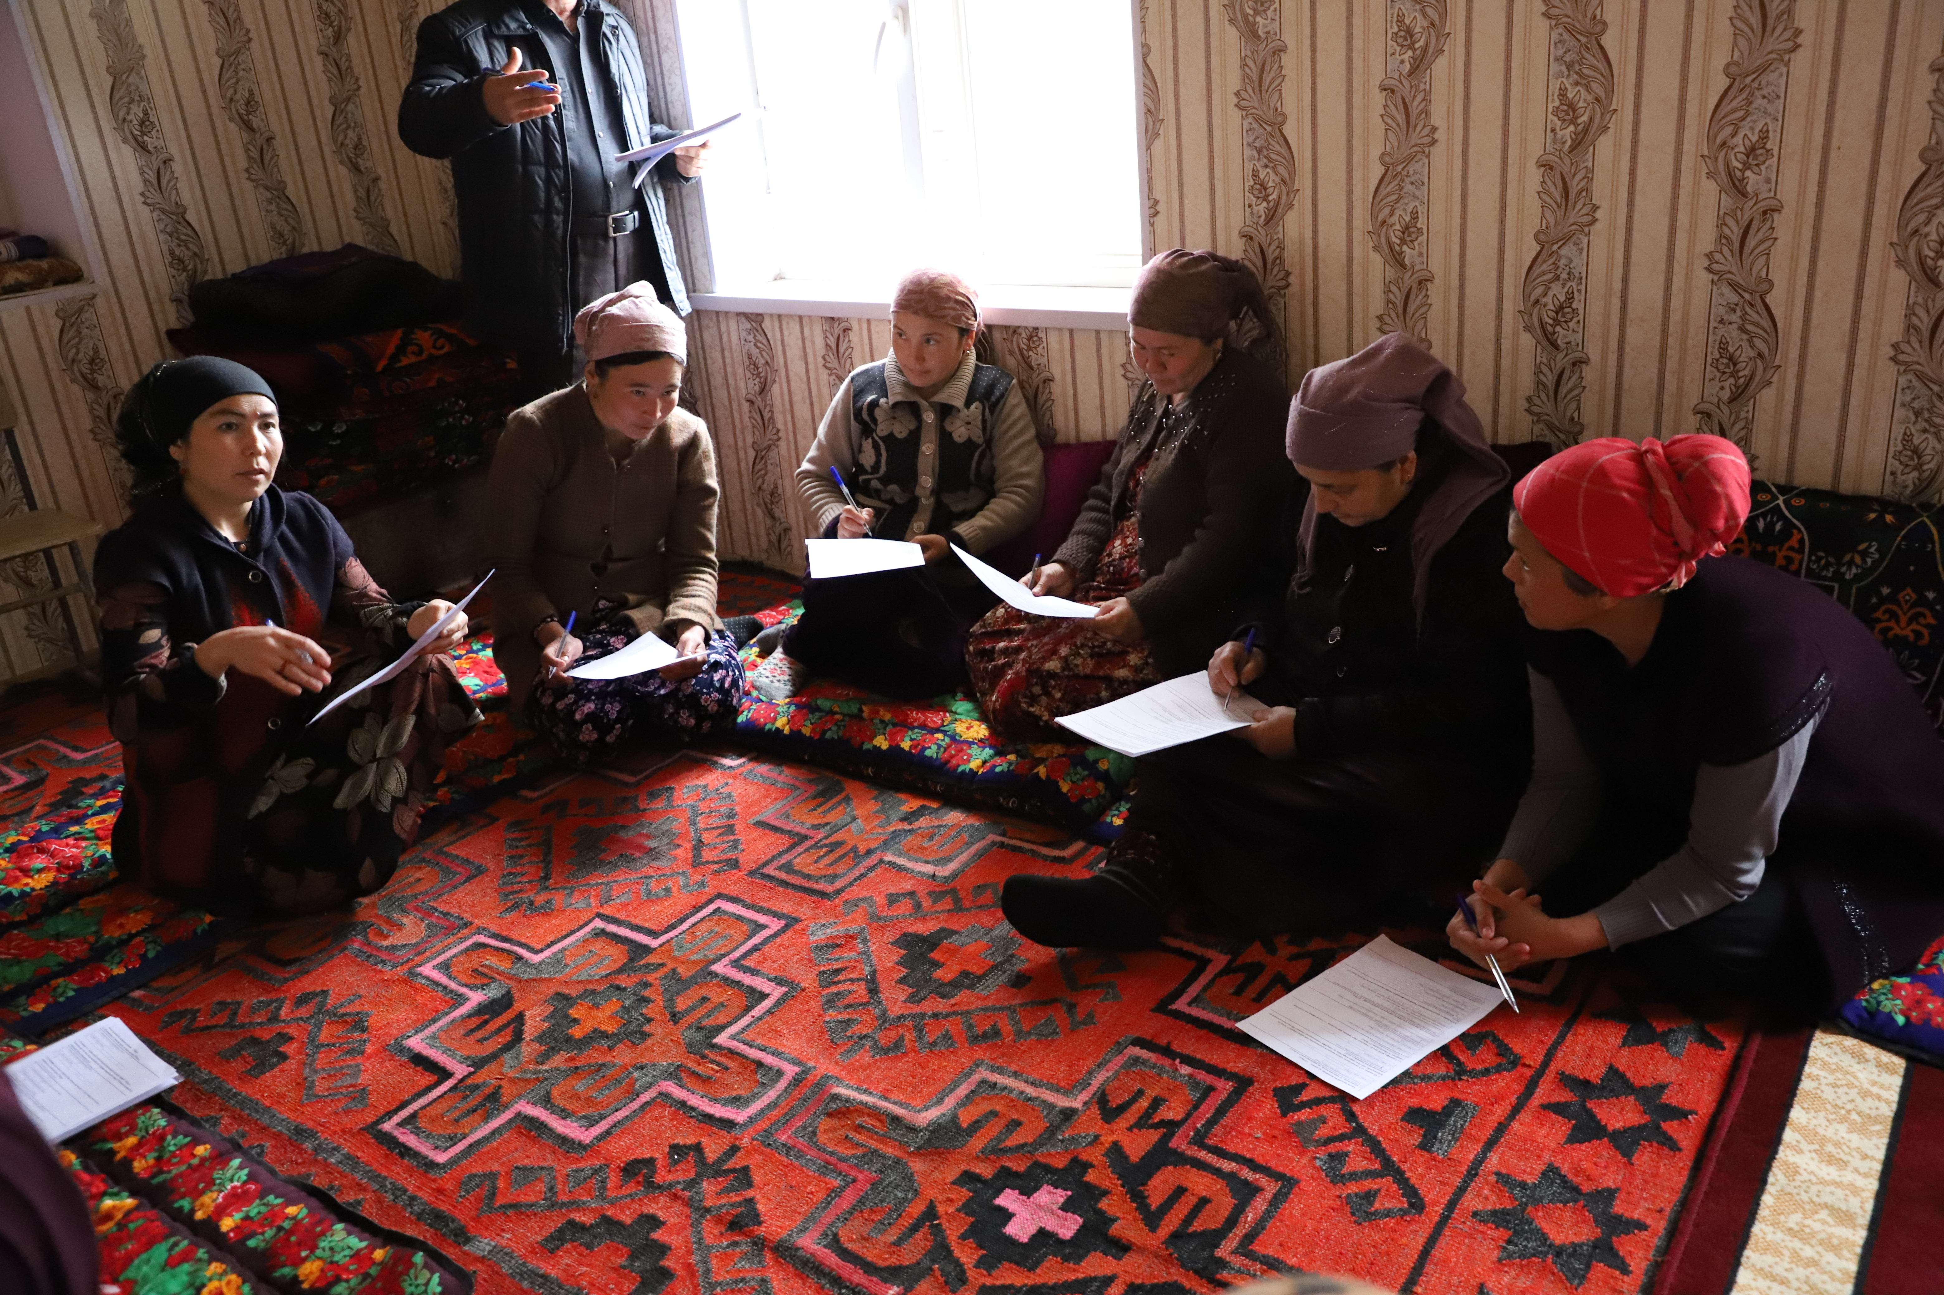
Figure 1 Population of Kushtegirmon village, Spitamen district

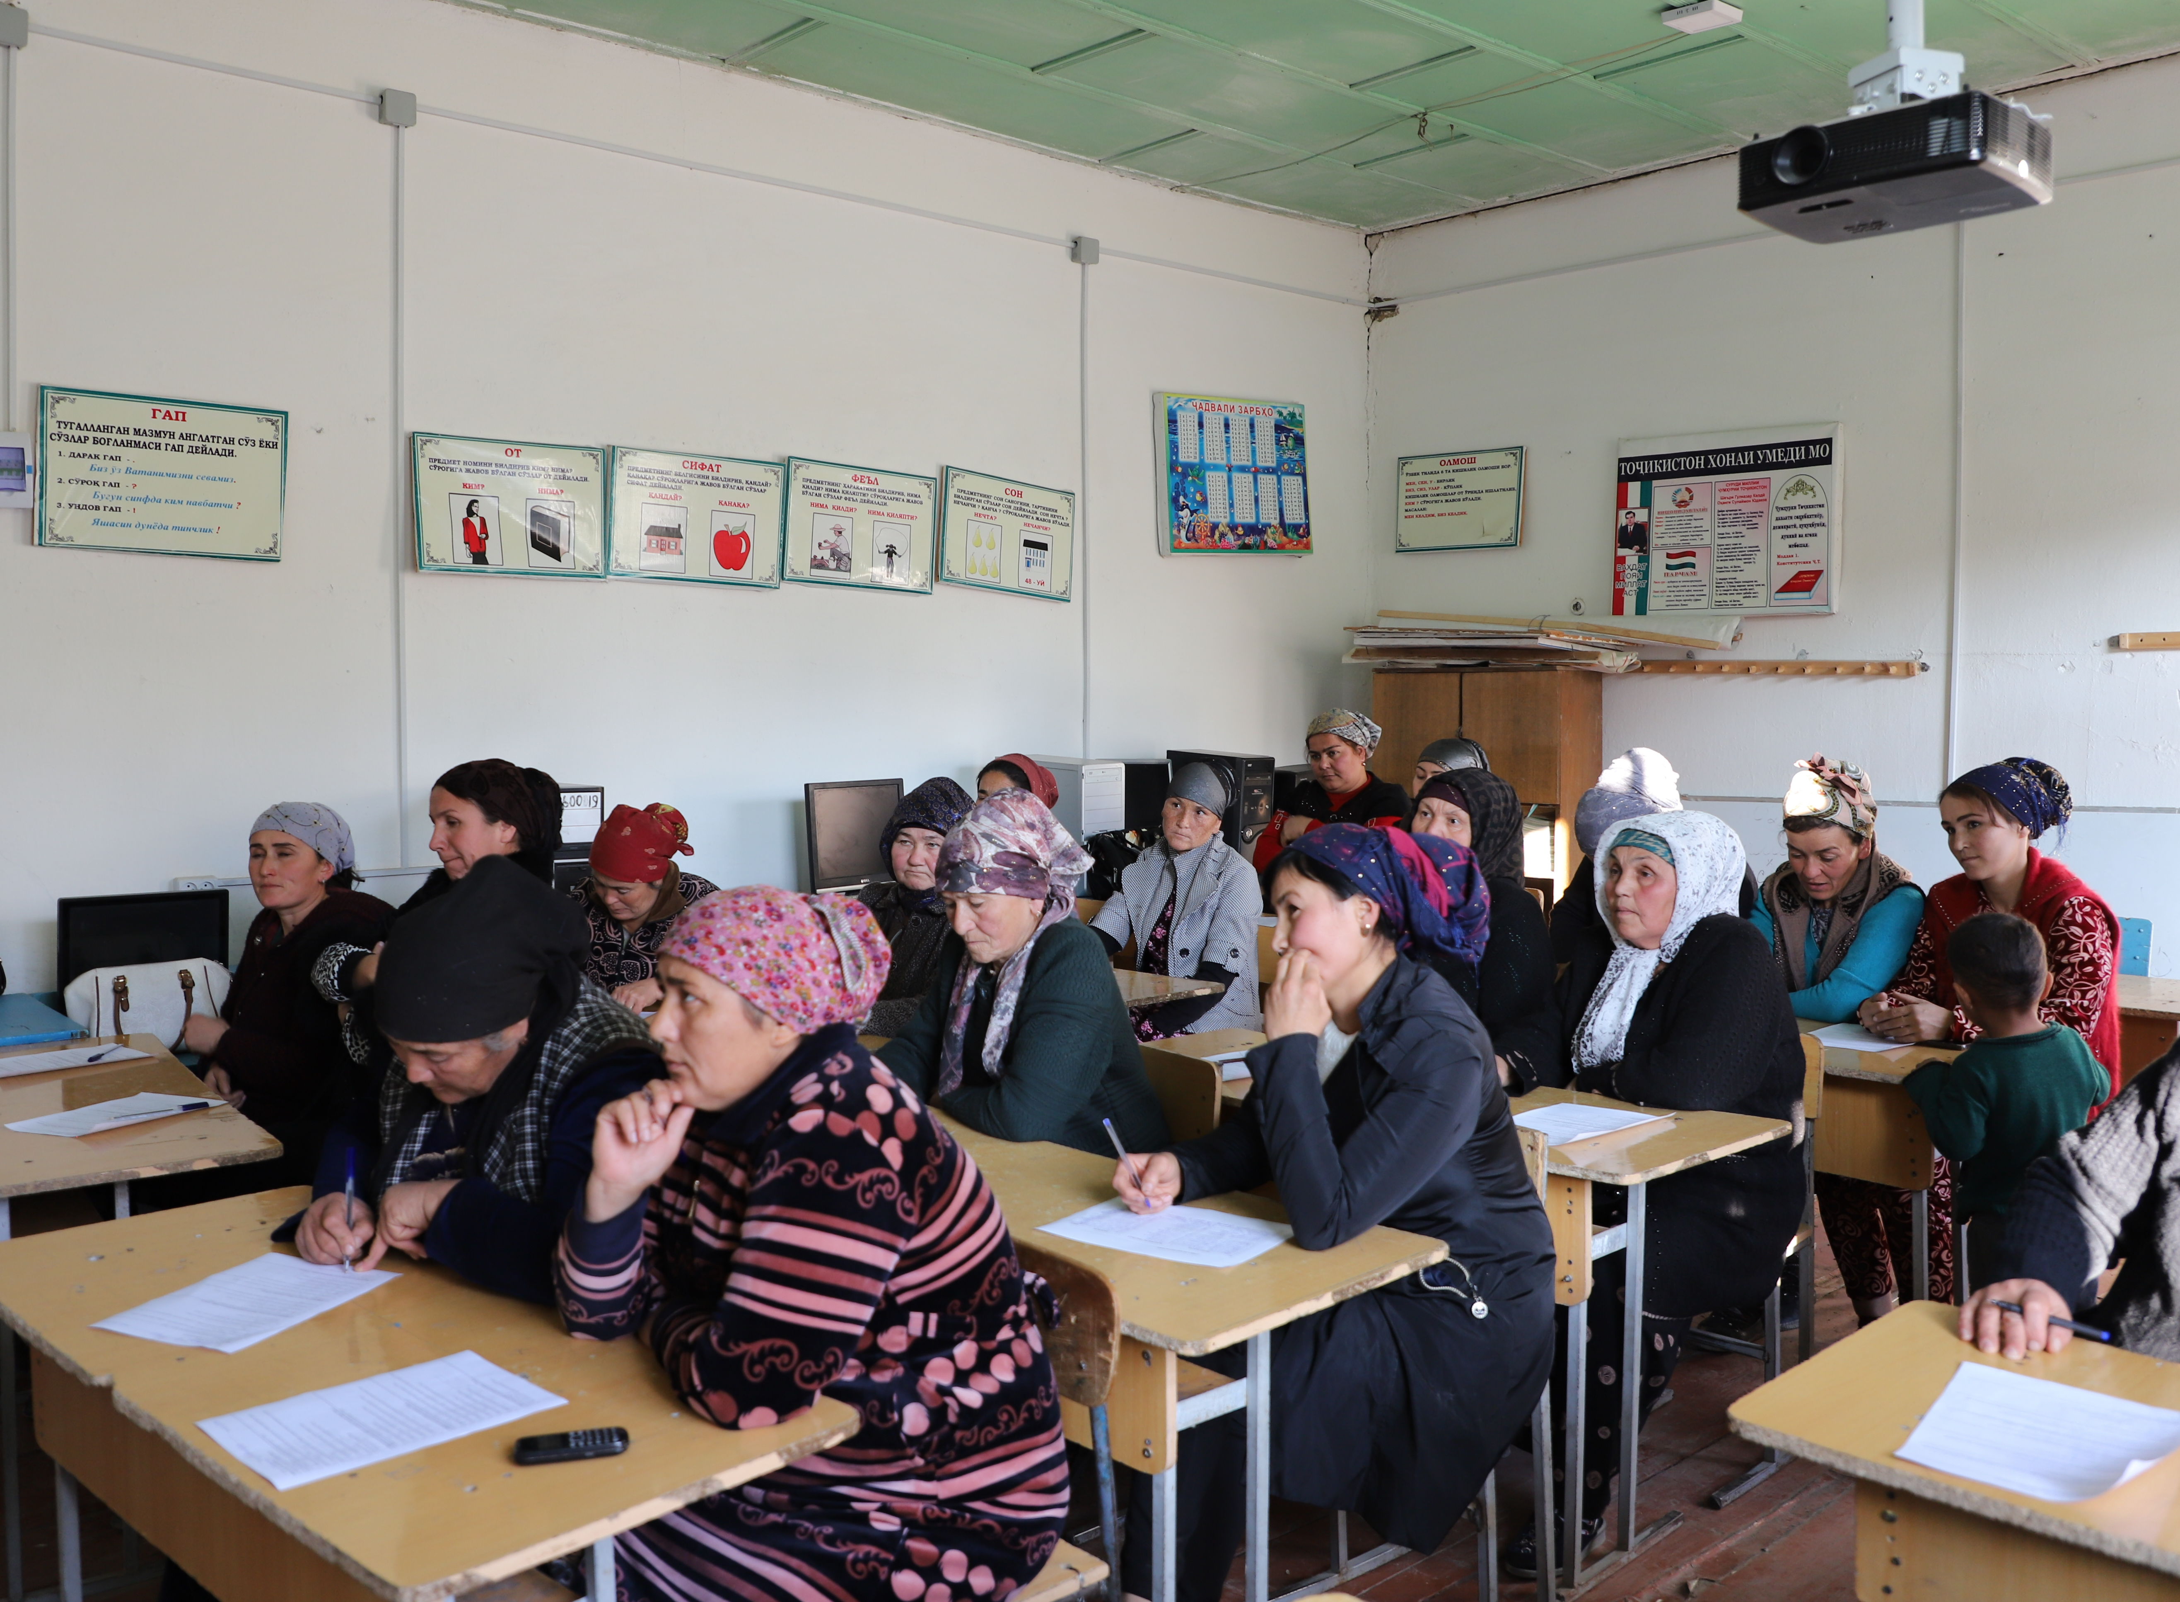
Figure 2. Population of Lolazor RHC, Devashtich district insert date

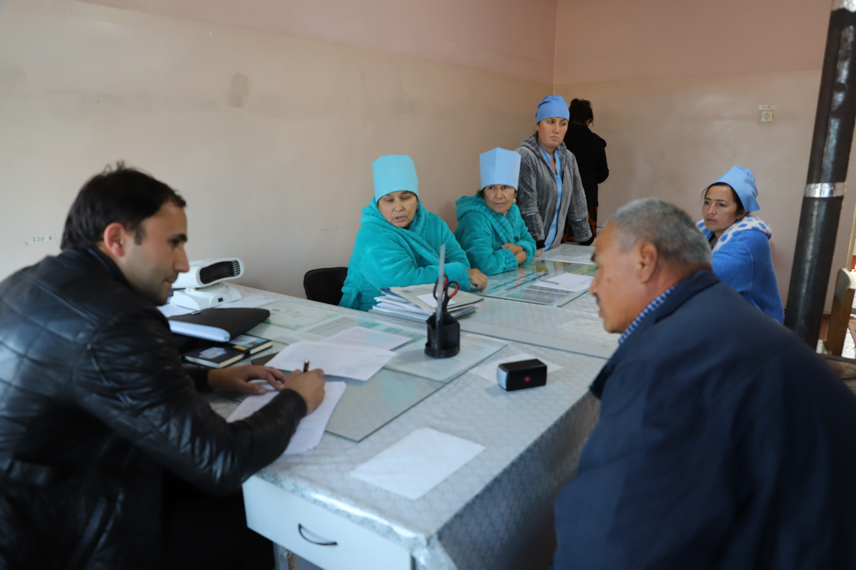
Figure 3. Lolazor RHC personnel, Devashtich district, insert date

Annex 2. Minutes of Stakeholder Consultations on E&S instruments in Gazantarak Jamoat, Devashtich District, Sughd Region
Hosted by: HSIP
Date: February 15, 2023
Venue: Gazantarak Jamoat, Devashtich District, Sughd Region
Number of attendants: 15 persons (9 women) consumers of medical services
Objective:
- To inform key stakeholders about the expected activities under the Millati Solim Project and the measures taken to ensure environmental and social security. Disclosure of drafts of social and environmental assessment reports.
- To obtain stakeholders comments and feedback on the entire package of documents to be disclosed.

Agenda:
- Welcome speech, Deputy Head of the Primary Health Care Network of Devashtich District, Project Implementation Specialist in Sughd Region
- Basic information about the scheduled activities under the Millati Solim Project. (Speech by Shokirov F.);
- Participants polling (Pulatova G.).

Familiarization with the Millati Solim Project was organized for key stakeholders and provided at the level of representatives of the district health center, citizens having access to PHC services.
The event was opened by Tuychiev K., Deputy Head of the Devashtich PHC Network, he welcomed all the participants, expressed gratitude to the Health Services Improvement Project for the support provided to the healthcare sector and briefly informed attendants about the HSIP activities carried out in this sector.
In his speech, Shokirov F., Implementation Specialist, HSIP in the Sughd Region, noted that the purpose of public consultations is to provide basic information about the expected activities under the Millati Solim Project and review key project documents prepared as the basic warranties of the social and environmental safety under the project. In his speech, Shokirov F. noted the WB environmental and social safeguards, the construction and institutional focuses.
Further, the participants were briefed on topics such as resettlement information, Grievance Redress Mechanism (GRM), Electronic Patient Register, health emergency preparedness and response. Then, the participants were given a questionnaire.
Question 1. Do you agree to resettlement if a hospital or an RHC will be constructed at the place of your residence or your house?
Yes - 12 persons, No - 5 persons
Question 2. Do you have information about the procedure for citizens appeals?
Yes - 0 persons, no - 15 persons
Question 3. If you have any complaints or suggestions, where would you like to apply?
– Box of complaints and suggestions - 6 persons, in the DHC - 12 persons
Question 4. Do you have information about the "electronic register" or not?
No - 15 persons
Question 5. Do your health facilities have the proper conditions, satisfying or not satisfying you? Does your health facility have a washbasin, water supply, toilet and is everything operational or not?
Yes – 12 pers., No – 3 persons
Khidoyatova M., a resident of the Kalachai Rais village put a question - What is an electronic register? Avyasov T., PBF MIS Data Monitoring Specialist explained that it is scheduled to implement special Software where medical data on patient diseases, treatment, and vaccinations will be entered.
At the end of the event, the participants were asked to provide their comments on the presented materials in writing.
All parties involved were satisfied with public hearings and expressed their hope that the implementation of the Millati Solim Project would make a positive contribution to strengthening the district PHC.
Sample questionnaire and a list of participants are below.

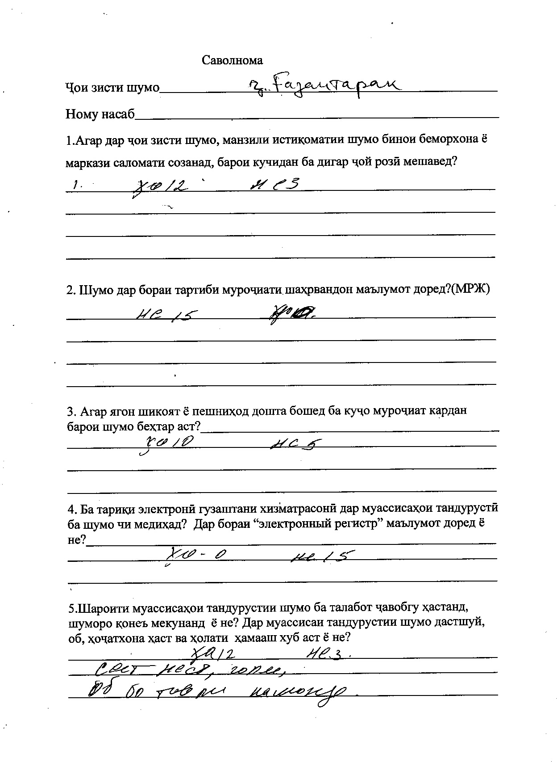
List of participants of Gazantarak Jamoat, Devashtich District, Sughd Region

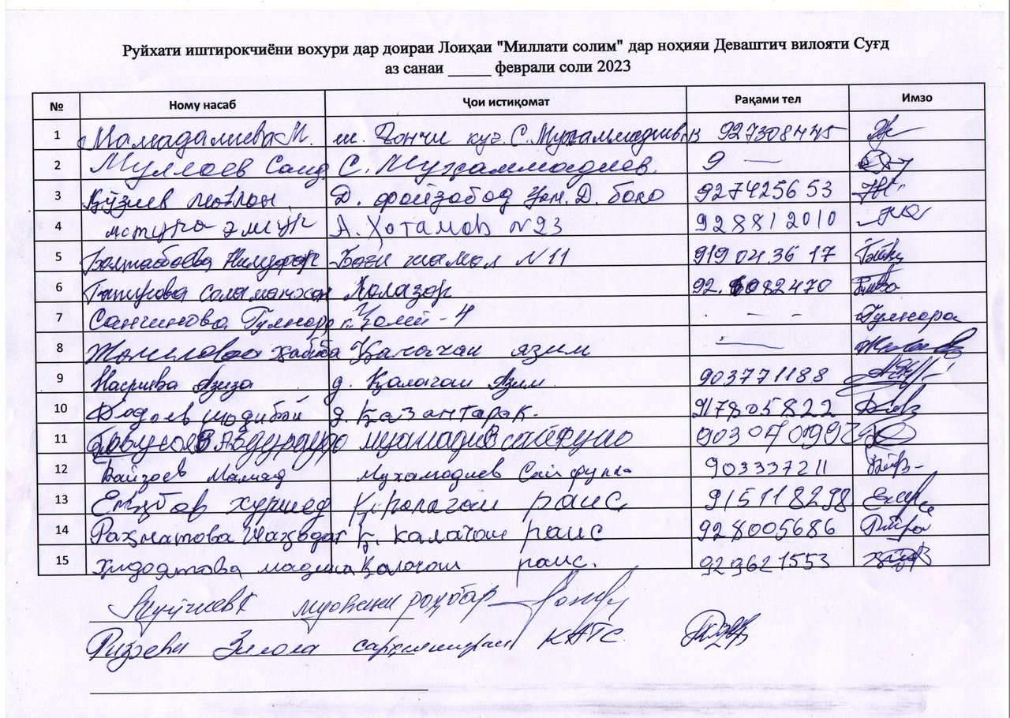

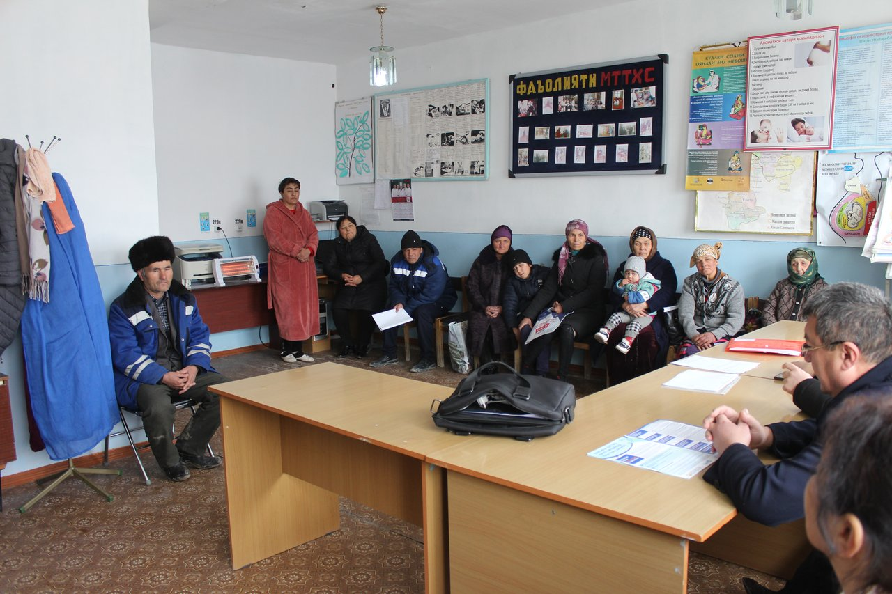
Figure 4 Consultations in Gazantarak Jamoat, Devashtich District, Sughd Region

Annex 3. Minutes of Stakeholder Consultations on E&S instruments Yakhtan Jamoat, Devashtich District, Sughd Region
Hosted by: HSIP
Date: February 15, 2023
Venue: Yakhtan Jamoat, Devashtich District, Sughd Region
Number of attendants: 16 persons (11 women)
Objective:
- To inform key stakeholders about the expected activities under the Millati Solim Project and the measures taken to ensure environmental and social security. Disclosure of drafts of social and environmental assessment reports.
- To obtain stakeholders comments and feedback on the entire package of documents to be disclosed.

Agenda:
- Welcome speech, Deputy Head, PHC Network, Devashtich District, Project Implementation Specialist in Sughd Region
- Basic information about the scheduled activities under the Millati Solim Project. (Speech by Shokirov F.);
- Participants polling (Pulatova G.).

Familiarization with the Millati Solim Project was organized for key stakeholders and provided at the level of representatives of the district health center, citizens having access to PHC services.
The event was opened by Tuichiev K., Deputy Head, PHC Network, Devashtich District, he welcomed all the participants and expressed gratitude to the Health Services Improvement Project for the support provided to the healthcare sector and briefly informed attendants about the HSIP activities carried out in this sector.
In his speech, Shokirov F., Implementation Specialist, HSIP in the Sughd Region, noted that the purpose of public consultations is to provide basic information about the expected activities under the Millati Solim Project and review key project documents prepared as the basic warranties of the social and environmental safety under the project. In his speech, Shokirov F. noted the WB environmental and social safeguards, the construction and institutional focuses.
Further, the participants were briefed on topics such as resettlement information, Grievance Redress Mechanism (GRM), Electronic Patient Register, health emergency preparedness and response. Then, the participants were given a questionnaire.
Question 1. Do you agree to resettlement if a hospital or an RHC will be constructed at the place of your residence or your house?
Yes - 11 persons, No - 5 persons
Question 2. Do you have information about the procedure for citizens appeals?
Yes - 2 persons, no - 14 persons
Question 3. If you have any complaints or suggestions, where would you like to apply?
– Complaints and Suggestions Box - 4 persons, in the DHC - 12 persons
Question 4. Do you have information about the "electronic register" or not?
No - 16 persons
Question 5. Do your health facilities have the proper conditions, satisfying or not satisfying you? Does your health facility have a washbasin, water supply, toilet and is everything operational or not?
Yes – 16 persons
Ergashev R., a Khushtoiri Mughlon Village resident thanked the HSIP for the support provided in equipping, improving the RHC sanitary and hygienic conditions and improving the quality of health services provided in this Jamoat.
At the end of the event, the participants were asked to provide their comments on the presented materials in writing.
Yakhtan Jamoat Chairman assured that the local population would support the project implementation.
All parties involved were satisfied with public hearings and expressed their hope that the implementation of the Millati Solim Project would make a positive contribution to strengthening the district PHC.

List of participants of the meeting is below.

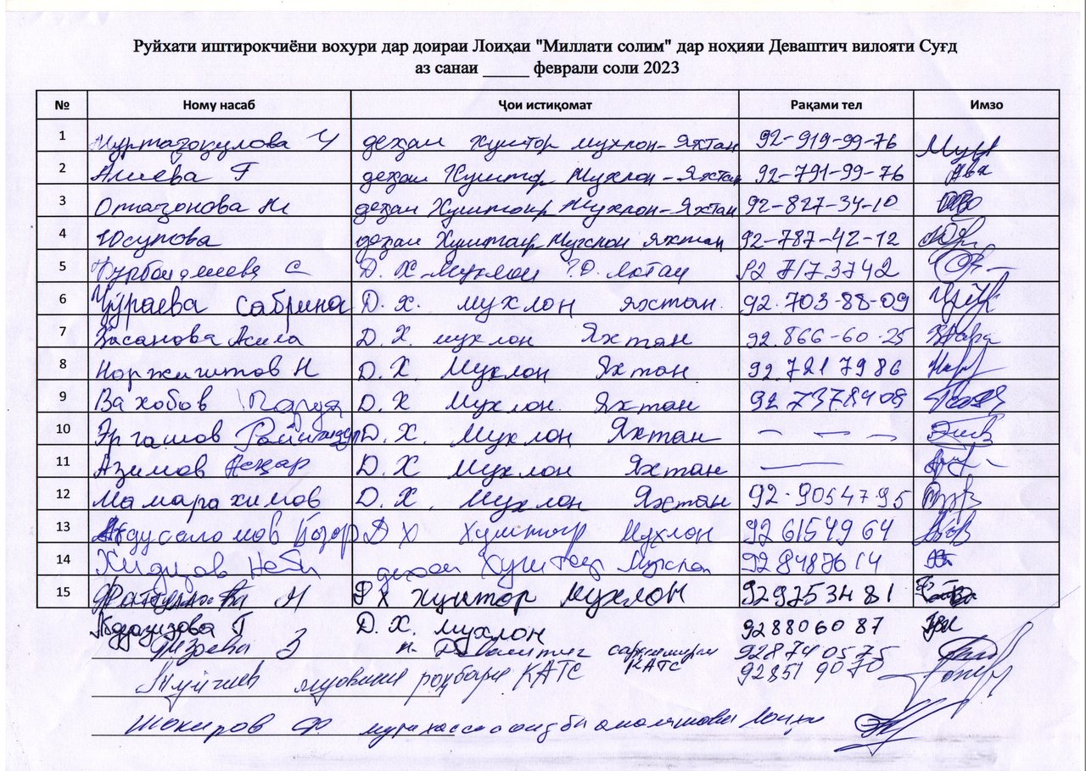

Annex 4. Minutes of Stakeholder Consultations on E&S instruments Kurush Jamoat, Spitamen District, Sughd Region

Hosted by: HSIP
Date: February 16, 2023
Venue: Kurush Jamoat, Spitamen District, Sughd Region
Number of attendants: 16 persons (13 women)
Objective:
- To inform key stakeholders about the expected activities under the Millati Solim Project and the measures taken to ensure environmental and social security. Disclosure of drafts of social and environmental assessment reports.
- To obtain stakeholders comments and feedback on the entire package of documents to be disclosed.

Agenda:
- Welcome speech, Head Physician, Kurkat RHC, Spitamen District, Project Implementation Specialist in Sughd Region
- Basic information about the scheduled activities under the Millati Solim Project. (Speech by Shokirov F.);
- Participants polling (Pulatova G.).

Familiarization with the Millati Solim Project was organized for key stakeholders and provided at the level of representatives of the district health center, citizens having access to PHC services.
The event was opened by Karaboeva Kh., Head Physician, Kurkat RHC, Spitamen District, she welcomed all the participants, expressed gratitude to the Health Services Improvement Project for the support provided to the healthcare sector and briefly informed attendants about the HSIP activities carried out in this sector.
In his speech, Shokirov F., Implementation Specialist, HSIP in the Sughd Region, noted that the purpose of public consultations is to provide basic information about the expected activities under the Millati Solim Project and review key project documents prepared as the basic warranties of the social and environmental safety under the project. In his speech, Shokirov F. noted the WB environmental and social safeguards, the construction and institutional focuses.
Further, the participants were briefed on topics such as resettlement information, Grievance Redress Mechanism (GRM), Electronic Patient Register, health emergency preparedness and response. Then, the participants were given a questionnaire.
Question 1. Do you agree to resettlement if a hospital or an RHC will be constructed at the place of your residence or your house?
Yes - 1 persons, No - 15 persons
Question 2. Do you have information about the procedure for citizens appeals?
Yes - 0 persons, no - 15 persons
Question 3. If you have any complaints or suggestions, where would you like to apply? – Complaints and Suggestions Box - 3 persons, in the DHC - 13 persons
Question 4. Do you have information about the "electronic register" or not?
No - 16 persons
Question 5. Do your health facilities have the proper conditions, satisfying or not satisfying you? Does your health facility have a washbasin, water supply, toilet and is everything operational or not?
Yes – 16 pers., No – 0 persons
Kurbanova M., a Kurush Jamoat resident put a question – Where complaints can be submitted, if arise? She was given the answer that in all RHCs of the district there are boxes for receiving complaints from citizens, and there are also booklets with phone numbers and the GRM website link.
At the end of the event, the participants were asked to provide their comments on the presented materials in writing.
All parties involved were satisfied with public hearings and expressed their hope that the implementation of the Millati Solim Project would make a positive contribution to strengthening the district PHC.

The list of participants is below

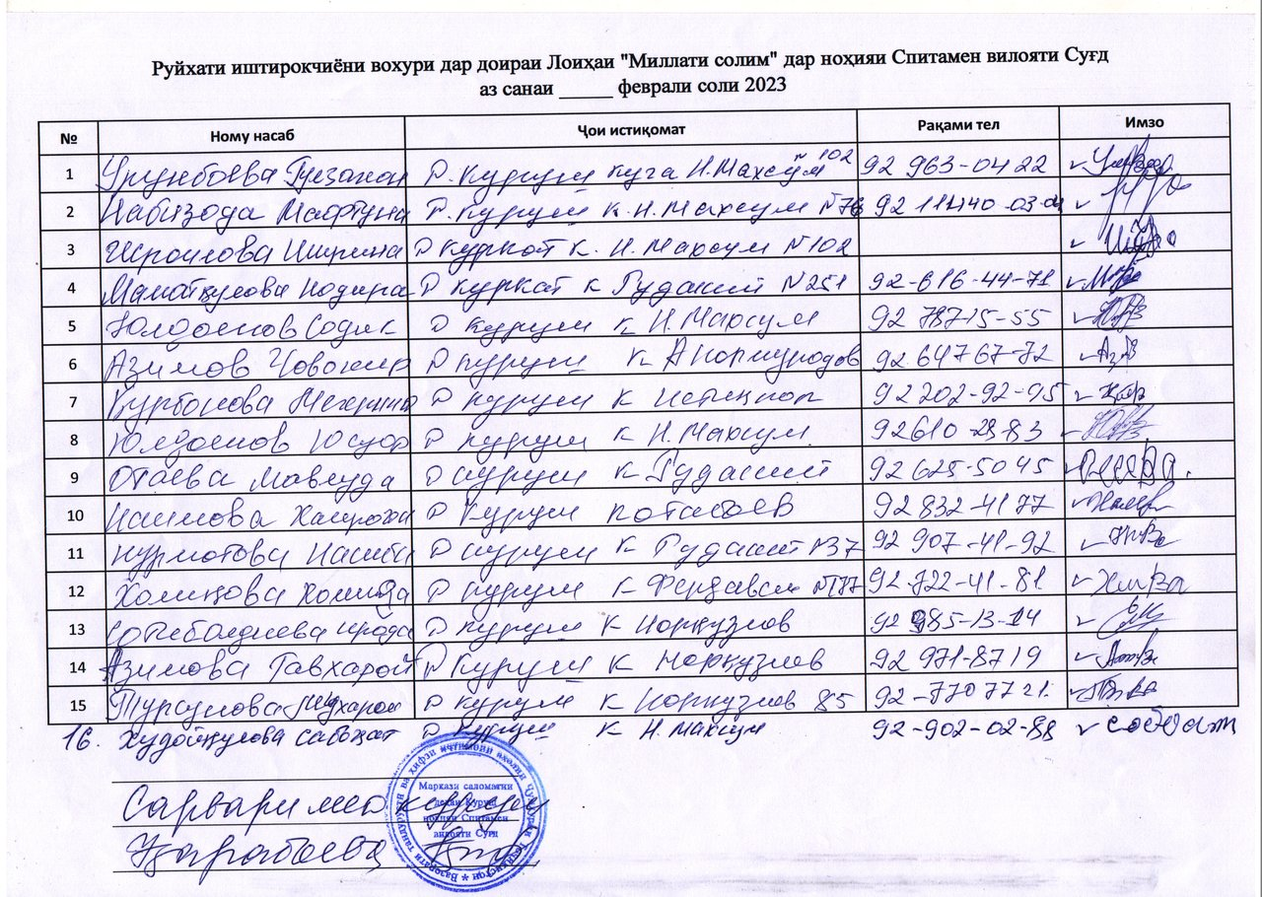

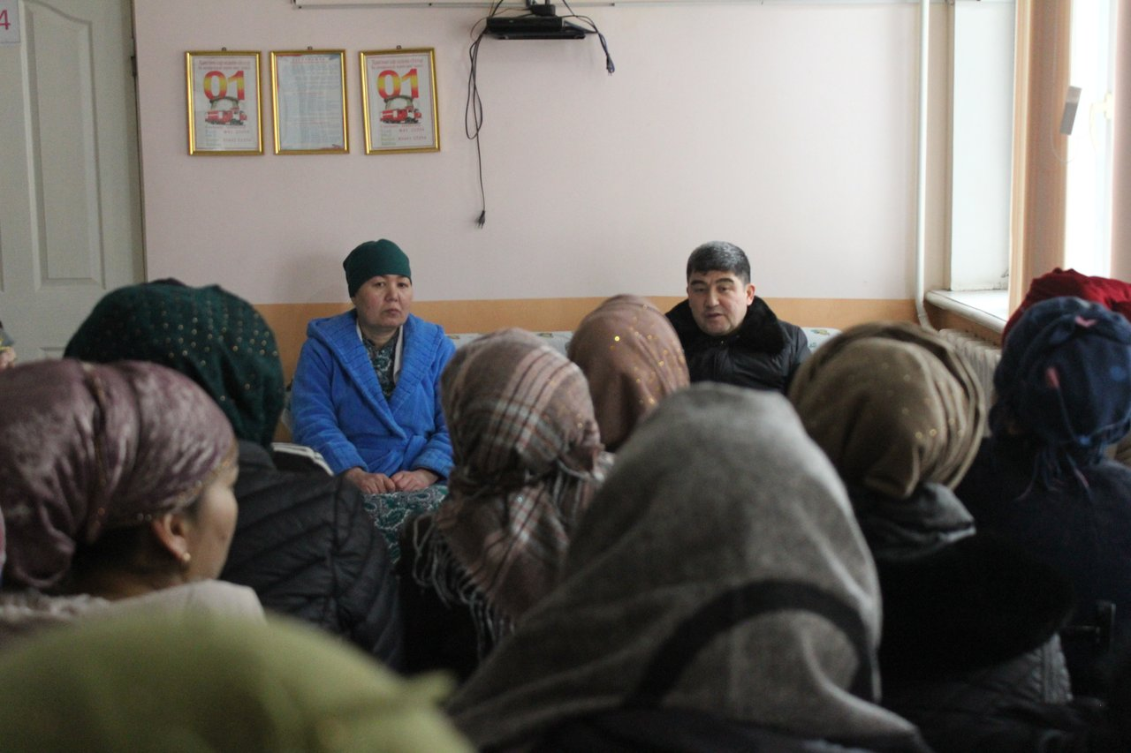
Figure 5. Consultations in Kurush Jamoat, Spitamen District, Sughd Region

Annex 5. Minutes of Stakeholder Consultations on E&S instruments Yangiobod Jamoat, Spitamen District, Sughd Region
Hosted by: HSIP
Date: February 16, 2023
Venue: Yangiobod Jamoat, Spitamen District, Sughd Region
Number of attendants: 11 persons (8 women)
Objective:
- To inform key stakeholders about the expected activities under the Millati Solim Project and the measures taken to ensure environmental and social security. Disclosure of drafts of social and environmental assessment reports.
- To obtain stakeholders comments and feedback on the entire package of documents to be disclosed.

Agenda:
- Welcome speech, Acting Head Physician, Andarsoy RHC, Spitamen District, Project Implementation Specialist in Sughd Region
- Basic information about the scheduled activities under the Millati Solim Project. (Speech by Shokirov F.);
- Participants polling (Pulatova G.).

Familiarization with the Millati Solim Project was organized for key stakeholders and provided at the level of representatives of the district health center, citizens having access to PHC services.
The event was opened by Kholmatova M., Acting Head Physician, Andarsoy RHC, Spitamen District, she welcomed all the participants, expressed gratitude to the Health Services Improvement Project for the support provided to the healthcare sector.
In his speech, Shokirov F., Implementation Specialist, HSIP in the Sughd Region, noted that the purpose of public consultations is to provide basic information about the expected activities under the Millati Solim Project and review key project documents prepared as the basic warranties of the social and environmental safety under the project. In his speech, Shokirov F. noted the WB environmental and social safeguards, the construction and institutional focuses.
Further, the participants were briefed on topics such as resettlement information, Grievance Redress Mechanism (GRM), Electronic Patient Register, health emergency preparedness and response. Then, the participants were given a questionnaire.
Question 1. Do you agree to resettlement if a hospital or an RHC will be constructed at the place of your residence or your house?
Yes - 0 persons, No - 11 persons
Question 2. Do you have information about the procedure for citizens appeals?
Yes - 4 persons, no - 7 persons
Question 3. If you have any complaints or suggestions, where would you like to apply?
– DHC, SHSPSS - 1 person, in RHC - 10 persons
Question 4. Do you have information about the "electronic register" or not?
No - 10 persons, Yes – 1 person
Question 5. Do your health facilities have the proper conditions, satisfying or not satisfying you? Does your health facility have a washbasin, water supply, toilet and is everything operational or not?
Yes – 11 persons, No – 0 persons
Zikriyoev M., a Yangiobod Jamoat resident thanked the HSIP for the support provided in equipping, improving the RHC sanitary and hygienic conditions and improving the quality of health services provided in this Jamoat.
At the end of the event, the participants were asked to provide their comments on the presented materials in writing.
All parties involved were satisfied with public hearings and expressed their hope that the implementation of the Millati Solim Project would make a positive contribution to strengthening the district PHC.
Sample questionnaire is attached.
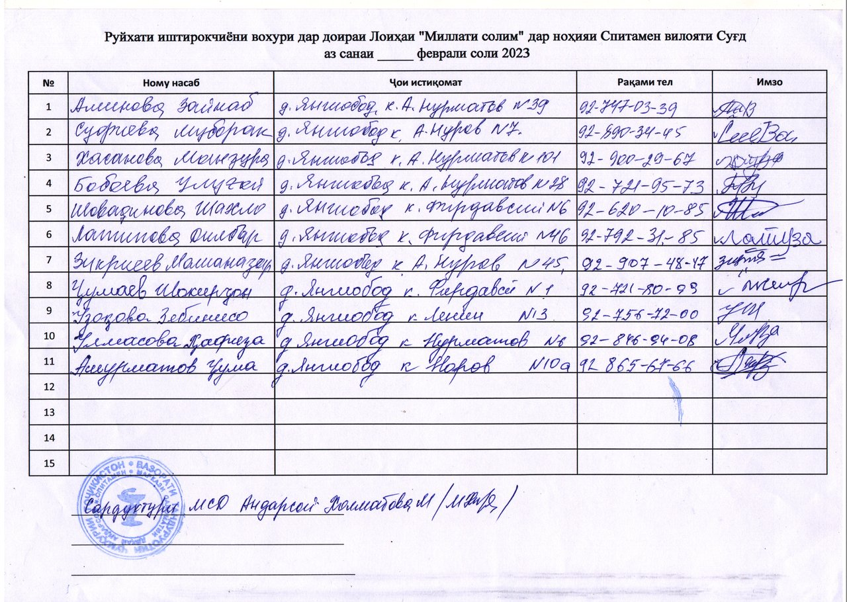

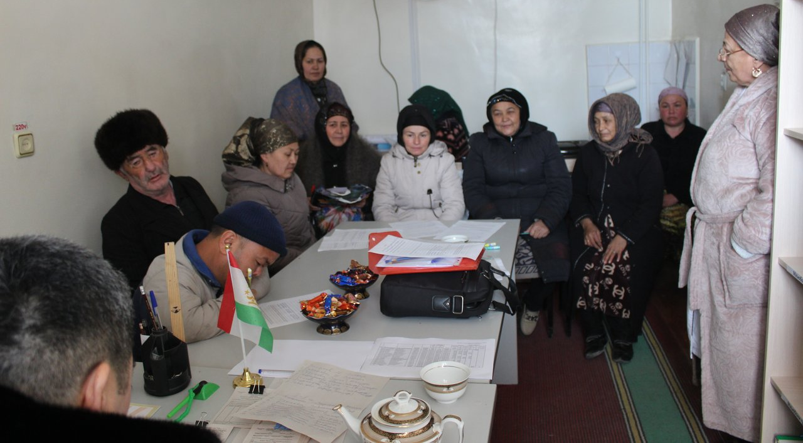
Figure 6. Consultation in Yangiobod Jamoat, Spitamen District, Sughd Region

Annex 6. Minutes of Stakeholder Consultations on E&S instruments Navobod Jamoat, J. Balkhi District, Khatlon region
Hosted by: HSIP
Date: February 15, 2023, 9:00- 12:00
Venue: Navobod RHC hall, Navobod Jamoat, J. Balkhi District
Number of attendants: 53 persons (47 women)
Working language: official language (Tajik)
Objective:
- To inform key stakeholders about the expected activities under the Millati Solim Project and the measures taken to ensure environmental and social safeguards. Disclosure of drafts of social and environmental assessment reports.
- To obtain beneficiary comments and feedback on all components under the Tajikistan Millati Solim Project.

Agenda:
- Welcome speech, Doliev S.R., HSIP Implementation Specialist in Khatlon Region;
- Basic information about the scheduled activities under the Tajikistan Millati Solim Project (Doliev S.R., HSIP Implementation Specialist in Khatlon Region);
- Presentation, Social and Environmental Commitment Plan; (Asrorov D.R., PBF HMIS Data Monitoring Specialist in Khatlon Region);
- Presentation, Procedures Regulations of Labor-Management Relations (Shukurov M.N. – PBF Specialist in Khatlon Region);
- Presentation document: Stakeholder Engagement Plan, (Doliev S. R., HSIP Implementation Specialist in Khatlon Region);
- Presentation: Environmental and Social Management Framework (Asrorov D. R., PBF HMIS Data Monitoring Specialist in Khatlon Region);
- Presentation: Resettlement Framework (Asrorov D.R., PBF HMIS Data Monitoring Specialist in Khatlon Region);
- Beneficiaries key takeaways and comments.

Meeting with citizens was organized for beneficiaries of the Project's services both for citizens and the PHC health staff.
The event was opened by Doliev S.R., HSIP Implementation Specialist in Khatlon Region, he welcomed all the participants, expressed gratitude to the Government of the Republic of Tajikistan, WB and MOHSP for the support provided to the Tajikistan health sector and briefly informed attendants about activities of the Government of the Republic of Tajikistan carried out in the health sector. In particular, it was said that the purpose of this meeting is to provide basic information about the expected activities under the Millati Solim: Tajikistan - healthy nation Project and review key project documents prepared as the basic environment and social safeguards of the project. Further, Doliev S. R. noted about the environmental and social safeguard policy, about the construction and institutional orientation of the project in strengthening the primary health care system. It was suggested that the meeting participants take an active part and provide their proposals on the presented materials.
In his speech, he noted that the purpose of public consultations is to provide basic information about the expected activities under the Tajikistan Millati Solim Project and Project goals, objectives and components, phased WB support to Tajikistan health sector, main project beneficiaries and pilot districts to be supported under the Project.
D. R. Asrorov, PBF HMIS Data Monitoring Specialist in Khatlon Region presented information on the environmental and social aspects of the Project. He mentioned the WB requirements for the identification and assessment of social and environmental risks and impacts associated with projects. It was noted that the main purpose of this event is to inform population about the expected project activities, to get feedback and proposals on the presented project materials.
Further, Doliev S.R., HSIP Implementation Specialist in Khatlon Region, in his speech on the Stakeholder Engagement Plan, noted that this document was prepared in order to identify all parties interested in the project, to establish close and constructive interaction with them and develop an appropriate engagement framework, taking into account their views and needs. It was noted that the introduction of this mechanism under the project, as well as the feedback mechanism, will improve transparency and accountability in the sector.
Asrorov D. R., PBF HMIS Data Monitoring Specialist in Khatlon Region, presented the Environmental and Social Management Framework. He provided information on WB requirements and legal regulations of the Republic of Tajikistan requiring environmental and social assessment. It was said that the document sets out the expected environmental and social risks and impacts associated with the project, defines measures to prevent risks and manage negative impacts.
Shukurov M.N., PBF Specialist in Khatlon Region, in his presentation on Procedures Regulations of Labor-Management Relations said that this document is as a tool to manage the risks that may arise in relation to the recruitment and working conditions of project employees. Speaker told that the document was developed in accordance with the requirements of SES 2. "Labor and working conditions" and defines the main requirements in the field of labor legislation and the risks associated.
Asrorov D. R., PBF HMIS Data Monitoring Specialist in Khatlon Region provided listeners with information about the Resettlement Framework with an overview of the WB and the Republic of Tajikistan policies and procedures related to the issues of land acquisition, restriction of land use rights and involuntary resettlement.
It should be noted that all the materials provided to the participants of the event were presented as slides in Power Point format in a compressed form.
At the end of the event, the participants were asked to provide their feedback on the presented materials in writing.
Participants put the following questions:
1. What is the citizen engagement mechanism in the project implementation process?
2. How the health staff will be involved in the project implementation process?
3. In villages where there is no health facility or it is located at a remote distance from the nearest health facility, how the project will be implemented? Is it possible to construct there a health facility under the project, for example, in Kzyl Namuna village, Lenin Yul village, Urtabuz, Chorbog, Karaboy, 1 brigade village?
4. In Pushkin village, the Health House is in critical condition and even is not subject to rehabilitation. Will a new building of the Health House be constructed under the project?
5. In presentation, it was mentioned payment of compensation in case of natural disaster, how it works?

Satisfactory answers were given to the questions received by speakers. Discussions took place in a lively atmosphere.
All parties involved were satisfied with public hearings and expressed their hope that the project implementation would make a positive contribution to improving the level, quality and volume of healthcare provided to the population at the primary health care level and strengthening their physical infrastructure.
List of participants and photos are attached.
Doliev S.R., HSIP Implementation Specialist
Asrorov D.R., PBF MIS Data Monitoring Specialist
Shukurov M.N., PBF Specialist
List of participants
# | Navobod Jamoat
1 | Aliev Manon
2 | Sattorova Khairiniso
3 | Bokiyeva Oybibi
4 | Saidaliev Shamsuddin
5 | Hasanova Shahlo
6 | Raqabova Khairi
7 | Zoirova Halima
8 | Gulmakhmadova Zebo
9 | Abdukhamidova Zamira
10 | Nazrieva Farzona
11 | Kamolova Dilraba
12 | Yusupova Gulobru
13 | Alisher Abdumirzo
14 | Saidova Mohpari
15 | Rakhimova Rano
16 | Rasulova Safarmo
17 | Kurbonova Mayram
17 | Zubaidova G
19 | Mahmadalieva Z
20 | Zubaydova Sharif
21 | Holova S
22 | Saidova K
23 | Nazrieva R
24 | Gulomova Sh
25 | Nosirova D
26 | Turaeva M
27 | Holova h
28 | Kurbonov X
29 | Sharipov Z
30 | Narzulloeva U
31 | Boeva A
32 | Saidova D
33 | Makhmaraqabova Sh
34 | Saidova F
35 | Azizova F
36 | Saidova M
37 | Zokirova M
38 | Fayzulloeva X
39 | Saidova R
40 | Sharipova Sh
41 | Halimova O
42 | Rahimov X
43 | Turaeva M
44 | Salimova M
45 | Hamidova Sh
46 | Hamidova G
47 | Uzbekova S
48 | Rakhimova F
49 | Holmurodova S
50 | Holmurodova M
51 | Mirzoeva Tuti
52 | Turaeva Farzona
53 | Nazarova Nasiba

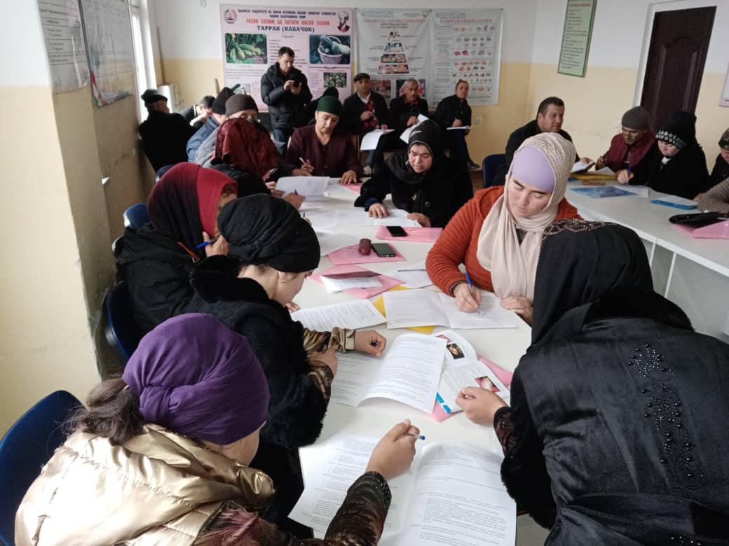
Figure 7. Consultation in Navobod Jamoat, J. Balkhi District

Annex 7. Minutes of Stakeholder Consultations on E&S instruments Guliston Jamoat, J. Balkhi District, Khatlon region
Hosted by: HSIP
Date: February 15, 2023, 14:00- 17:00
Venue: Guliston RHC hall, Guliston Jamoat, J. Balkhi District
Number of attendants: 39 persons (26 women)
Working language: official language (Tajik)
Objective:
- To inform key stakeholders about the expected activities under the Millati Solim Project and the measures taken to ensure environmental and social safeguards. Disclosure of drafts of social and environmental assessment reports.
- To obtain beneficiary comments and feedback on all components under the Tajikistan Millati Solim Project.

Agenda:
- Welcome speech, Doliev S.R., HSIP Implementation Specialist in Khatlon Region;
- Basic information about the scheduled activities under the Tajikistan Millati Solim Project (Doliev S.R., HSIP Implementation Specialist in Khatlon Region);
- Presentation, Social and Environmental Commitment Plan; (Asrorov D.R., PBF HMIS Data Monitoring Specialist in Khatlon Region);
- Presentation, Procedures Regulations of Labor-Management Relations (Shukurov M.N. – PBF Specialist in Khatlon Region);
- Presentation document: Stakeholder Engagement Plan, (Doliev S. R., HSIP Implementation Specialist in Khatlon Region);
- Presentation: Environmental and Social Management Framework (Asrorov D. R., PBF HMIS Data Monitoring Specialist in Khatlon Region);
- Presentation: Resettlement Framework (Asrorov D.R., PBF HMIS Data Monitoring Specialist in Khatlon Region);
- Beneficiaries key takeaways and comments.

Meeting with citizens was organized for beneficiaries of the Project's services both for citizens and the PHC health staff.
The event was opened by Doliev S.R., HSIP Implementation Specialist in Khatlon Region, he welcomed all the participants, expressed gratitude to the Government of the Republic of Tajikistan, WB and MOHSP for the support provided to the Tajikistan health sector and briefly informed attendants about activities of the Government of the Republic of Tajikistan carried out in the health sector. In particular, it was said that the purpose of this meeting is to provide basic information about the expected activities under the Millati Solim: Tajikistan - healthy nation Project and review key project documents prepared as the basic environment and social safeguards of the project. Further, Doliev S. R. noted about the environmental and social safeguard policy, about the construction and institutional orientation of the project in strengthening the primary health care system. It was suggested that the meeting participants take an active part and provide their proposals on the presented materials.
In his speech, he noted that the purpose of public consultations is to provide basic information about the expected activities under the Tajikistan Millati Solim Projectand Project goals, objectives and components, phased WB support to Tajikistan health sector, main project beneficiaries and pilot districts to be supported under the Project.
D. R. Asrorov, PBF HMIS Data Monitoring Specialist in Khatlon Region presented information on the environmental and social aspects of the Project. He mentioned the WB requirements for the identification and assessment of social and environmental risks and impacts associated with projects. It was noted that the main purpose of this event is to inform population about the expected project activities, to get feedback and proposals on the presented project materials.
Further, Doliev S.R., HSIP Implementation Specialist in Khatlon Region, in his speech on the Stakeholder Engagement Plan, noted that this document was prepared in order to identify all parties interested in the project, to establish close and constructive interaction with them and develop an appropriate engagement framework, taking into account their views and needs. It was noted that the introduction of this mechanism under the project, as well as the feedback mechanism, will improve transparency and accountability in the sector.
Asrorov D. R., PBF HMIS Data Monitoring Specialist in Khatlon Region, presented the Environmental and Social Management Framework. He provided information on WB requirements and legal regulations of the Republic of Tajikistan requiring environmental and social assessment. It was said that the document sets out the expected environmental and social risks and impacts associated with the project, defines measures to prevent risks and manage negative impacts.
Shukurov M.N., PBF Specialist in Khatlon Region, in his presentation on Procedures Regulations of Labor-Management Relations said that this document is as a tool to manage the risks that may arise in relation to the recruitment and working conditions of project employees. Speaker told that the document was developed in accordance with the requirements of SES 2. "Labor and working conditions" and defines the main requirements in the field of labor legislation and the risks associated.
Asrorov D. R., PBF HMIS Data Monitoring Specialist in Khatlon Region provided listeners with information about the Resettlement Framework with an overview of the WB and the Republic of Tajikistan policies and procedures related to the issues of land acquisition, restriction of land use rights and involuntary resettlement.
It should be noted that all the materials provided to the participants of the event were presented as slides in Power Point format in a compressed form.
At the end of the event, the participants were asked to provide their feedback on the presented materials in writing.
Participants put the following questions:
- It was said about providing assistance to poor citizens, large families, orphans and widows under the project, in what kind it would be provided and what is the amount of assistance?
- It is not clear, it was said that citizens will be incentivized and interested in project implementation, under the project. What does it mean?
- As for questions related to medical care or healthcare, we certainly apply to the health facility and get some answer, at least. And regarding issues related to the standard of living, land management, utilities, and natural disasters consequences, whom we can contact, who can provide assistance or solve these problems?
- What is the citizen engagement mechanism in the project implementation process?
- How the health staff will be involved in the project implementation process?
- In presentation, it was mentioned payment of compensation in case of natural disaster, how it works?

Satisfactory answers were given to the questions received by speakers. Discussions took place in a lively atmosphere.
All parties involved were satisfied with public hearings and expressed their hope that the project implementation would make a positive contribution to improving the level, quality and volume of healthcare provided to the population at the primary health care level and strengthening their physical infrastructure.
List of participants and photos are attached.
Doliev S.R., HSIP Implementation Specialist
Asrorov D.R., PBF MIS Data Monitoring Specialist
Shukurov M.N., PBF Specialist

List of the meeting participants:
# | Guliston Jamoat
1 | Ubaydov Ahliddin
2 | Begova Shukron
3 | Zokirova Savri
4 | Sattorova Muhabbat
5 | Eshonkulova Zulfiya
6 | Islomova Nigina
7 | Kosimova Kurbonbi
8 | Eshmirzoev Saifiddin
9 | Yodgorov Dustmurod
10 | Khudchanova Early
11 | Sharipova Shakhnoza
12 | Kholmatova Rohila
13 | Toirova Gulsanam
14 | Rahmonbekova Zamira
15 | Abdurakhimova Sanavbar
16 | Tilloev Ravshan
17 | Holmuminov Murtazokul
18 | Mahmudov to Mehrubon
19 | Rakhmatov Barotali
20 | Berdiyeva Safargulmakh
21 | Hukmatova Shamsia
22 | Sufiev Muhammad
23 | Turakhonova Gulchehra
24 | Odinaeva Rukia
25 | Durmanov Nazarali
26 | Chutova Fotima
27 | Boltaev Shermahmad
28 | Mustafokulova Momogul
29 | Markaev Zhumanazar
30 | Allaberdieva Mahbuba
31 | Kosimova Muhabbat
32 | Allaberdiev Muzaffar
33 | Arapova Mukhabbathon
34 | Ravshanova Lobar
35 | Khamzaev Ergash
36 | Kurbonova Adolathon
37 | Allaberdieva Chamila
38 | Allaberdiev Muzaffar
39 | Amonkulova Mohira

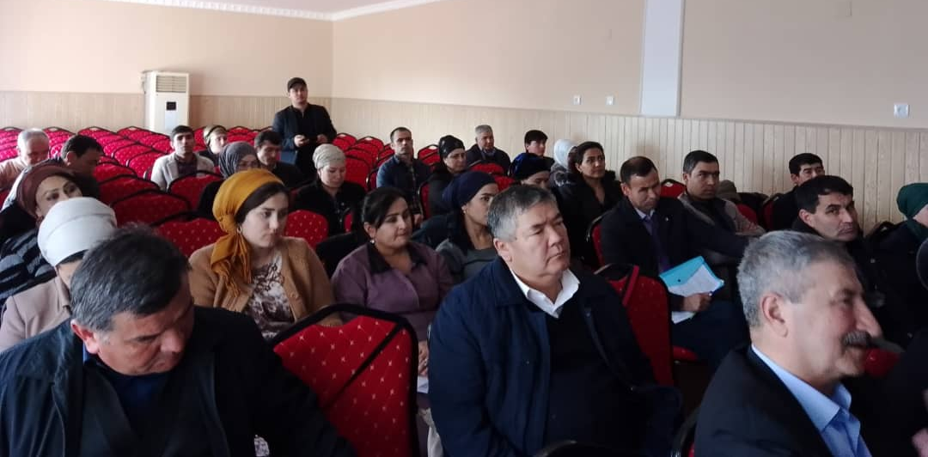
Figure 8. Consultation in Guliston Jamoat, J. Balkhi District

Annex 8. Minutes of Stakeholder Consultations on E&S instruments Fakhrobod Jamoat, Khuroson District, Khatlon region
Hosted by: HSIP
Date: February 17, 2023
Venue: hall of the Fakhrobod HH, Fakhrobod Jamoat, Khuroson District
Number of attendants: 32 persons (23 women)
Working language: official language (Tajik)
Objective:
- To inform key stakeholders about the expected activities under the Millati Solim Project and the measures taken to ensure environmental and social security. Disclosure of drafts of social and environmental assessment reports.
- To obtain beneficiary comments and feedback on all components under the Tajikistan Millati Solim Project.

Agenda:
- Welcome speech, Doliev S.R., HSIP Implementation Specialist in Khatlon Region;
- Basic information about the scheduled activities under the Tajikistan Millati Solim Project (Doliev S.R., HSIP Implementation Specialist in Khatlon Region);
- Presentation, Social and Environmental Commitment Plan; (Asrorov D.R., PBF HMIS Data Monitoring Specialist in Khatlon Region);
- Presentation, Procedures Regulations of Labor-Management Relations (Shukurov M.N. – PBF Specialist in Khatlon Region);
- Presentation document: Stakeholder Engagement Plan, (Doliev S. R., HSIP Implementation Specialist in Khatlon Region);
- Presentation: Environmental and Social Management Framework, (Asrorov D. R., PBF HMIS Data Monitoring Specialist in Khatlon Region);
- Presentation: Resettlement Framework (Asrorov D.R., PBF HMIS Data Monitoring Specialist in Khatlon Region);
- Beneficiaries key takeaways and comments;

Meeting with citizens was organized for beneficiaries of the Project's services both for citizens and the PHC health staff.
The event was opened by Doliev S.R., HSIP Implementation Specialist in Khatlon Region, he welcomed all the participants, expressed gratitude to the Government of the Republic of Tajikistan, WB and MoHSPP for the support provided to the Tajikistan health sector and briefly informed attendants about activities of the Government of the Republic of Tajikistan carried out in the health sector. In particular, it was said that the purpose of this meeting is to provide basic information about the expected activities under the Millati Solim: Tajikistan - healthy nation Project and review key project documents prepared as the basic environment and social safeguards of the project. Further, Doliev S. R. noted about the environmental and social safeguard policy, about the construction and institutional orientation of the project in strengthening the primary health care system. It was suggested that the meeting participants take an active part and provide their proposals on the presented materials.
In his speech, he noted that the purpose of public consultations is to provide basic information about the expected activities under the Tajikistan Millati Solim Projectand Project goals, objectives and components, phased WB support to Tajikistan health sector, main project beneficiaries and pilot districts to be supported under the Project.
D. R. Asrorov, PBF HMIS Data Monitoring Specialist in Khatlon Region presented information on the environmental and social aspects of the Project. He mentioned the WB requirements for the identification and assessment of social and environmental risks and impacts associated with projects. It was noted that the main purpose of this event is to inform population about the expected project activities, to get feedback and proposals on the presented project materials.
Further, Doliev S.R., HSIP Implementation Specialist in Khatlon Region, in his speech on the Stakeholder Engagement Plan, noted that this document was prepared in order to identify all parties interested in the project, to establish close and constructive interaction with them and develop an appropriate engagement framework, taking into account their views and needs. It was noted that the introduction of this mechanism under the project, as well as the feedback mechanism, will improve transparency and accountability in the sector.
Asrorov D. R., PBF HMIS Data Monitoring Specialist in Khatlon Region, presented the Environmental and Social Management Framework. He provided information on WB requirements and legal regulations of the Republic of Tajikistan requiring environmental and social assessment. It was said that the document sets out the expected environmental and social risks and impacts associated with the project, defines measures to prevent risks and manage negative impacts.
Shukurov M.N., PBF Specialist in Khatlon Region, in his presentation on Procedures Regulations of Labor-Management Relations said that this document is as a tool to manage the risks that may arise in relation to the recruitment and working conditions of project employees. Speaker told that the document was developed in accordance with the requirements of SES 2. "Labor and working conditions" and defines the main requirements in the field of labor legislation and the risks associated.
Asrorov D. R., PBF HMIS Data Monitoring Specialist in Khatlon Region provided listeners with information about the Resettlement Framework with an overview of the WB and the Republic of Tajikistan policies and procedures related to the issues of land acquisition, restriction of land use rights and involuntary resettlement.
It should be noted that all the materials provided to the participants of the event were presented as slides in Power Point format in a compressed form.
At the end of the event, the participants were asked to provide their feedback on the presented materials in writing.
Participants asked the following questions:
1. What is the citizen engagement mechanism in the project implementation process?
2. How the health staff will be involved in the project implementation process?
3. It is not clear, it was said that citizens will be incentivized and interested in project implementation, under the project. What does it mean?
4. As for questions related to medical care or healthcare, we certainly apply to the health facility and get some answer, at least.
5. On urgent issues related to the standard of living, land management, utilities, and natural disasters consequences, whom we can contact, who can provide assistance or solve these problems?
6. In presentation, it was mentioned payment of compensation in case of natural disaster, how it works?

Satisfactory answers were given to the questions received by speakers. Discussions took place in a lively atmosphere.
All parties involved were satisfied with public hearings and expressed their hope that the project implementation would make a positive contribution to improving the level, quality and volume of healthcare provided to the population at the primary health care level and strengthening their physical infrastructure.
List of participants and photos are attached.
Doliev S.R., HSIP Implementation Specialist
Asrorov D.R., PBF MIS Data Monitoring Specialist
Shukurov M.N., PBF Specialist

List of participants:

Imomberdieva Parda
Sangaliyev Michgona
Khakimova Sanahvar
Rajabova Arafamokh
Shaimonova Shakhnoza
Kayumova Oimoma A
Namozova Bibisanam
Khanzharova Bibiraykha
Kulaeva Khazhara
Sharipov Khomid
Tagoykulov Mozhid
Gulmurodov Urozali
Ibodullova Salima
Babamuratov Mukhmaddavud
Shoymonova Zamira
Azimova Dilafruz
Yunusova Shoira
Chamshetova Mukaramma
Shirinova Mavludakhon
Tashtemurova Marziya
Samatov Sherali
Chaborova Idigul
Yarboboeva Manzura
Abduloeva Hosiyat
Imomov Khudoynazar
Mamadalieva Komila
Imomov Khursandkul
Tagaynazarova Malohat
Kukiev Almuhammad
Erdanov Tilavmurod
Kuganova Farida
Abduzoirova Bibisoro
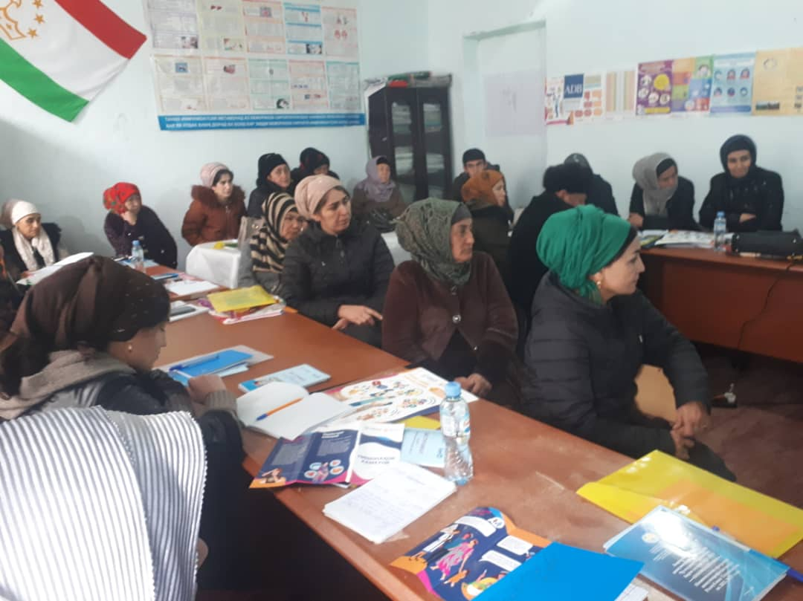
Figure 9. Consultation in Fakhrobod Jamoat, Khuroson District

Annex 9. Minutes of Stakeholder Consultations on E&S instruments Kyzyl Kala Jamoat, Khuroson District
Hosted by: HSIP
Date: February 17, 2023, 8:30 a.m.- 11:50 a.m
Venue: RFMCTC hall, Kyzyl Kala Jamoat, Khuroson District
Number of attendants: 37 persons (31 women)
Working language: official language (Tajik)
Objective:
- To inform key stakeholders about the expected activities under the Millati Solim Project and the measures taken to ensure environmental and social safeguards. Disclosure of drafts of social and environmental assessment reports.
- To obtain beneficiary comments and feedback on all components under the Tajikistan Millati Solim Project.

Agenda:
- Welcome speech, Doliev S.R., HSIP Implementation Specialist in Khatlon Region;
- Basic information about the scheduled activities under the Tajikistan Millati Solim Project (Doliev S.R., HSIP Implementation Specialist in Khatlon Region);
- Presentation, Social and Environmental Commitment Plan; (Asrorov D.R., PBF HMIS Data Monitoring Specialist in Khatlon Region);
- Presentation, Procedures Regulations of Labor-Management Relations (Shukurov M.N. – PBF Specialist in Khatlon Region);
- Presentation document: Stakeholder Engagement Plan (Doliev S. R., HSIP Implementation Specialist in Khatlon Region);
- Presentation: Environmental and Social Management Framework (Asrorov D. R., PBF HMIS Data Monitoring Specialist in Khatlon Region);
- Presentation: Resettlement Framework (Asrorov D.R., PBF HMIS Data Monitoring Specialist in Khatlon Region);
- Beneficiaries key takeaways and comments.

Meeting with citizens was organized for beneficiaries of the Project's services both for citizens and the PHC health staff.
The event was opened by Doliev S.R., HSIP Implementation Specialist in Khatlon Region, he welcomed all the participants, expressed gratitude to the Government of the Republic of Tajikistan, WB and MOHSP for the support provided to the Tajikistan health sector and briefly informed attendants about activities of the Government of the Republic of Tajikistan carried out in the health sector. In particular, it was said that the purpose of this meeting is to provide basic information about the expected activities under the Millati Solim: Tajikistan - healthy nation Project and review key project documents prepared as the basic environment and social safeguards of the project. Further, Doliev S. R. noted about the environmental and social safeguard policy, about the construction and institutional orientation of the project in strengthening the primary health care system. It was suggested that the meeting participants take an active part and provide their proposals on the presented materials.
In his speech, he noted that the purpose of public consultations is to provide basic information about the expected activities under the Tajikistan Millati Solim Projectand Project goals, objectives and components, phased WB support to Tajikistan health sector, main project beneficiaries and pilot districts to be supported under the Project.
D. R. Asrorov, PBF HMIS Data Monitoring Specialist in Khatlon Region presented information on the environmental and social aspects of the Project. He mentioned the WB requirements for the identification and assessment of social and environmental risks and impacts associated with projects. It was noted that the main purpose of this event is to inform population about the expected project activities, to get feedback and proposals on the presented project materials.
Further, Doliev S.R., HSIP Implementation Specialist in Khatlon Region, in his speech on the Stakeholder Engagement Plan, noted that this document was prepared in order to identify all parties interested in the project, to establish close and constructive interaction with them and develop an appropriate engagement framework, taking into account their views and needs. It was noted that the introduction of this mechanism under the project, as well as the feedback mechanism, will improve transparency and accountability in the sector.
Asrorov D. R., PBF HMIS Data Monitoring Specialist in Khatlon Region, presented the Environmental and Social Management Framework. He provided information on WB requirements and legal regulations of the Republic of Tajikistan requiring environmental and social assessment. It was said that the document sets out the expected environmental and social risks and impacts associated with the project, defines measures to prevent risks and manage negative impacts.
Shukurov M.N., PBF Specialist in Khatlon Region, in his presentation on Procedures Regulations of Labor-Management Relations said that this document is as a tool to manage the risks that may arise in relation to the recruitment and working conditions of project employees. Speaker told that the document was developed in accordance with the requirements of SES 2. "Labor and working conditions" and defines the main requirements in the field of labor legislation and the risks associated.
Asrorov D. R., PBF HMIS Data Monitoring Specialist in Khatlon Region provided listeners with information about the Resettlement Framework with an overview of the WB and the Republic of Tajikistan policies and procedures related to the issues of land acquisition, restriction of land use rights and involuntary resettlement.
It should be noted that all the materials provided to the participants of the event were presented as slides in Power Point format in a compressed form.
At the end of the event, the participants were asked to provide their feedback on the presented materials in writing.
Participants put the following questions:
- It was said about providing assistance to poor citizens, large families, orphans and widows under the project, in what kind it would be provided and what is the amount of assistance?
- It is not clear, it was said that citizens will be incentivized and interested in project implementation, under the project. What does it mean?
- As for questions related to medical care or healthcare, we certainly apply to the health facility and get some answer, at least. And regarding issues related to the standard of living, land management, utilities, and natural disasters consequences, whom we can contact, who can provide assistance or solve these problems?
- Will there be representatives of the project on place at the local or at least the regional level, as citizens do not have the opportunity to apply and go to the capital on vital issues?
- No one has ever seriously dealt with issues of sanitation and ecology on the ground, even household waste is not taken out and disposed, to say nothing of solid or construction waste. What is the mechanism for managing this problem?

Satisfactory answers were given to the questions received by speakers. Discussions took place in a lively atmosphere.
All parties involved were satisfied with public hearings and expressed their hope that the project implementation would make a positive contribution to improving the level, quality and volume of healthcare provided to the population at the primary health care level and strengthening their physical infrastructure.
List of participants and photos are attached.
Doliev S.R., HSIP Implementation Specialist
Asrorov D.R., PBF MIS Data Monitoring Specialist
Shukurov M.N., PBF Specialist

List of participants

# | Kyzyl Kala Jamoat
1 | Rakhmonov Safar
2 | Tagikhonov Alisher
3 | Sharipova Sailigul
4 | Boboeva Zulfiya
5 | Yuldosheva Fayzigul
6 | Sangova Bibioisha
7 | Tagoeva Malika
8 | Ganieva Gulrukhsor
9 | Rahmonova Safarbi
10 | Rakhimova Gulbegim
11 | Farzonai Shodi
12 | Rakhimova Mahfirat
13 | Nodiray Nurali
14 | Holova Parvina
15 | Raqabova Latofat
16 | Nazifova Shamsia
17 | Nazarova Gulrukhsor
18 | Latifai Jamoliddin
19 | Boboeva Matluba
20 | Khidirova Kurbongul
21 | Berganova Maidagul
22 | Rakhimova Mavluda
23 | Faizalieva Adiba
24 | Mirzoeva Mastona
25 | Rakhimova Saida
26 | Sunatulloeva Gulafzo
27 | Tavakalova Firuza
28 | Mirzoeva Mavluda
29 | Nuralieva Mavkuda
30 | Nazarova Sayyora
31 | Ziyovudinzoda Toshkuvat
32 | Rasulov Rustam
33 | Mirzoev Orif
34 | Saidova Malika
35 | Mahmadaliev Mohira
36 | Zugurova Umada
37 | Bobobekov Khairullo

Figure 10. Consultation in Kyzyl Kala Jamoat, Khuroson District

Improved efficiency of primary healthcare services will be achieved in pioneer areas (Sughd region and Dushanbe City) under Component 2, while improved quality will be achieved in selected districts under Component 1.
Mobile Engage is an SMS-based platform, initially supported by the World Bank through the Korea Trust Fund for Economic and Peace-Building Transitions, for broad communication to the citizen that was successfully used during the COVID-19 pandemic to inform the public about COVID-19 risks. Mobile phone coverage rates are above 90% even in rural areas of Tajikistan.
IEG (2014) The World Bank Group Support to Health Financing. An Independent Evaluation. https://ieg.worldbankgroup.org/sites/default/files/Data/reports/chapters/health_finance_evaluation_w_appendix_updated_0.pdf
This includes staff that will work in the purchasing structure of purchaser and excludes health workers.
Through the Disbursement-Linked Indicators in the ECDP, supported by the GFF and the World Bank, the MoF is introducing program-based budgeting (PBB) in district and urban PHC facilities as well as a single program budget line for PHC to allow for more flexibility by PHC managers to move expenditures across expenditures categories, which is needed to implement PBB. To date the regulatory and legal changes needed for these alterations to the public financial management system have been introduced. Yet the implementation of the new changes at the facility level is still work in progress.
To ensure the sustainability of strategic purchasing and digitalization, there are plans to include a policy action related to increasing the share of total government expenditure (without external funding) spent on the health sector, in a future Development Policy Operation in Tajikistan.
Vulnerable status may stem from an individual’s or group’s race, national, ethnic or social origin, color, gender, language, religion, political or other opinion, property, age, culture, literacy, sickness, physical or mental disability, poverty or economic disadvantage, and dependence on unique natural resources.

